apr. 30, 2026 – PKS Cataloging User Group Agenda

What’s happening at your library?
- Bobbi at Grand Forks – they are working on new label printers. She and Audrey have got a Zebra printer that is different from thermal ones, and they are hoping to address their fading label problem.
- Stacey at the State Library – next door the state museum is expanding. That means their road will be closed for a little bit. They have had a few power outages as well. Their co-worker, Al, will be presenting at a virtual conference.
- Dustin at West Fargo – they have added two full-time librarians to the adult services department. The one last person who was in the adult services department got their position changed around. So basically, the whole adult services department has been revamped. They are also in the process of hiring a new children’s librarian. In all 4 brand new people in the past two or so months. Every second grade class has been coming through doing tours, so he has been practicing his parade wave as they go by.
- Michele at the School for the Blind – She is working through a list of incorrect material types and fixing them. Things that are labeled as book instead of braille for example. They are also working on sending out overdue and renewal lists to their teachers.
- Cindy at Dickinson Public – They are getting close to being done with the expansion of the library. They will have to close so new shelves can be built. She is separating out all of the young adult materials from the children and create new collections for them. Then they will be separating out the easy nonfiction from the other children. They will also be getting rid of other collections. The plan is to be done by mid-June.

New items:

- Overlaying on order bibliographic records- Checking in to make sure that everything is working okay with a library overlaying the on order bibliographic record from another library.
  - Dustin said it is okay to keep doing it. With Midwest tape bib records when he imports records for those, if the brief record is overlaid, he will get provisional records. He would rather keep this workflow because he knows how to fix it.
  - Audrey said it is going well.
- Sometimes a regular print book bibliographic record will have the large print ISBN listed along with the hardcover/paperback/ebook ISBNs. Should this be removed? We have separate records for the large print, so it may be confusing.
  - Audrey sometimes sees both large print and regular print on a record.
  - Michele said that in the past her library put large print and braille items on regular print records. She is now going through those and fixing them. Another thing is, they get large print books that are a copy of the regular print book just enlarged, so the ISBN isn’t different. She changes the material type on these to large print.
  - We don’t think there is a problem with deleting the ISBN for large print off a regular print record.
- How will the implementation of Vega Discover impact the work of cataloging?
  - Vega Discover Rollups
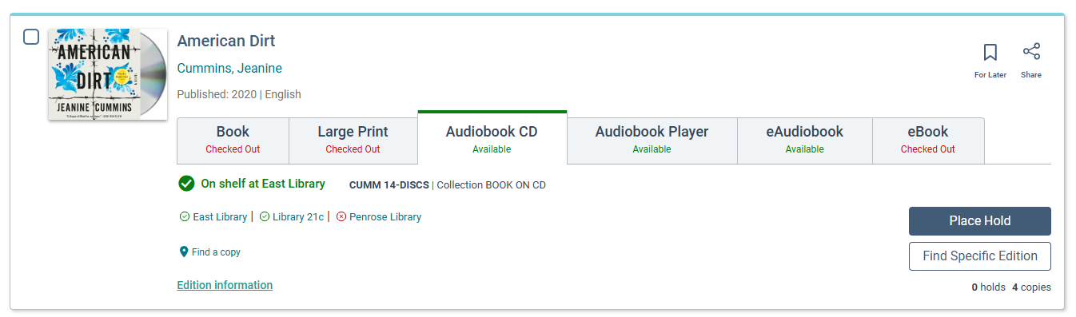
- If you want to search a live catalog that is using Vega Discover: Pikes Peak Library District
- Roll ups may impact cataloging work if you need to fix formats. Liz included instructions on fixing roll ups. She also included a MARC to BIBFRAME conversion guide because Vega uses BIBFRAME.
- We believe there will be a tab for Braille in roll ups.
- Lynn recommends that if you have unique needs in your library, keep a list of those with examples. Also, just ask ODIN if you need something fixed or if you have questions. Your examples can help us test the new pac.
- We believe we can have a tab for State documents too.

