# Guidelines for Shared Bibliographic Records in Polaris

## Adding Bibliographic Records

Before adding a new record to the database, conduct a comprehensive search to verify that the record is not already present in the shared Polaris database.

Match points:

* Numbers: ISBN, Publisher Number, UPC, ISSN
* Title
* Edition
* Responsibility – Authors, Illustrators, Editors, Translators, Directors, Performers, etc.
* Publication information
* Physical description – Book vs. eBook, DVD vs. Blu-ray, regular print vs. large print, number of pages, running time, etc.
* Language
* Series

## Editing Bibliographic Records

Imported bibliographic records require minimal editing. However, if adding some information will improve the record for all users, please do so. Examples are page numbers, a note, or a subject heading. All enhancements to bibliographic records should be made according to [MARC standards](https://www.loc.gov/marc/bibliographic/). OCLC’s [Bibliographic Formats and Standards](https://www.oclc.org/bibformats/en/home.html) is MARC standards-based and has more examples.

## Duplicate Bibliographic Records

Do not add duplicate bib records to the shared Polaris database. This helps prevent confusion among patrons and ensures items are not split across multiple records, which can complicate the holds process.

Take steps to eliminate existing duplicate records whenever possible.

## Local information in bibliographic records

Local information or copy-specific notes are better placed in the item record rather than the bibliographic record. However, if you want to add a note that is local in nature, place it in the 590 note. Polaris will preserve 590 notes and 690 subject headings in the overlay process.

Examples:

* Appropriate notes for the bibliographic record:
  + 590 Author grew up in Stanley, North Dakota.
  + 690 North Dakota author.
* Appropriate notes for the item record:
  + Public Note: Signed by author.
  + Public Note: Book only, CD missing.

## Overlaying records

1. Make sure both records are for the same resource:

* Use the OCLC number as a match point. The OCLC number is in the 035 field, subfield a, and has a prefix “ocm” or “(OCoLC).” Do not overlay records that have different OCLC numbers. Remember that some libraries set their holdings in OCLC with the OCLC number. To preserve this number, bibliographic records with different OCLC numbers must not be merged.  
  Example of a duplicate detection OCLC number match:   
  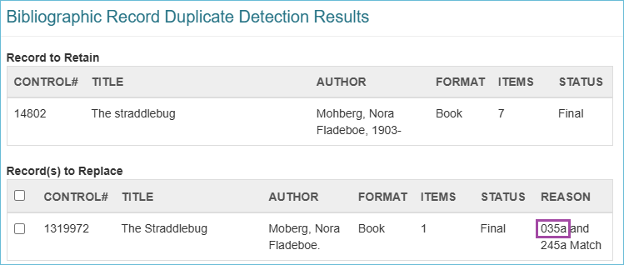

1. Even if the OCLC numbers are the same, make sure one of the records is not modified for Braille. ND Vision Center has modified bib records for Braille because records are not always available.

* Modifying an OCLC record to change its format (regular print to Braille) is frowned upon, but the ND Vision Center is permitted to do this since Braille records are so rare. Leap may consider the records a match because the OCLC number is the same.

1. If one of the records does not have an OCLC number, make sure it is a match—does it have the same ISBN, Title, Edition, physical description (see list above)? If yes, overlay it with the record that contains the OCLC number.

## What to do when you cannot find a record

When you cannot find a record for the resource in Polaris or WorldCat, then you will create a record using a template available in Leap. [The ODIN website has instructions on how to create a record from a template](https://www.odin.nodak.edu/training/cataloging/leap-copy-cataloging-adding-records-template).