Shoutbomb FAQ’s
- Are patrons required to sign up manually?
  - No. Manual sign-up was only required during testing. Once we go live, there will be an hourly process in place that automatically opts them in once their account registration is specified with the “TXT Messaging” notification option or the “Additional TXT Message” checkbox.
- What patron info is kept by Shoutbomb or what does it have access to? How long is that info kept?
  - Shoutbomb maintains the patron’s phone number and library card number. All other transactional information used to generate the notices are kept for a maximum of 30 days.
- If a patron cancels a hold via text (CXH), how are library staff alerted?
  - Requests must be in ‘Held’ status to qualify for cancelation. If a patron cancels a hold via text, that hold will automatically update to Canceled status in Polaris and move to the ‘Holds to Action’ tab of the library’s picklist. This will alert staff to remove it from the holds shelf and check it back in.
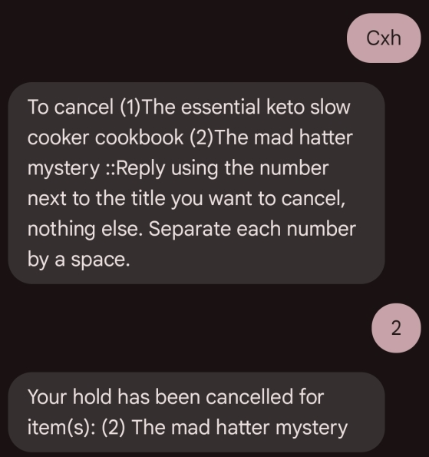
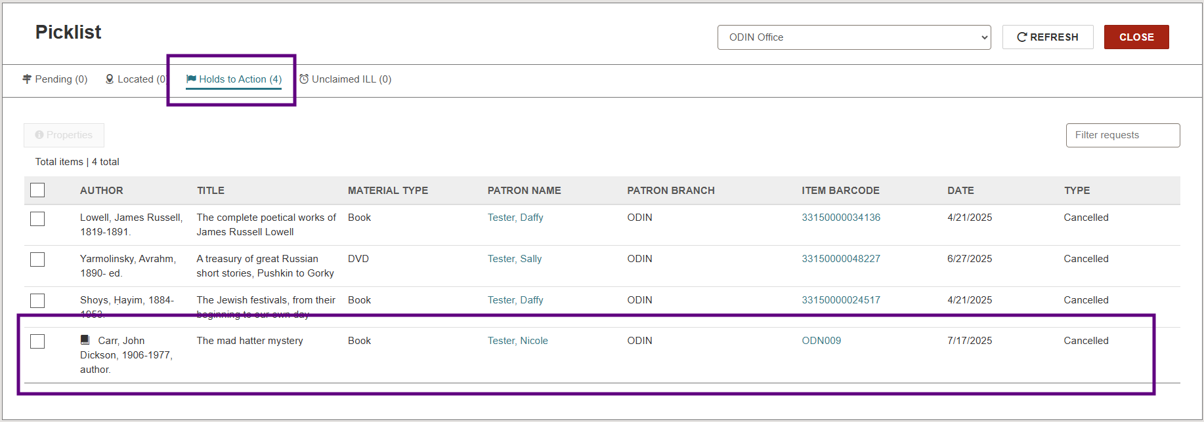
- My patron wants to opt out of text notifications. Are they automatically opted out once their notification preferences are updated in their registration?
  - Yes. Once the notification preferences in the patron’s registration are updated, the text notifications will become inactive once the hourly, automated process runs.
  - If they want to opt-out immediately, they may reply STOP to block all future messages.
- What if a patron accidentally turns off a needed notification and doesn’t realize it?
  - The keyword NOTICES will send a list of active & inactive notifications to the patron’s phone. To reactivate a notification, enter the keyword listed for that notification.
  - If there is concern about text notifications being missing or accidentally deactivated, library staff may opt to make text notifications the additional notification method, rather than the main one, by selecting the ‘Additional TXT Notice’ checkbox in the Polaris registration.
- The MYCARDS keyword lists my registered barcodes as links, interpreting them as phone numbers. When I click the links, I receive options to call, text, or facetime. Can this be fixed?
  - Unfortunately, no. The messaging app used by the patron’s smartphone is responsible for presenting the barcodes as links. We have seen this behavior with iPhone and Android phones.

