# How to Use the IPEDS Dashboard

Sign in to Alma and click on the Analytics menu.

Select the Access Analytics link.

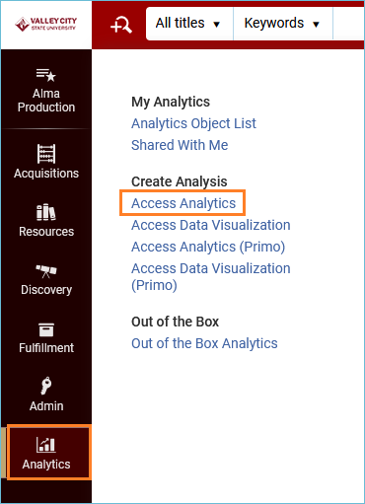

Analytics opens in a new tab in your web browser. Click on the **Catalog** menu at the top of the screen.



In the left pane, navigate to the Institution folder. To do this, click the triangle next to **Shared Folders** to open the file structure. When you find your Institution, click that folder to open it.

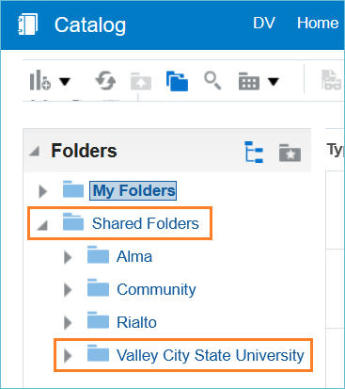

In the right pane, you will see files and reports that are in the Institution folder. Near the top, you should see the IPEDS Dashboard. Click **Open** to use the IPEDS Dashboard.

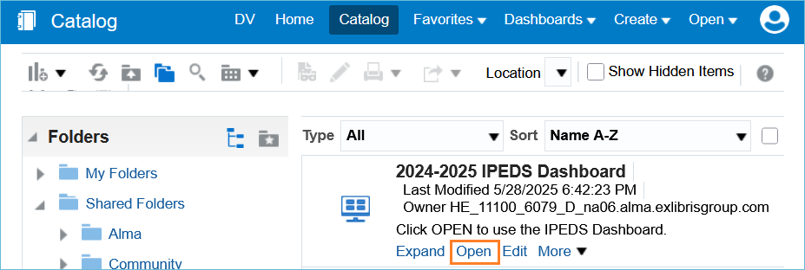

Once open, the IPEDS Dashboard features a tab for each data element requested by IPEDS. Most tabs have prompts asking for a date.

Example: Physical – Books

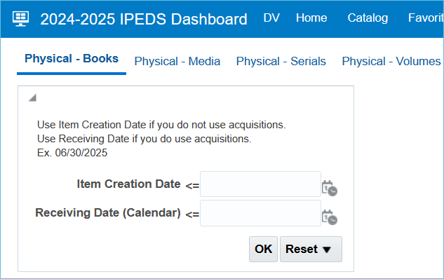

The prompt for this report asks for a date equal to or less than for Item Creation OR Receiving Date. This date would be the last day of the fiscal year for your IPEDS report, ex. 06/30/2025. If your library uses Acquisitions, you should use the Receiving Date box, and if you do not use Acquisitions, you should use the Item Creation box. Click OK to run the report.

The report appears, and at the bottom of the report you have Export and Print options:

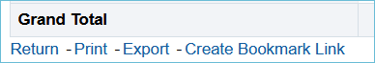

* **Return** will return you to the main dashboard where you can continue to run and view reports
* **Print** will print the report
* **Export** will give you options for exporting the report
* **Create Bookmark Link** will create a URL in the browser address bar that you can use to return to this report

If you have questions about the IPEDS dashboard, please submit an ODIN Helpdesk ticket.