June 26, 2025 – Academic Cataloging Group Notes

What’s happening at your library?
Kelly, Mayville State – Has had bibliographic record from OCLC for an EBSCO ebook fail to export into the Network Zone. This has happened before and she’s wondering why that would happen.

Lisa, Bismarck State – They are still recovering from flood in December. They sent several thousand books to a freeze drying company. Many are not in good enough condition to return to the shelves. They have purchased many ebooks and print books since it is the end of the fiscal year.

Drew, University of North Dakota- UND has received two very large donations. One for theses and dissertations, and independent studies from the College of Education. A number of them are ones the library didn’t previously have. The other donation is 5000 items of natural history books.

Ben, Valley City State – Valley City is continuing their reading challenge with Jamestown University. That has been going well, and other than that it has been a quiet summer so far. They are working on a project for accessibility for archives and doing an inventory.

Patty, Minot State – the library received a massage chair from student health. They have it upstairs behind some gray partitions. It comes with a little video that you can watch to see what it does.

Jenny, North Dakota State University- the library is doing a lot of weeding. They are also filling vacant positions.

AI in Technical Services (Amy and Kelly) Discussion
Kelley and Amy gave a presentation on the use of AI in libraries, focusing on Cataloging and Metadata creation. (Link to the presentation)

Two webinar recordings from Ex Libris and LJ (both are 1 hour):

Simplify metadata management with Academic AI
- Developing Custom AI workflows for metadata management

Demo of new Metadata Editor AI features
Liz did a demo of the new Metadata Editor AI features. Now you can specify to add contents notes or summary statements.

Cataloging Guidelines
The group voted to approve the Cataloging Guidelines and review them annually.

Suppressed Bibliographic Records in the NZ
Do this advanced search in Alma:
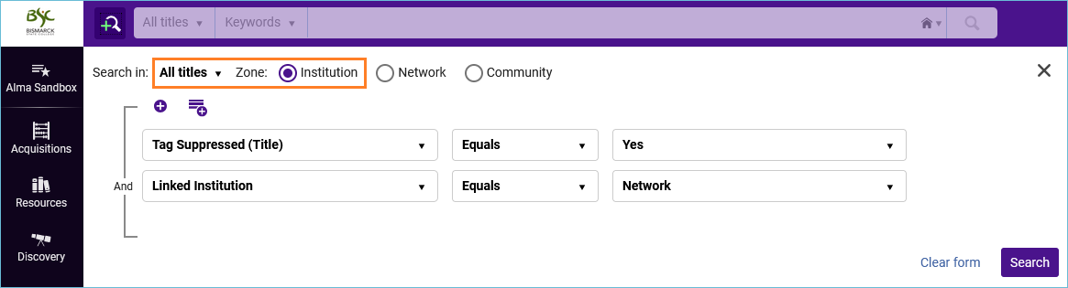
Then create a set from the results. You can then catalog the set in the metadata editor, and “copy to catalog” each record, or you can run a job, “Unlink a set of records from the Network” on the set.

There is a CERV enhancement, “Synchronization of suppressed records between NZ and IZs” Proposed Solution:
Implement a synchronization mechanism that evaluates suppression status changes across IZs, and automatically updates the corresponding record in the NZ based on predefined logic:
Suppression Rule: If a bibliographic record is suppressed in all IZs, it will be automatically suppressed in the NZ.
Unsuppression Rule: If a bibliographic record is unsuppressed in at least one IZ, it will be automatically unsuppressed in the NZ.
The above synchronization rules to be applied to the suppression-related workflows mentioned above, not limited to the MDE.

If this request goes into effect, we would not need to worry about suppressed bibs in the NZ.

