# How to Correct the Wrong Book Cover in the PAC

## Check all the ISBNs in the record to make sure they are for the correct book

The book cover image for this book is wrong in the PAC:

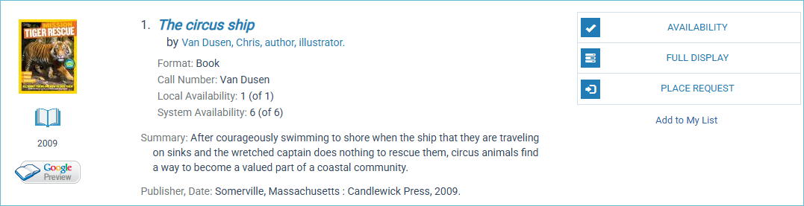

Open the MARC record in Leap and check all the ISBNs in the record. The ISBN appears in the 020 field.

For audiovisual material, you would check the UPC in the 024 field.

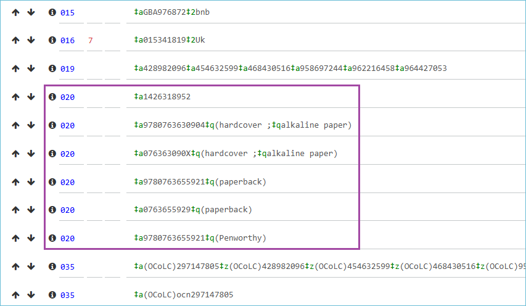

You can use Google to verify that each ISBN or UPC is correct:



This ISBN in the incorrect one:

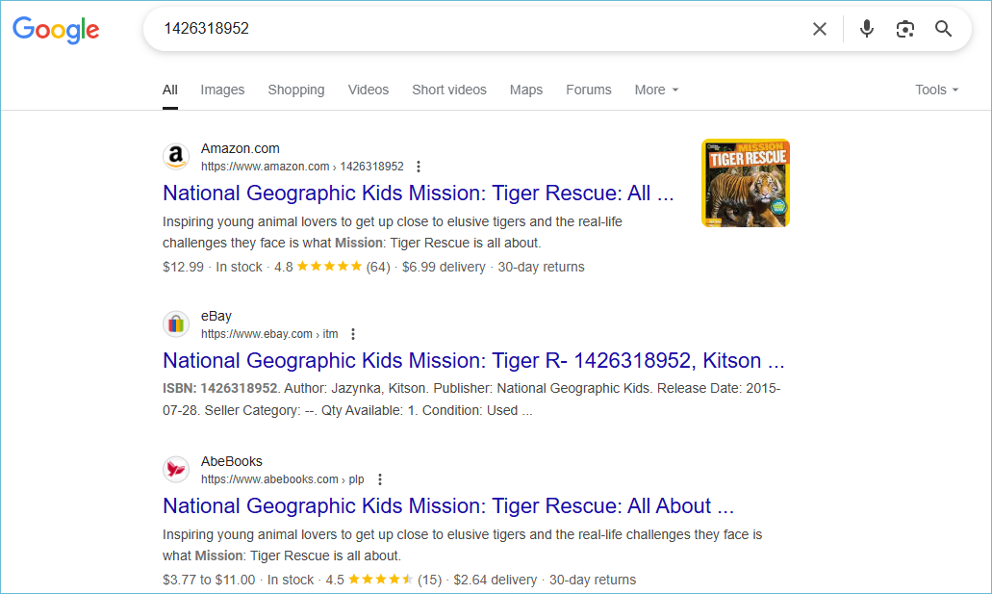

Now that you have identified the incorrect number, you can remove it from the bibliographic record. Click the minus sign to delete the field.



Save the record.

The image in the PAC should be updated in just a few minutes.

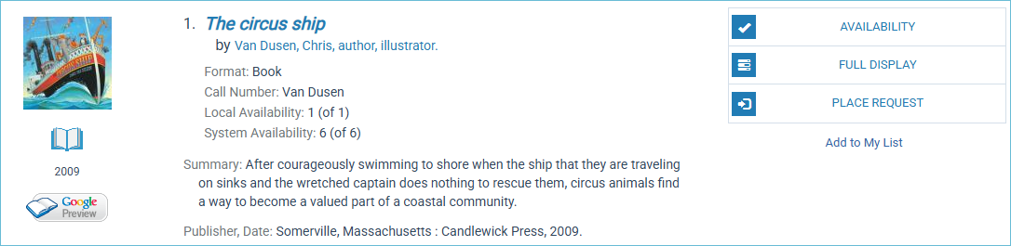

## What to do when all the ISBNs or UPCs in the bibliographic record are correct

If all the numbers are correct, you will need to report the problem to ODIN, and the ODIN office will report it to Syndetics.