# Volume Information in Item Records

## Enter volume information into item records only when necessary

Use volume information for multivolume sets. A multivolume set is a monograph that is complete with multiple parts. You can recognize these when the MARC record indicates multiple volumes should be on one record. See this example, *Music in American life*:

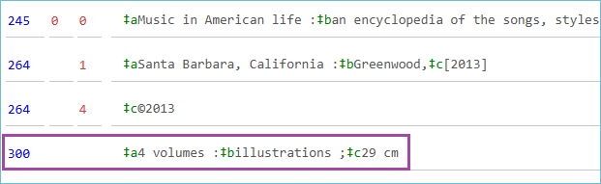

Volume information is important to distinguish each part from the others.

Another example would be a DVD set, and the library circulates each disc separately. Each item record is attached to the same MARC record, and each disc is distinguished with disc 1, disc 2, disc 3 in the volume field.

## Impact on holds

When a hold is placed on an item record containing volume information, the system creates an item-level hold for that item.

There are two types of holds: item-level and title-level. Title-level holds are more efficient as they are fulfilled by the first available copy, ensuring patrons receive their requested items faster. An item-level hold can only be fulfilled by a specific copy, which is appropriate for multivolume sets, but can be disruptive when managing hold lists for popular items. For example, if an item-level hold is placed on a long overdue copy, it gets “stuck” and does not automatically move to an available copy. For this reason, volume information should be entered in the item record only when necessary.

## What you can do instead

When you want to add more information to the item record, for example, by adding series information, you can add it to the call number suffix field or the cutter field.

Here is the call number area for *Fourth Wing,* by Rebecca Yarros:

Here is how it looks in the PAC:

