# Managing Electronic Resources with a Local Electronic Collection

There may be times when you want to gather portfolios into an electronic collection. This could be because an electronic collection is not available in the Community Zone, or because you want to retain local control.

**Roles:** To manage local electronic collections, you will need the following roles: **Electronic Inventory Operator** and **Electronic Inventory Operator Extended**.

## Creating a Local Electronic Collection

To create a Local Electronic Collection, click the Resources menu, and under **Create Inventory**, select **Add Local Electronic Collection**.

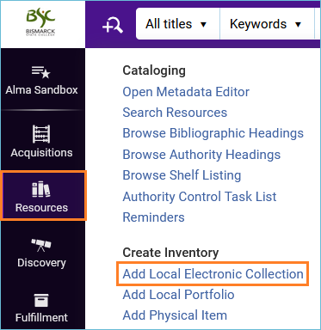

Give the local electronic collection a name and set the **Collection type** and **Service type**. Click **Save and continue**.

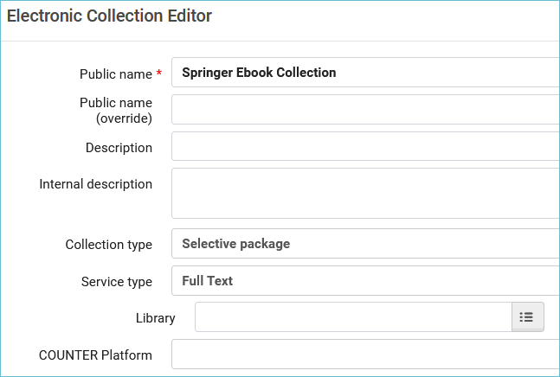

On the **Activation** tab, change **Service activation status** to **Available**. Fill in any of the other fields if they are necessary. If you prefer, you may wait until after you have added portfolios to the local electronic collection to set the collection to Available.

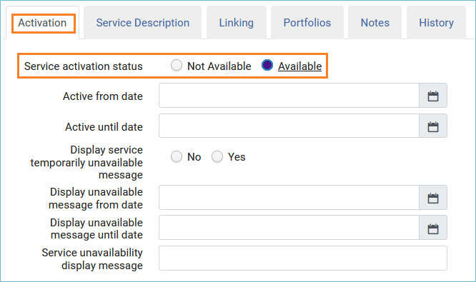

Click the **Service Description** tab. Choose either **Full Text** or **Selected Full Text**.

Click the **Linking** tab. Fill this tab in according to your collection. If the links must be proxied as for this Springer eBook Collection, you would put that information in the linking tab: **Proxy enabled: Yes** and select your proxy from the drop-down box. It is much more efficient to set the proxy here in the electronic collection service than in each portfolio.

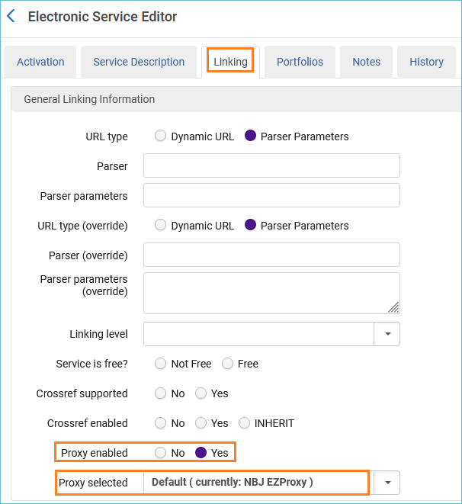

Click **Save** twice to set up the collection.

Note: if you missed setting up the service when you created a Local Electronic Collection, you can get to it easily by searching for the collection and using the row action menu and selecting **Edit Service**:

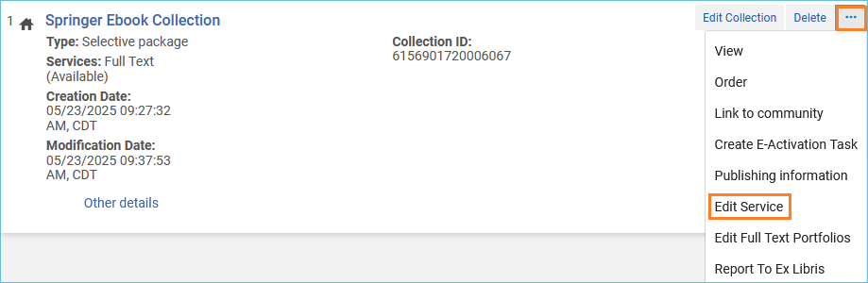

## Adding portfolios to the electronic collection when you create the portfolio

There are different ways to add portfolios to a local electronic collection. For example, if you are purchasing eBooks each month from a vendor, you can add portfolios to the local electronic collection during the cataloging and portfolio creation process. See: [How to Add a Portfolio to a Bibliographic Record](https://www.odin.nodak.edu/training/resource-management/how-add-portfolio-bibliographic-record).

You can also create a portfolio from the electronic collection. Click on the row action menu, and select **Edit Service**. Click on the **Portfolio** tab and click on the **Add** dropdown and select **Add Local Portfolio**. (You can get the same form by clicking on the **Resources** menu and selecting **Add Local Portfolio**.) The portfolio work form appears. At the top, you have the option to save the portfolio to the Network Zone or Institution Zone. Always select the Institution Zone for local portfolios. The rest of the instructions are the same as found in [How to Add a Portfolio to a Bibliographic Record](https://www.odin.nodak.edu/training/resource-management/how-add-portfolio-bibliographic-record).

## Adding Portfolios to the Electronic Collection with a Set

A quick way to add portfolios to a local electronic collection is to create a set of them through a search in Alma. Once they are in a set, you can add them as a batch to the local electronic collection.

Click on the magnifying glass in Alma to open the Advanced search. Make sure your search is set to **Electronic Portfolios** in the **Institution Zone**. Search for a **keyword** in the **URL**, and add the criteria **Is Standalone** to **Yes**.

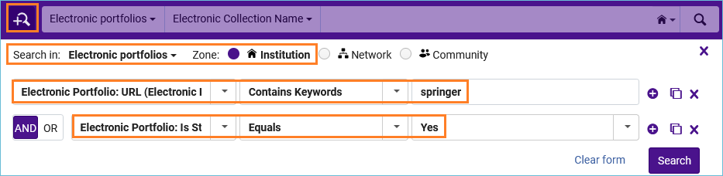

Click **Save Query**, and give the set a name, then click **Save**.

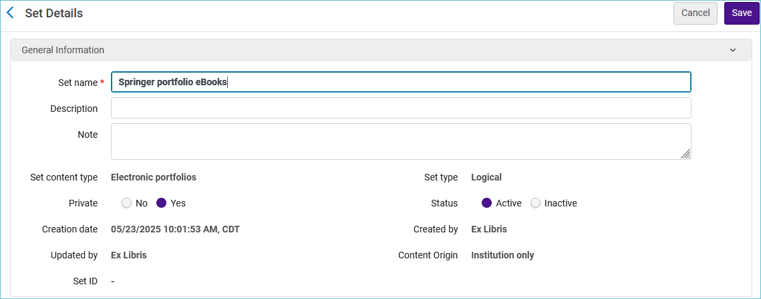

Next, find the Local Electronic Collection, click the row action menu, and select **Edit Service**.



Click on the **Portfolios** tab. Click the **Add** dropdown and select **Add from Set**.

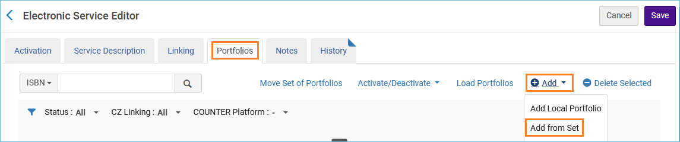

A box appears where you click into the box and a list of sets appears. Click on the correct one, then click **Submit**. A confirmation message appears asking if you want to proceed, click **Confirm**. A job runs that will add the portfolios to the collection. Once the job has finished, click the Portfolios tab again, and you will see the portfolios listed under the tab.

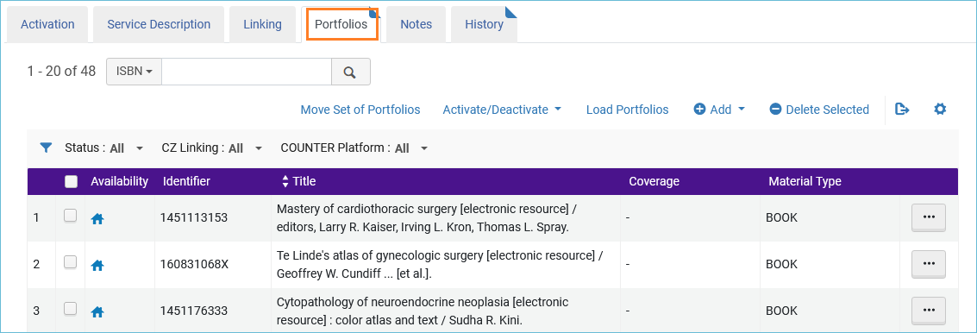

## Using the Portfolio Loader

You can use an imported spreadsheet to add, remove, or update portfolios in an electronic collection. You can download the Excel template from the [Alma documentation page](https://knowledge.exlibrisgroup.com/Alma/Product_Documentation/010Alma_Online_Help_(English)/Electronic_Resource_Management/030_Working_with_Local_Electronic_Resources/015Managing_Electronic_Resources#Using_Portfolio_Loader_for_Adding.2C_Updating_or_Removing_Portfolio_Information_in_Bulk). The Excel template is extensive, and you will not be using all the available columns. Keep the columns you will be using and remove the rest.

For this example, we will **add** three eBook portfolios to the Springer eBook collection. This is the Excel spreadsheet with only the necessary columns.



From the Electronic service, on the portfolios tab, click on the link **Load Portfolios**.

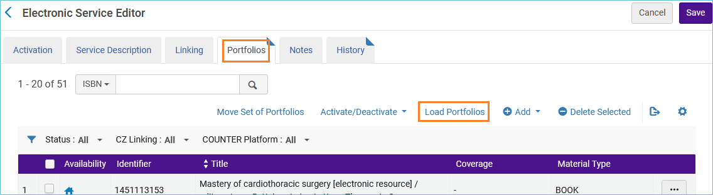

The **Activation Wizard** opens.

Image of the Activation Wizard.


Choose whether to load the bibliographic records to the Network Zone or the Institution Zone. Since none of the records will have OCLC numbers, these will load to the Institution zone.

Next, add your Excel file containing the portfolio information.

Next, select the **Loading Policy**.

* Complete – loads a complete set of portfolios, overwriting any existing portfolios.
* Incremental – loads a file that includes only the incremental changes to the portfolio list.

After that, select the **Action.** The actions available each **Loading Policy** are different. [Refer to the Alma documentation for complete descriptions](https://knowledge.exlibrisgroup.com/Alma/Product_Documentation/010Alma_Online_Help_(English)/Electronic_Resource_Management/030_Working_with_Local_Electronic_Resources/015Managing_Electronic_Resources#Using_Portfolio_Loader_for_Adding.2C_Updating_or_Removing_Portfolio_Information_in_Bulk).

For this example, I selected **Incremental** for the loading policy, with the action, **Add New**.

Lastly, select the **Validation Policy**.

* **Validate online** - Files less than 2 MB can be validated online.
* **Validate offline** - For files over 2 MB select Validate offline. You will then get the options: **Load file if there are no errors**, **Load file - ignore lines with errors**, and **Analysis only**.

Click **Next**, and the activation summary appears, and then click **Load**.

The new portfolios were added to the electronic collection.