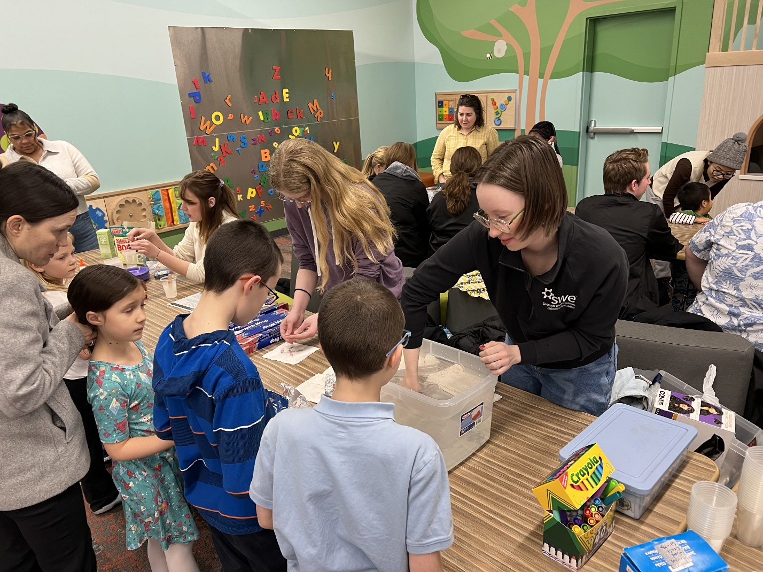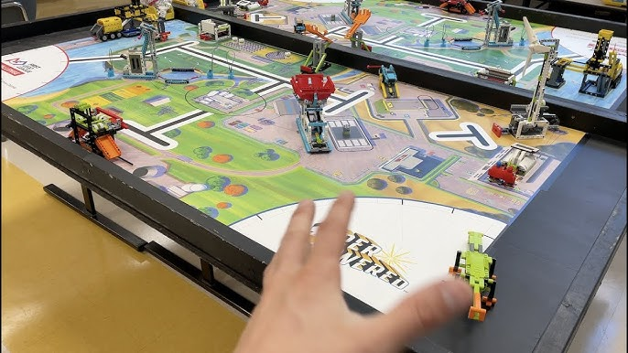

The chamber music concerts were done in partnership with the North Dakota Museum of Art and were paid for through a grant. The library has also hosted Northern Valley Youth Orchestras chamber music concerts.

STEM@ My Library programs are held one Sunday per month (October through May) from 2:00 to 3:00 p.m. There is a different focus each month, including Geosciences, Engineering, Chemistry, Physics, Robotics, and Paleontology.  We set up a variety of hands-on activity stations that are led by UND students and faculty.

Here is a description of the FIRST LEGO League: The *FIRST* Lego League Challenge is an international competition organized by *FIRST* for elementary and middle school students (ages 9–14). Each year in August, FIRST Lego League Challenge teams are introduced to a scientific and real-world challenge for teams to focus and research on. The robotics part of the competition involves designing and programming LEGO Education robots to complete tasks. The students work out a solution to a problem related to the theme (changes every year) and then meet for regional tournaments to compete, share their knowledge, compare ideas, and display their robots.

