# Creating a Shelf List Report

You may opt to conduct inventory by creating a **Shelf List Report** of all items found in each collection, printing it out, and manually comparing the items in the report to what is found on the shelves.

Navigate to **Simply Reports** directly from Leap under the **Utilities** menu:

Log in using your Leap credentials. Navigate to the **Items tab** and choose **Item List Reports**:

Add your criteria to **Columns Selected for Output** and sort by *Item Call Number*. Leave *Include Header Rows* and *Excel File* checked:

For further details on adding & removing fields from these menus, visit our Simply Reports Basics tutorial.

* **Criteria (can be adjusted as needed):**
  + Columns Selected for Output
    - Item Assigned Branch name (Optional)  
      Item Assigned Collection Name (Required)  
      Item Barcode (Required)  
      Item Call Number (Required)  
      Item Circ Status (Required)  
      Item Material Type (Optional)  
      MARC Title (Required)

MARC Author (Optional)

* + Columns Selected for Sort
    - Item Call Number
    - MARC Title

Once your chosen criteria are entered, add your filters.

* **Filters** 
  + Item General Filters
    - Assigned Branch (choose your branch)  
      Collection (choose your desired reporting collection)  
      Record Status = Final

Once all criteria and filters are in place, click *Submit. Y*our Report Preview will appear:

Download your full report results by clicking the checkbox next to **Download report output** and selecting *Download*:

Your file will be downloaded to your computer’s *Downloads* folder. Access the folder and open the file as an Excel spreadsheet. The spreadsheet will require some initial clean-up involving widening columns or changing the barcode column to a number format:

Once you have completed your adjustments, save your spreadsheet as an **Excel Workbook (.xlsx):**

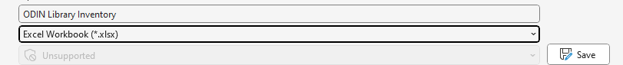

Print out your report and use it as a basis of comparison for the items found on your shelves.

If any items with an *Available* status are missing from your shelves, update the record’s **Circ Status** to *Missing* in Leap.