Leap – Creating a new bibliographic record from a template
Make sure to check the ODIN Polaris database and OCLC WorldCat before adding a record from a template. If there is already a record that is the one you should use. See the instructions Leap: Adding Items, and Leap Copy Cataloging: Adding Records from Another Source.

- After logging into Leap, click on the New menu, and select Bibliographic Record.
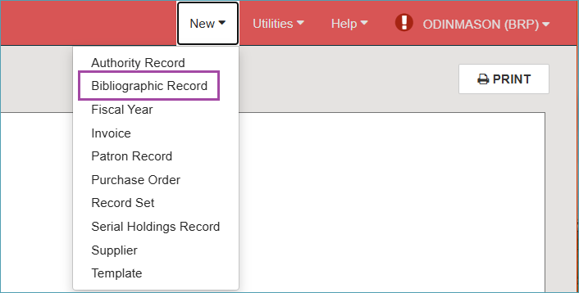
- From the drop-down menu, select the template that matches the material you are working on.
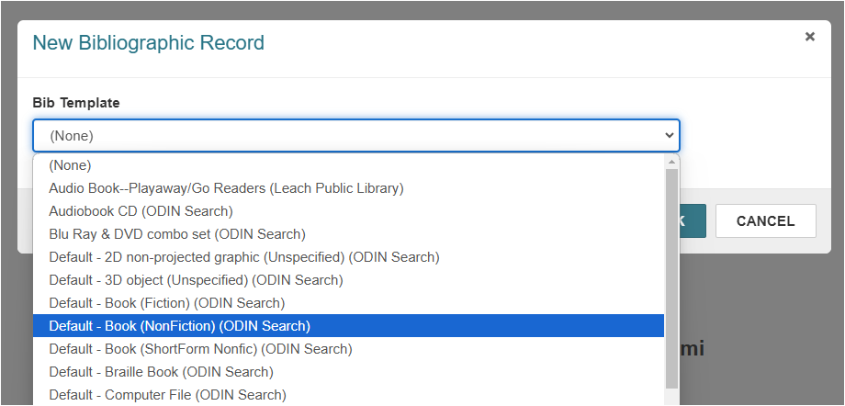
- Select the template and click OK. It will open in the MARC editor in Leap.
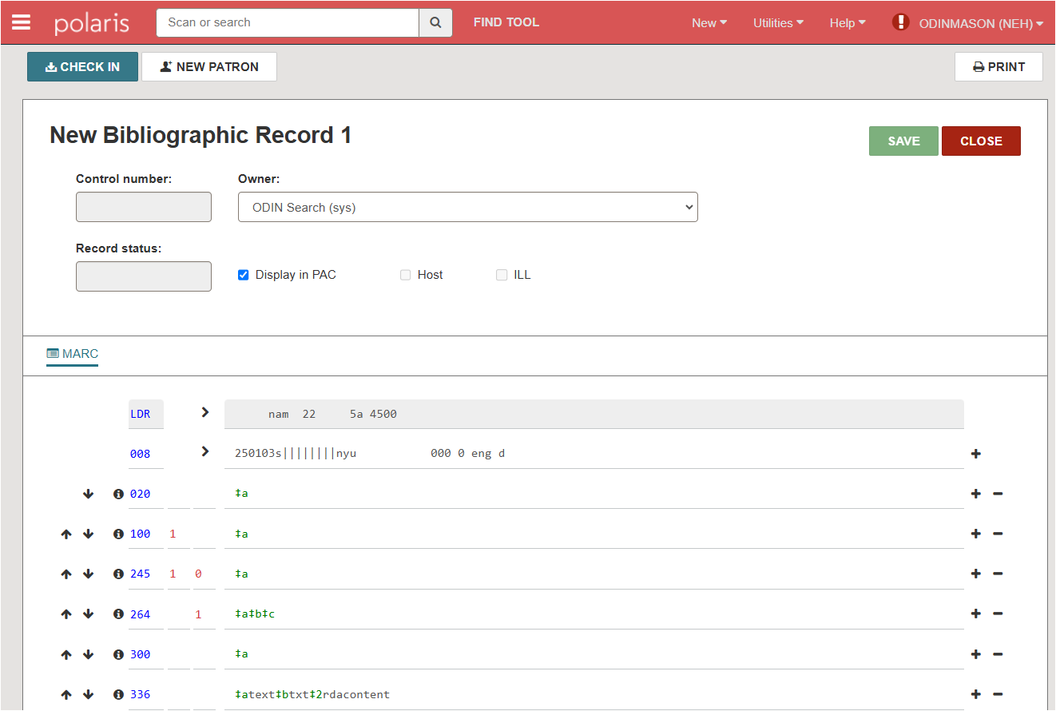
- Use the “i” icon to see what information goes into each field. The help appears in yellow under the field. Click the close button to close the help.
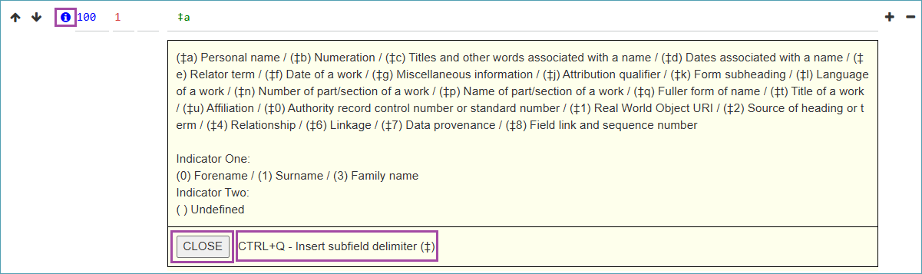
- To enter text into the field, click into the field and begin typing.
- To add a field, click the “plus” icon and a new field will appear below. To delete a field, click the “minus” icon.
- When you have finished adding information to the record, delete any fields you are not using. *Keep the 901 Brief bib note in the record.
- Save the record to the Polaris database.
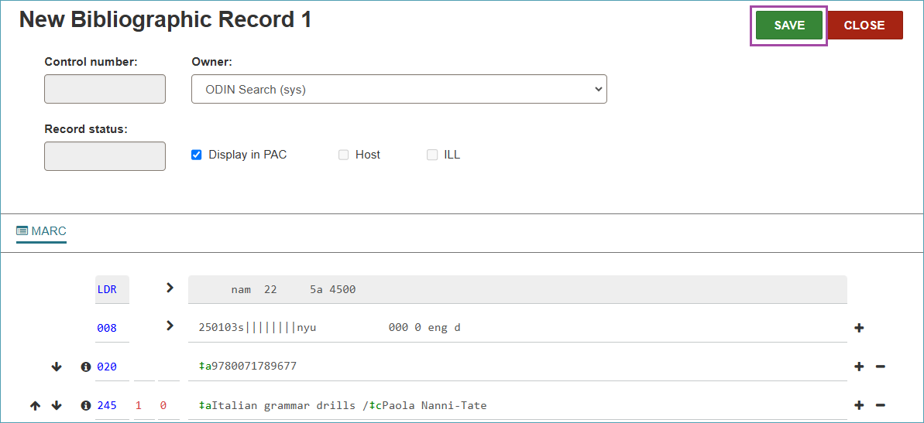
- Once the record is saved it has a control number and a record status of Final.
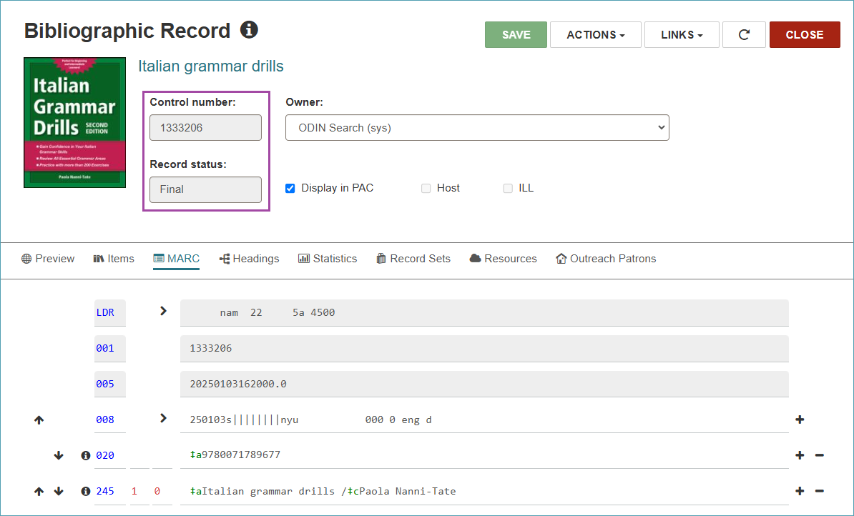
- Now you can add an item record to it according to the instructions Leap: Adding Items.

