# Add a Local Extension Field to a Bibliographic Record

Adding a local extension field to a bibliographic record will:

* Make that field visible only to the owning library in Alma and Primo VE
* Protect that field from being over-written by newly imported records

To add the local extension, open the bibliographic record in the Metadata Editor. Click the Editing Actions menu and select **Add Local Extension** or click (CTRL+L).

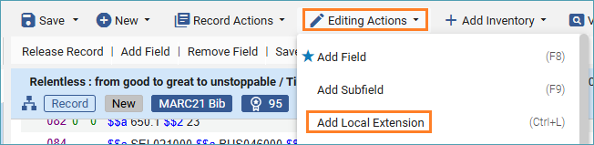

A blank field with the local extension icon will appear.

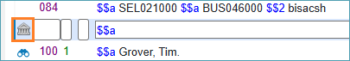

Fill in the field information:

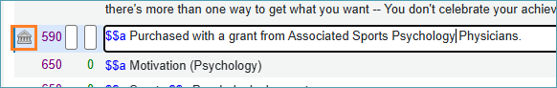

Save the record. By saving the record the MARC fields are automatically sorted into their correct places.

Local extension fields can be call number fields, notes, or subjects. They are in fields with a **9** in them (09X, 59X, 69X, 9XX). [Here is a list of local extension fields for ODIN libraries](https://docs.google.com/spreadsheets/d/1MkSlkXf0YQSiC8XM3q_uMjzvPlfdZW1nxtmRsynLIis/edit#gid=0).