**Discovery/PAC User Group Meeting Notes – November 13, 202****4**

**Topics for discussion:**

* LX Starter Project –We are working on some basic templates. If you would like to have a walk-through session, let Lynn know.
* SMS solution – Jason working with procurement.
* TRN upgrade to Polaris 7.7 on November 8th. PROD scheduled for early January 2025. <https://www.odin.nodak.edu/events/announcement/pks-training-server-upgrade-polaris-77>
  + What’s New Webinar – Nov 20th noon – [REGISTRATION LINK](https://www.iii.com/event/webinar-whats-new-in-polaris-7-7/)
  + Configuring Display of Reading Level Facet in PowerPAC. This will let patrons filter search results based on reading levels your library catalogs in the bib records (521 tag subfield $b to include in facet count; 521 subfield $a determines which reading level range the record falls within)
    - Examples:

Licorice Pizza cn=1187569

Ice claw cn=374609

Life, after cn=366466

* Sticky filters in LEAP!! – you can filter to your Assigned Branch or Patron’s Registered Library so you do not have to set it multiple times during your session.
* PROD alert window when signing into LEAP and Remote Client – request to remove requirement to click CONTINUE for which server working on. TRAINING server alert window would remain. Watch for email “call for comments” or let us know if this change would create problems for your library.

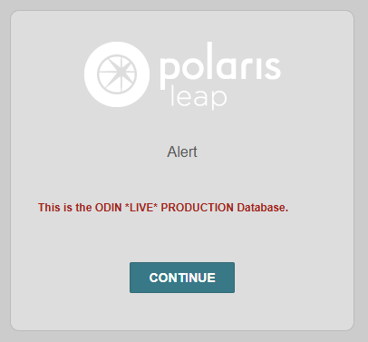

* Accessibility rules – new rules going into effect April 2026 – working through sites and applications to ensure compliance - <https://www.ada.gov/resources/2024-03-08-web-rule/>

**Roundtable Open Forum:**

* West Fargo Public – progress on new library site – done by January?
* NDSL – changes in labeling for packaging (tracking and email for tracking), working on PAC updates
* Wishek – weeding books, redoing library (adding outside accessibility)
* Dickinson Area – bookmobile librarian position filled (Becky Needham), new Bookmobile in February, Scholastic Book Fair next week
* ODIN – We will be scheduling a review session to walk through some of the relevant changes in Polaris v7.7 after it is installed on PROD (early January).

**Questions/Comments/Feedback**

* Patron records with email notices in plain text may become an issue when switching to Vega LX Starter – something to keep in mind when switching.

**Next meeting December 11th** – Second Wednesday of each month