**Requesting ILL’s from the ND State Library in Polaris Leap**

**\*\*NOTE:** Please ensure there are no available copies among the ODIN Polaris libraries before placing an ILL request with NDSL.

For instructions on placing a Hold or Transfer request for an item owned by another ODIN library, follow the link below:

<https://www.odin.nodak.edu/training/circulation-holds-ill/placing-hold-requests-leap-pac>

**Overview:**

Placing an ILL Request  
Cancelled ILL Requests  
Receiving an ILL  
Checking Out an ILL  
Returning an ILL  
Deleting an ILL Request  
Renewing an ILL  
Lost/Damaged ILL Procedures  
Generating Replacement Bills  
NDSL ILL Contact Information

**Placing an ILL Request:**

Under the patron’s account in Leap, navigate to the *Holds/Held*tab. Click **New Hold**, then **Unlock:**

*Unlock Hold Request* pop-up will appear. Click **Unlock**:

Fill out the request form with as much information as possible. Click **Place Hold:**

**\*\*Notes:**

* If including an ISBN (preferred), click the blue circle next to the ISBN option before entering the number into the field. Otherwise, it will not register in the request.
* If you have the OCLC # instead of an ISBN, it may be listed in the **Staff Display Notes** field under the *Notes* section:

Once the request appears under the *Holds/Held* tab, click the check box next to the request to select it and choose **Convert to ILL**:

The request will move to the *ILL/Held* tab. Navigate to that tab, click the check box next to the request to select it and choose **Export**:

This places the request into *Active* status and exports the request for NDSL to begin the process of fulfilling it in OCLC.

The request will appear in your library’s **Request Manager** (*Utilities > Request Manager*):

Navigate to the *ILL* tab and filter for **Active** status to view your active ILL requests:

Click into each ILL request from the list to view **Details**and **Notes** under their respective tabs:

If the request was successfully exported to NDSL for fulfillment, the request will list a **Sent Date.**

To check for a Sent Date, hover your cursor over the  icon in the ILL Request:

If the Sent Date field is blank, the request did not export successfully. You may want to follow-up with NDSL about the request ([ndslill@nd.gov](mailto:ndslill@nd.gov)) or export a new one.

**If a request can be fulfilled,** NDSL staff will enter a note in the *Note* tab of the request including the OCLC number and date the request was placed in OCLC on behalf of your library.

**If a request cannot be fulfilled,** it will be cancelled, and a note entered in the *Note* tab indicating why it was not able to be fulfilled. Notify the patron their request could not be fulfilled and delete it (either directly from their Leap account or via your Request Manager).

**Cancelled ILL Requests:**

To view cancelled ILL requests, open your *Request Manager*, navigate to the *ILL* tab and filter for **Cancelled** status. To delete, click the check box next to the request and choose **Delete:**

**\*\*Notes:**

* It is recommended to check your Cancelled ILL requests list regularly. Requests that have been exported to NDSL do not update automatically on their end.
* If library staff or your patron has cancelled an ILL request in Leap, email [ndslill@nd.gov](mailto:ndslill@nd.gov) as soon as possible, so they can attempt to cancel the request with OCLC.

**Receiving an ILL:**

Navigate to the *Check In* screen and enter the NDSL-provided barcode (OCLC number):

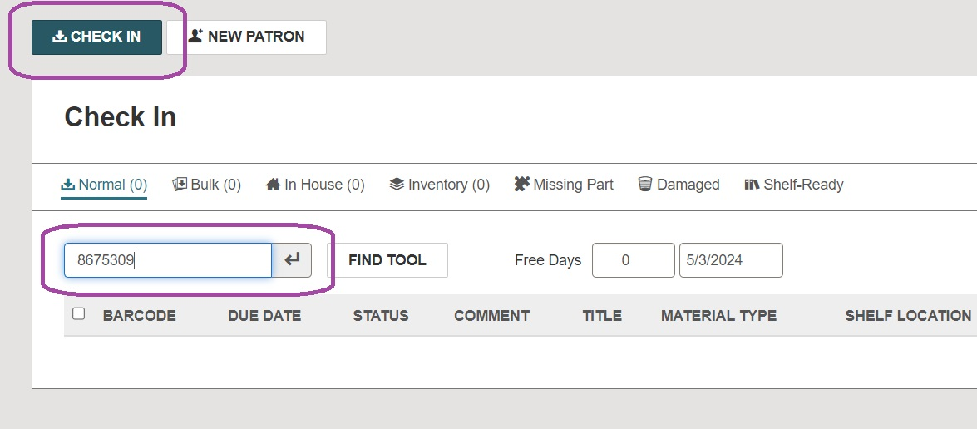

*Item is Blocked* pop-up will appear. Click **Continue***:*

*Fill ILL Request* pop-up will appear. Click **Yes**:

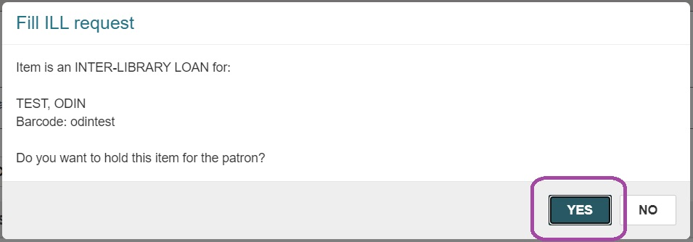

Print *Hold Slip* if desired, place it with item, and set on Hold Shelf (or in designated area).

**If automatic Hold notices are enabled for your library,** patron will be notified for pick up.

**If automatic Hold notices are not enabled for your library,** notify patron for pick up.

**Checking out an ILL:**

Access the patron’s account in Leap, navigate to the *Check Out* tab, and click on **Special Loan**:

Enter the due date (Loan Period field will update automatically) and click **OK:**

**\*NOTE:** The due date provided by NDSL is the date the item needs to arrive back to them, so it is recommended to adjust your patron’s due date 3-5 days BEFORE the NDSL date.

Scan the item barcode under the *Check Out* tab:

*Patron is Blocked* pop-up may appear. Click **Continue:**

*Item is Blocked* pop-up will appear. Click **Continue:**

If the checkout is successful, the ILL will be listed under the *Out/Overdue* tab of the patron’s account. Click **Complete** to close:

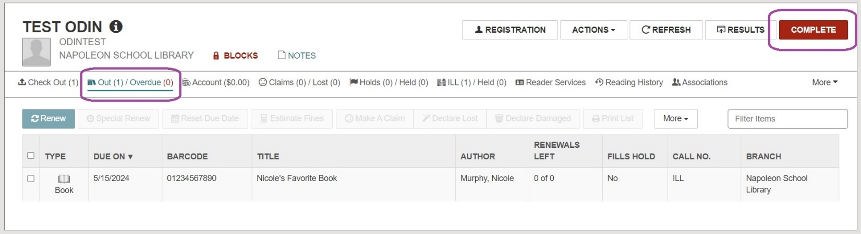

**Returning an ILL:**  
When the item is returned, navigate to the *Check In* screen and enter the NDSL-provided barcode (OCLC number):

*Item is Blocked* pop-up will appear. Click **Continue:**

*Item is In-Transit* pop-up will appear. Click **OK:**

Item status will update from *Loaned* to *In-Transit*:

Mail the item, including all paperwork, back to NDSL.

To view the request, navigate to the *ILL* Tab of your *Request Manager* and filter for *Received* status. Item will appear as *In-Transit*:

**Deleting an ILL Request:**

Under the *ILL* tab of your library’s *Request Manager*, continue checking your *Received* items regularly. Once a return is processed by NDSL, it will update to *Available* status and may be deleted.

**\*\*NOTE:** Before deletion can occur, the request must first be ‘returned.’ Do this by clicking the box next to it and choosing **Return:**

The request will move into *Returned* status. To complete the deletion, filter for *Returned* status, click the box next to the request to select it, and choose **Delete:**

**Renewing an ILL:**

If your patron requests a renewal for their ILL, email [ndslill@nd.gov](mailto:ndslill@nd.gov) with the renewal request. Make sure to include the title and barcode (OCLC #) of the item. NDSL will ask the owning library for permission to renew the item on your behalf.

**If the renewal is denied**, the item must be returned to NDSL.

**If the renewal is granted**, access the patron’s record. Navigate to the *Out/Overdue* tab, click the check box next to the item, and choose **Special Renew**:

Enter the renewal date in the calendar (Loan Period field will update automatically) and click **Special Renew**:

**\*NOTE:** The renewal date provided by NDSL is the date the item needs to arrive back to them, so it is recommended to adjust your patron’s renewal date 3-5 days BEFORE the NDSL date.

*Item is Blocked* pop-up will appear. Click**Continue:**

Under the *Out/Overdue* tab, item will update with the new due date:

Contact the patron to inform them of the new due date.

**Lost/Damaged ILL Procedures:**

If an ILL becomes Lost or Damaged, contact [ndslill@nd.gov](mailto:ndslill@nd.gov) to acquire a replacement amount from the owning library. In the meantime, you may want to place a Note (blocking or non-blocking) on the patron’s account.  
 *Example:*

NDSL will respond with an invoice for the correct replacement amount.

When received, navigate to the patron’s record. Under the *Out/Overdue* tab, click the check box next to the lost/damaged item and choose **Declare Lost** or **Declare Damaged** (depending on the situation):

The *Declare Item Lost/Damaged* pop-up will appear with the correct replacement amount. Choose **Charge** under the *Action* menu and enter the NDSL-provided amount. If you want to send a bill to the patron at this point, select the check box next to *Send a Bill*. Click **OK:**

The charge will appear under the *Account* tab of the patron’s record.

Mail payment with a copy of the invoice to NDSL for the item and follow your library’s policy for recouping this cost from the patron.

**Generating Replacement Bills:**

Replacement bills may be generated under Utilities > Print Notices > Overdues > Patron Billing Statement by Patron Barcode:

The *Report Wizard* will appear. Enter the *Patron Barcode* and **Submit Report**:

The *Patron Billing Statement* will be generated. You will have the option to print it or download a pdf version to your computer.

*Example Patron Billing Statement:*

NDSL ILL Contact Information:  
  
**Email:** [**ndslill@nd.gov**](mailto:ndslill@nd.gov)  
**Phone:** 701-328-4622  
 **Mailing Address:**   
Interlibrary Loan Dept.  
North Dakota State Library  
604 E Boulevard Ave. Dept. 250   
Bismarck, ND 58505-0800