The 2024 Primo enhancements cycle will not be going to a Round 2 vote this year, so the final results are below. The scoping and pointing process got considerably more complex this year, but the following will be developed over the course of the next year:

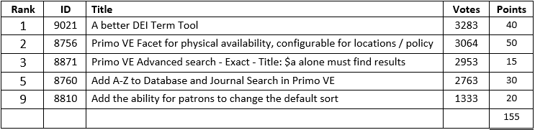

Out of the typical 200 complexity points allotted for this voting cycle, 150 were used for Primo and 50 were used for the CDI Enhancements Trial. Due to this year’s total being 155, 5 points could potentially be ‘borrowed’ from next years cycle.

Since Ex Libris has been working on the [Next Discovery Experience User Interface (NDE UI)](https://knowledge.exlibrisgroup.com/Primo/Product_Materials/010_Primo_Next_Discovery_Experience_User_Interface)  set for release in 2025, the following will be developed for that interface without requiring any community points:

Additionally, there has been an agreement for a *research and consultation process* for the following consistently requested item of Primo VE product development. Ex Libris has committed to it for the 2025 Roadmap in some form:

Here are some additional details regarding the following 4 rejected submissions:

