OAC Meeting Minutes 6/10/2024
- (10:00) Start meeting
- (10:04) ODIN Director Report (Jason)
  - Director updates
    - SMHS – Kenneth Ruit (Interim, Erika left in May)
    - McKenzie County Library – Irene Sealy
  - ODIN updates
    - Polaris ‘double delete’ purge moved to Fall
    - New reporting added for K-12 end of year cleanup
      - Loaned by Patron (follow up with students)
      - Loaned, Lost, Missing by Call Number (double checking shelves)
    - Easy Active activated for Williston and Mayville, Bottineau in progress
    - Article Galaxy Integration at UND
    - Annual ODIN Survey Report
    - Polaris Holds/ILL investigations
  - ODIN Highlights
    - June 19th – PreK-12 Literacy Conference for ND Educators at UND
      - Sharing a booth with NDSL
      - Electronic Resources/Databases Support
    - June 28th – Updates to support tickets form
      - Separating ‘incidents’ from ‘service requests’
      - Tweaks to organization/categories
      - Minimal impact
  - Polaris Updates
    - 7.6 installed on Production last Thursday
      - Advanced MARC Editor
      - Item Templates now in Leap
      - Bulk changes from Find Tool
    - 7.7 coming late this year
      - Split screen MARC editing
      - Additional enhancements to Find Tool
        - Recent search history
        - Show all/range selection
    - ODIN Highlights Session – June 27th at 2pm
  - Vega LX Starter (Polaris)
    - ODIN selected as beta tester for consortia
    - Replacement for existing notices system
      - Additional branding options
      - HTML enhanced messages
      - Library access to manage own notices
      - No additional cost
    - Initial Participants
      - Divide County Public/School, NDSL, Grand Forks Public, Carrington City, West Fargo Public
      - Rest will follow later
  - Alma Updates
    - May release updates
      - Continual improvements of Alma UI for Borrowing/Lending requests
      - Alma Peer to peer, ISO between OCLC products
      - Person cards (Linked data) in Primo
      - Showcase carousel options
      - Support for parallel work in multiple browser tabs
      - Link for ODIN highlight session: https://www.odin.nodak.edu/events/user-group/almaprimo-ve-may-feature-release-overview
  - NERS Updates
    - Alma 2nd round voting begins today
      - 23 total enhancements
      - Look for discussion session invite: June 20th at 10am
    - Primo approved enhancements – no additional rounds
- 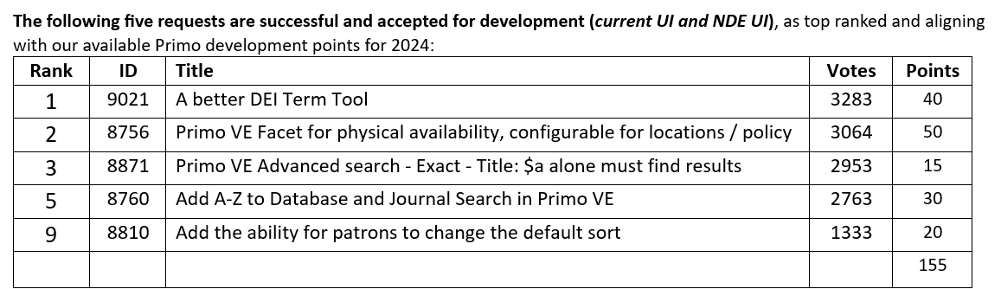
  - Primo NDE UI
    - “Next Discovery Experience”
    - Next ‘version’ of Primo is being developed for release mid-2025
    - Built on Angular (vs. current AngularJS)
    - More to come
- 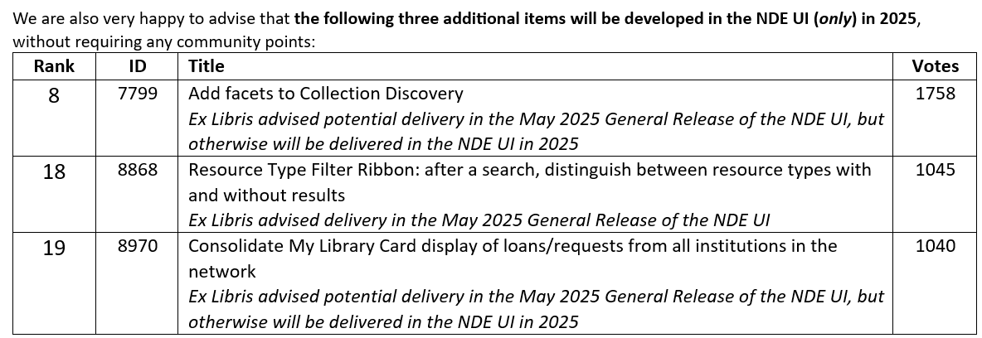
  - UMWUG Updates (Upper Midwest User Group)
    - Decommissioning the UMWUG website
    - Next conference meeting will be online- TBD
    - General ELUNA listservs link: https://el-una.org/about/mailing-lists/
    - UMWUG: umwug-l@exlibrisusers.org
  - Academic Search Complete Renewed
    - Renewed as a statewide purchase through FY25 with option to renew under existing statewide Minitex/EBSCO contract
    - CTS/ODIN will cover 20% of bill
    - For Academic Search Ultimate upgrade, we encourage you to go through Minitex (cpers@umn.edu) to ensure consortia pricing
    - Special thanks to the following libraries for financially making this renewal possible for everyone:
      - Bismarck State College
      - Dickinson State University
      - Lake Region State College
      - Mayville State University
      - Minot State University
      - North Dakota State University
      - Trinity Bible College
      - University of Jamestown
      - University of Mary
      - University of North Dakota – Chester Fritz
      - Valley City State University
      - Williston State College
  - EBSCO New UI
    - Expected roll out this summer
    - New EBSCOhost demonstration & open questions
    - Session tomorrow at 10am
  - Academic Cost Sharing Formula Committee
    - Had an initial meeting
    - Shared existing numbers/formula
    - Gathering info from peer groups/ideas
    - Will meet again later this summer
    - Committee members
      - Amy Carson (NDSCS)
      - Sally Dockter (UND)
      - Tuya Dutton (UJ)
      - Jennifer Jenness (VCSU)
      - Phyllis Kuno (TBC)
      - Nicole Murphy (ODIN)
  - Meescan Consortia Purchase Update
    - Alternative procurement was approved
    - Working on finalizing contract language
    - Will communicate further info once finalized
    - If anyone else is interested, contact Jason
    - Libraries that have shown interest
      - Grand Forks Public Library
      - NDSU
      - UND
      - Dickinson Area Public Library
      - Divide County Public Library
      - Bowman Public Library
      - Mandaree School Library
      - Stanley Public Library
      - Hatton School/Public Library
      - Williston State College
  - Israel and Ex Libris
    - Campus protests and divestments from Israel businesses
    - Both Ex Libris and Innovative are owned by Clarivate
    - 15/19 Big 10 are on Alma; last RFP reviewed 5 systems in 2022
    - Link to article in PowerPoint presentation
- (10:22) State Librarian Update (Mary)
  - No Personnel Updates
  - Library Coordinating Council Appointments
    - Michele Seil, Public Library
    - Traci Lund, At-large
    - Andrea Placher, Special populations
  - Library Vision Grants
    - Working on improving the guidelines
    - Webinar series on a variety of topics to help libraries improve their grant application
    - Webinars will be optional rather than required
    - Library Vision document will be updated this year
    - Feedback on the draft will be solicited late summer or early Fall
  - Library Vision Tribal Academic Grants
    - Total available: 50K
    - Total awarded: 30K
    - 3 Tribal academic institutions applied and were awarded full grant requests
      - One Collection Development grant
      - One Programming grant for ‘story walk’ on medicinal plants
      - One equipment grant for laptops
  - Library Skills for Today and Tomorrow
    - 3 virtual conferences throughout the year
    - Open to all library types but each one focuses on a particular library type
    - Academic and Special Libraries will be June 27-28
    - School Libraries will be Oct 17-18
    - Public Libraries was in April
    - Include keynote speakers and breakout sessions

- (10:34) 2024 ODIN Annual Survey Results (Jason)
  - Measured areas and overview
    - Systems Feedback
    - Service and Training
    - Vendor Sentiment
    - Future services/support
  - For simplicity
    - Percentages and counts are of respondents to measure only
    - Non-respondent are not included
  - Top Positives/Opportunity Areas
    - Alma
      - Positives
        - Resource Management
        - Fulfillment
        - Primo/Discovery
      - Opportunities
        - Resource Sharing
        - Analytics
        - Acquisitions
        - Serials
        - Electronic Resources/CDI
    - Polaris
      - Positives
        - Cataloging
        - Circulation
        - Acquisitions
        - Electronic Materials
        - Simply Reports
      - Opportunities
        - PAC Enhancements
        - Holds/ILL Workflows
        - Serials
    - Note: No area had a majority disapproval rating
      - Systems Feedback – Positive/Neutral Areas
        - Circulation/Fulfillment
        - Cataloging/Resource Management
        - Cost of System
      - Systems Feedback – Opportunities
        - Holds/ILL/Resource Sharing
        - Acquisitions
        - Serials
        - Electronic Resources/Materials
        - Discovery – PAC/Primo
        - Simply Reports/Analytics
  - Systems Feedback - Comment Themes
    - Alma
      - Ex Libris ‘fatigue’ = General neutral feelings
      - Steep learning curve/appreciation for ODIN community support/training
      - Resource sharing difficult/complicated
      - Analytics difficult to navigate/use
    - Polaris
      - Holds/ILL issues
      - LEAP should limit to library
      - Selecting other libraries’ patrons
  - Support Feedback Charts
    - Timely responses
    - Issues Resolved
    - Friendly & Professional
    - Knowledgeable Staff
    - Ticketing System
  - Training and Outreach
    - In-person training visits
    - ODIN-led training sessions/webinars
    - ODIN Work Days
    - One-on-one online meetings/trainings
    - Text-based trainings/documentation on the ODIN website
    - User Group meetings
    - Video trainings on the ODIN Website
  - Themes from the comments
    - Positives
      - Many appreciative comments
      - Knowledgeable
      - Friendly and helpful
    - Opportunities
      - Would like to see us more (in-person and one-on-one)
      - Better support for understanding workflows within libraries
  - Vendors with No ‘Dislikes’
    - Britannic
    - Kanopy
    - Meescan
    - Minitex
    - Overdrive
  - Vendors with ‘Higher’ Dislikes
    - EBSCO
    - Ex Libris (Alma/Primo)
    - Gale
    - Hoopla
    - Innovative (Polaris)
  - Future Possibilities – 50% + Likelihood (All)
    - AI-related services
    - Collaborative e-Resource purchasing
    - ILL Bridge (Statewide ILL System)
    - Mobile App for ILS
  - Future Possibilities – 50% Likelihood (PKS)
    - New library website support/service
    - Self-check/mobile app checkout support/consortial contract
  - Future Possibilities – 50% Likelihood (Academic)
    - OLR Usage Analytics/data visualizations
    - OER’s (Open Educational Resources)
    - Digital/institutional repository
    - Enhanced discovery system
    - Enhanced LMS integrations (e.g. Leganto or Libguides in Blackboard)
  - Everything else…
    - Age-based verification/authentication
    - Bursar office integrations (e.g. Alma to Peoplesoft)
    - Children’s catalog/PAC
    - Springshare support/consortial contract

- (10:50) Statewide ILL ‘Bridge’ RFI (Jason)
  - ILL has been a pain point for a while since we split systems
  - Jason and Nicole working on the RFI document, then will take it to a small committee for feedback
    - Participants from NDSL, Fargo Public Library, CDLN, ODIN
  - Would your library benefit from a system like this?
  - Mary: Goal is to make it easier and more equitable for all libraries in the state to borrow/lend. Would love a courier service as well, but there was no support for that at the legislative level. Some interest from Lt. Gov. Miller. Challenges for delivery system in ND include exorbitant cost and large amount of land to cover. The hope is that an ILL bridge will be a step in the right direction in making it easier to move materials from library to library.
  - Jason: Would Academic libraries benefit from a system like this?
  - Paul Amberg (NDI): We borrow/lend with Dickinson Public Library all the time. Delivery system would cut down on mail costs. Around 70% of stuff we send out are going to the public library.
  - Mary: Delivery system got hard pushback, but there will be a new governor in January, so hopefully strategy sessions will continue since they have been so beneficial. Gives chance to provide info on the library community to leadership.
  - Mary: Please send questions/comments to Jason or I, so we can formulate articulate comments as we seek funding.
  - Jason: Please send along any cost-saving angles or you can provide testimony yourself. We’ll make the best case that we can.
  - Mary: Just an update, for ODIN libraries that NDSL catalogs for, we are no longer uploading those records into OCLC Worldshare.
- (11:01) Polaris Holds/ILL Change Proposal (Jason)
  - Consortia – Many paths, common goals
    - ODIN is a consortium of many different types of libraries, but we all have a common goal.
  - The Problem
    - Holds/ILL in Polaris is one of the main pain points
    - An issue for small and large libraries; School and Public
  - Some Steps to improve the process
    - Changing staff permissions (ODIN Office - in progress)
      - Limit access to library patrons only
      - Other patrons will still show, but cannot be changed (no requests, checkouts, etc.)
      - Should eliminate/reduce placing requests on wrong accounts
    - Set secondary RTF to 1 cycle only (library-by-library request to change)
      - Your patron requests will cycle through all available libraries once. If not filled, it will ‘return’ to the home library’s Request Manager for further processing as an ‘Active’ request
      - Currently sits on Secondary RTF until filled or cycle time expires
      - A couple of libraries have done this already. Put in request to ODIN Office to make this change
    - Better reporting (ODIN Office – in progress)
      - Working on a ‘hindered’ holds report
      - Request Manager can be unwieldy alone
  - A Proposal for a 1 year trial
    - Allow schools (K-12 only) to ‘opt-out’ of Resource Sharing/ILL
    - Rationale
      - Limited staff/resources to check picklists regularly
      - Some operate as ‘in-house’ only already; 0 lent, 0 borrowed in 2023
      - Ones that are checking the picklist are largely denying
      - Ones that are not checking, requests are delayed till system moves request on
    - Benefits
      - Non-participating schools: No need to act on picklist (less stress)
      - Publics and Participating Libraries: Limits pool of ‘Satisfied by’ to only items at libraries participating
      - “System availability” in the PAC will reflect change (items will still be ‘visible’ in PAC, but patrons cannot request)
    - Logistics
      - ODIN Office will contact the list that currently have holds off for the summer to discuss individually as they return
      - Library holdings will be bulk updated to “Holdable by Patrons from this branch only”
      - Trial will run for next School Year (FY25)
      - Revisit outcomes at end of school year
      - Possible proposal to revise the ODIN Governance (currently requires all libraries to ‘participate’ in ILL)
    - Thoughts, Questions, Concerns
      - Mary: NDSL and ODIN will run reports to compare with each other to verify libraries’ resource sharing activities. We both believe if you borrow, you also need to lend, we just want to make things easier for those small school libraries that are only in the library part-time.
      - Jason: We believe this will be a win-win and alleviate some issues with Holds getting stuck.
      - Traci in chat: I like it. Good work!
      - Jenna in chat: I support that.
- (11:12) 60-second Fun Library Facts
  - Irene Sealy (MCP): Have been at McKenzie County for a week now. Came from New Mexico. I have 10 years experience in Public libraries and 3 years in Academic libraries.
  - Marlene Anderson (BSC): Library letters from old building were unveiled April 10th . When we moved from our old building, the letter that spelled ‘LIBRARY’ were saved and put in storage. Now they grace a wall in the new library building. New name for library building: Larry C. Skogen Hall (former president)
  - Paul Amberg (NDI): Setting up a bachelor’s in Library Science program and getting support for the idea. Hope to fill a need as there are only 6 bachelor’s in Library Science programs in the country.
  - Jane Laplante (NMI): Switched to EBSCO UI and will hopefully get used to it. In 2nd year of Course Improvement Grants, where we put out a call for faculty to apply. Offer $1500 to 2 faculty members per year. They partner with a librarian and develop an assignment in a course that includes information literacy. Worked great last year. Retiring as of July 2nd so this is my last OAC meeting. I’ll miss everyone. This is my 35th year. Jolene Nechiporenko will be the new Director. We’ll miss you, Jane!
  - Tuya Dutton (NDJ): We are doing a summer reading challenge with VCSU. Asking people to submit the books they’re reading. Over 250 submissions from both campuses so far. Promoting Libby, so each book from Libby earns 2 points and regular books earn 1 point.
  - Catie Palsgraaf (Law): Created and handed out some research guides at Fair Chance Job Fair for those who experience barriers to employment (i.e. criminal records, mental health, pardons, etc.)
  - Amy Carson (NDSCS): Agriculture Dept is temporarily moving to library as tech center is remodeled. Will have lots more traffic in the building. Preparing for Fall and will switch to new EBSCO UI this summer. Transitioning to Blackboard Ultra, so meeting with faculty about updates. Archivist is working on an archival photo project.
  - Traci Lund (DIVE): Mass renovation in building. New carpet and shelving. Reconfiguring space overall. Received $35,000 DPI grant and used it for some carpeting & shelving. NDLCC helped as well. Been a labor of love.
  - Jolie Graybill (NDSU): Renovations on first floor are done. Got money from student gov. for new furniture. Bid at a Target auction and got 12-13 standing desks and chairs for study rooms. Got other pieces as well. Got huge conference room table with electrical outlets and getting great reviews.
  - Mary: What’s a Target auction?
  - Jolie: In Minneapolis, Target’s corporate offices relocated from downtown to Maple Grove, and they auctioned off their furniture from the downtown offices, so NDSU Library bought some because they matched what they already had.
  - Jonathan Voigt (UNE): The 3 largest legal research providers, Westlaw, Lexus Plus, Blumberg Law, have released generative AI features in the last 6 months. Staff have been learning how to use them because they are brand new and formulating plans for teaching students how to use them.
  - Phyllis Kuno (TBI): School has gone through a major shift, so there are more Graduate and Doctoral students than Undergrads right now. Dean has secured funding for remote librarian for Graduate & Doctoral Students, much like Tuya at Jamestown has. She also raised additional money for access to Perlego starting in July and through another consortium we belong to we’re joining up with Overdrive. Tutoring lab, which has been temporarily housed in the library, will be there for a least 1-2 more years. Planning to ask them to contribute money to help renovate lower level and make their stay permanent. Hoping they’ll agree.
  - Jenna Kahly (WFP): Little Red Reading Bus is in rough shape and will be replaced with a van. Trying to open a 2nd location in some extra space where the West Fargo City Hall has recently moved to. Divide County sent extra shelving they were no longer using. Small space, so wall-mount shelving will likely be needed, but I’m cautiously optimistic.
- (11:35) End meeting

