How to configure Reporting Codes
To configure reporting codes, you must have one of the following roles:
- Acquisitions Administrator
- General System Administrator
You define reporting codes that can be used for analyzing acquisitions in subsequent reporting.
These codes appear in Alma in the drop-down lists on the PO line Summary tab. For example, if you have a reporting code for postage, you can then create a report that lists all PO lines that have postage reporting code. Reporting codes apply to all libraries within your institution.

You configure reporting codes in the 1st, 2nd, 3rd, 4^{th,} and 5th reporting code tables.
Configuration Menu>Acquisitions>Purchase Orders> 1st, 2nd, 3rd,4^{th,} and 5th Reporting Codes.
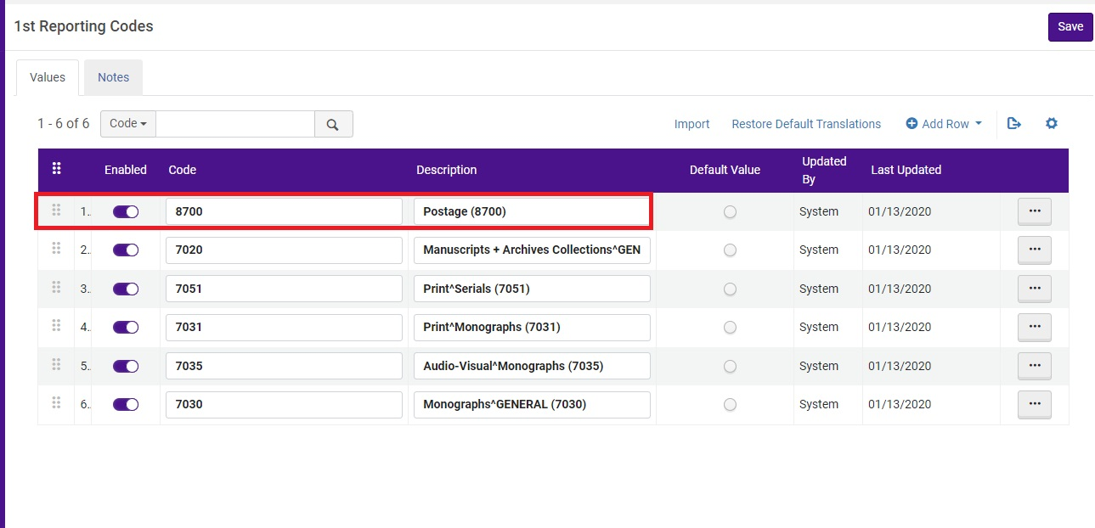

I clicked on 2nd reporting codes, and it showed none, so I am creating one by clicking on Add Row

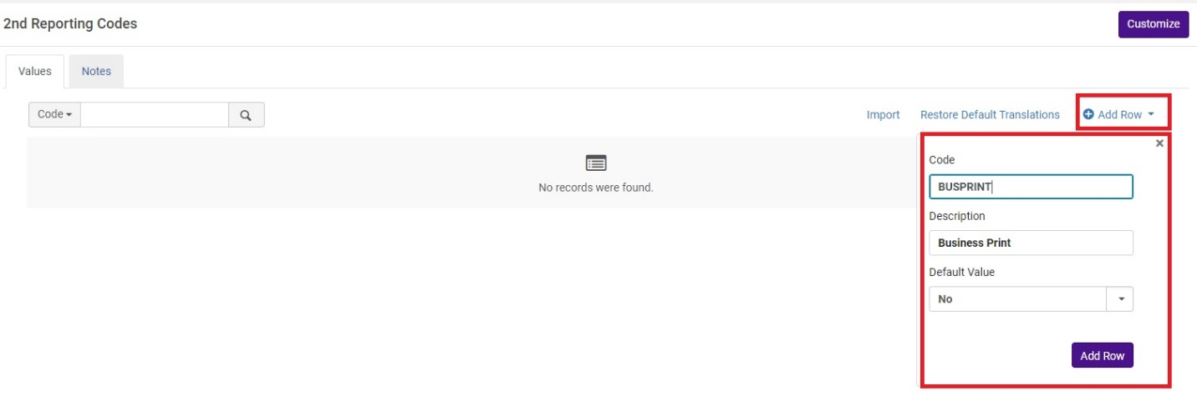
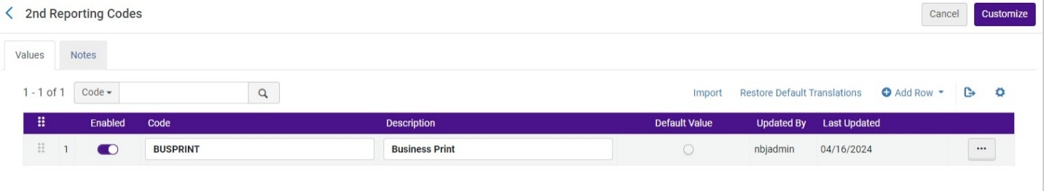

Click on Customize and search for one of your POLS and you will see the new reporting code in the dropdown.

