**Below are the final results of the 2024 Alma Enhancement Voting Cycle**:

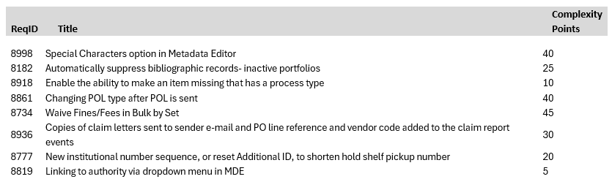

These enhancements will be developed for Alma over the course of the next year and should be delivered by September 2025.

The final results for the 2024 Primo Enhancement Voting Cycle went out earlier this month. In case you missed it, they are listed below:

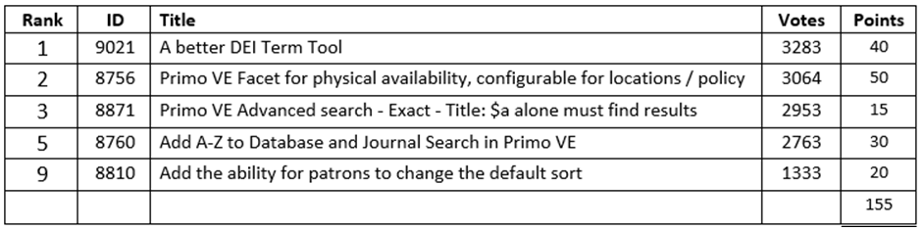

These enhancements will be developed for Primo over the course of the next year and should also be delivered by September 2025.