**ACAD Discovery/PrimoVE User Group Meeting – 6/21/24 via Teams**

**Discussion Items**

* No May meeting due to ELUNA
* **UPDATE:** SMS options w/NDUS -- still being worked on - no new update
* PrimoVE Showcase feature update – no update for external website option – Lynn was initially blocked when she tried to download code for the internal Primo option by the security software. She received revised procedures now and will try to test next week. Has anyone else tried to implement it?
  + Amanda at UJ has been putting LibGuides as gallery-type boxes.
    - <https://libguides.uj.edu/displays/pride>
    - <https://libguides.uj.edu/biology>
* Open Access resources display in Primo – not all OA items are tagged as such. For example, search ‘OpenStax’ (NDSU view) - some titles are marked OA, and some are not. This was discussed at the last Catalogers Meeting.
  + Documentation explaining how to designate: <https://knowledge.exlibrisgroup.com/Primo/Product_Documentation/020Primo_VE/Primo_VE_(English)/030Primo_VE_User_Interface/Open_Access_Indication_in_Primo_VE>
  + Open Access indicator = 506 tag: 506 0_ $f Unrestricted online access $2 star
* May 2024 release – PROD May 5th - Feature Walkthrough was May 23rd – any issues?
* The second round of voting for ALMA Enhancements was due yesterday to Nicole.
* PrimoVE Enhancement Voting – round 2 was not needed. Nicole sent out email 6/10/24 to odin-acad-libs. Results to be developed over the next year: 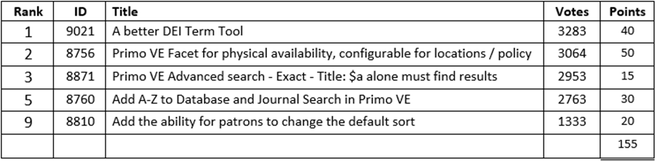
* ELUNA updates
  + [Next Discovery Experience (NDE)](https://knowledge.exlibrisgroup.com/Primo/Product_Materials/010_Primo_Next_Discovery_Experience_User_Interface) – will start seeing by the end of the year. General Release mid-2025
  + Discovery Research Assistant, Powered by Generative AI
* Anyone using Leganto beside Dickinson? UND would like to have further discussions on functionality and will request a price quote from ODIN Office.
  + OWD Session from 2021: <https://www.odin.nodak.edu/events/odin-workdays/odin-workday-2022-alma-session-leganto-bringing-library-point-need>
* Question on configuration of the new EBSCO user interface. UND is using it. UJ submitted a request to the vendor to switch over – successful switch and few minor adjustments needed but seems to be working well.

**Member Updates**:

* Bismarck State College -
* Dakota College at Bottineau
* Dickinson State University
* Lake Region State College
* Mayville State University -
* Minot State University
* North Dakota State College of Science - SBHE visit to MJL 6/13; EBSCO new UI; videos for Fall; Q: EBSCO survey
* North Dakota State University - Focusing on EOY; GreenGlass weeding project continues, as well as implementation of Rialto for book acquisitions; recruitment
* Trinity Bible College
* University of Jamestown – playing around with May Primo release features; updated to new EBSCO UI, summer project of updating help/how-to resources;
* University of North Dakota – advertising for Systems Librarian going out next week (will allow remote work if needed), working on Archive Space implementation (will be in contact with NDSU on their implementation)
* UND – Law
* UND – Med
* Valley City State University
* Williston State College
* ODIN – entire ODIN Staff attended ELUNA sessions in Mpls

**Future Topics**:

* MONITOR:  Email from Nili Natan (Primo Product Manager) sent to Primo Listserv 6/14/23. " We are working in Primo VE to make sure that there will be no difference when selecting the same type with the new Resource Type Filter Bar or Facet Resource type. We will update on this fix in the upcoming release notes so you will be able to test again and activate the Resource Type Filter Bar.”
* MONITOR: Display Documents Attributes for CDI Records from CDI-August 2023 Release: What's New with Primo Video – July 2023 has 8-minute segment with information at the 11:27 mark - [https://www.youtube.com/watch?v=WQGZqcJWxDE -](https://www.youtube.com/watch?v=WQGZqcJWxDE) documentation also found at -<https://knowledge.exlibrisgroup.com/Primo/Content_Corner/Central_Discovery_Index/Documentation_and_Training/Documentation_and_Training_(English)/CDI_-_The_Central_Discovery_Index/CDI_Document_Attributes>

***** NISO voting/discussion in December --- may have to delay until after things are decided there.

**Next Meeting**:  7/19/24 11 AM

Primo links for all colleges can be found: <https://www.odin.nodak.edu/academic>

======================================================================

**Ex Libris Sessions and Webinars**

**Primo VE Roadmap Highlights:**  most current is posted with link below

<https://knowledge.exlibrisgroup.com/Primo/Product_Materials/Roadmap/020Primo_VE_Roadmap_Highlights>

Video: <https://youtu.be/hp_cDadC2m0>

**Alma August 2024 Feature Release**:

* Primo VE semi-annual indexing in August
* Premium Sandbox refresh – AUGUST 11th
* Sneak Preview for new features in August: <https://knowledge.exlibrisgroup.com/Alma/Release_Notes/2024/July_2024/August_2024_Feature_Sneak_Preview>

**PrimoVE August Release:**

PDF download: