Placing Hold Requests in Polaris Leap & the PAC
The Holds process in Polaris can apply to items owned by your library OR items owned by other ODIN Polaris libraries. If the item must be requested from outside the ODIN system, it is considered an ILL (interlibrary loan).
NOTE: If your library is borrowing materials from other ODIN libraries, it is expected that your library is also lending to other ODIN libraries.
There are 2 types of Holds:
- Item-level Hold = A Hold is placed on a specific barcode and ONLY that item can fulfill the request.

- Title-level Hold = A Hold is placed on a particular title in the system and any associated copy can fulfill the request. Most Holds placed are Title-level (also known as Bibliographic Level).

A staff member can place Holds on a patron’s behalf in Leap or a patron can place their own Holds in the PAC (Public Access Catalog).
Placing a Hold in Leap:
Placing a Hold from the Patron Record
- Locate the patron’s record and click on the Holds/Held tab.

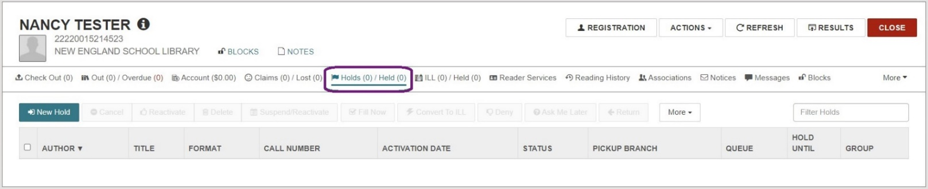

- Click New Hold and the workform will appear. Activation date and Expiration date are automatically entered based on system defaults but can be manually changed if needed. The Pickup Location will default to your library.
- You can search for a title using the search box or click the Find Tool button for advanced search options.
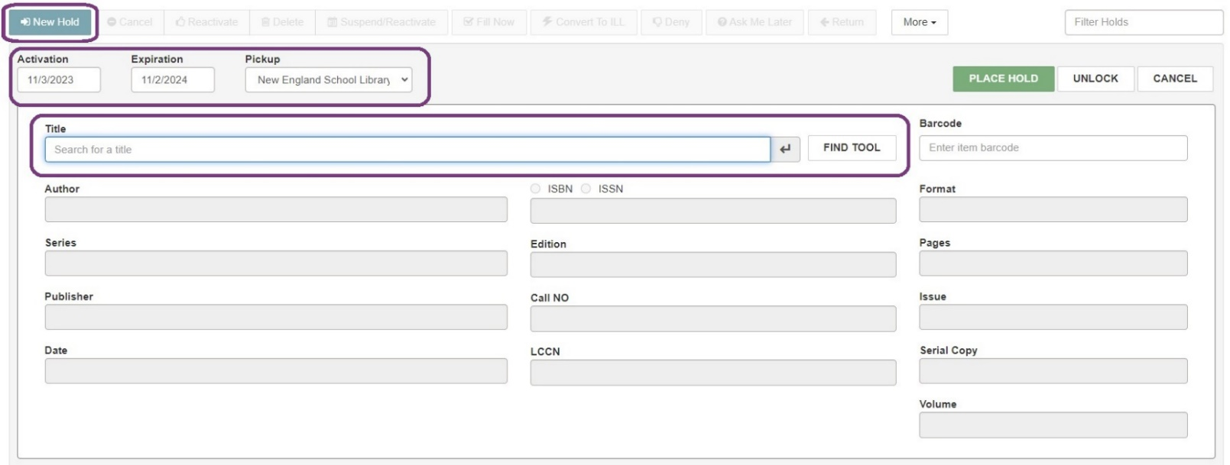
- Once you have selected your title, the bibliographic information will populate in the workform. You may also add Notes to the request at the bottom of the screen. Alternatively, you can click Unlock to enter the bibliographic information manually.

- Once all desired information is present, click Place Hold.
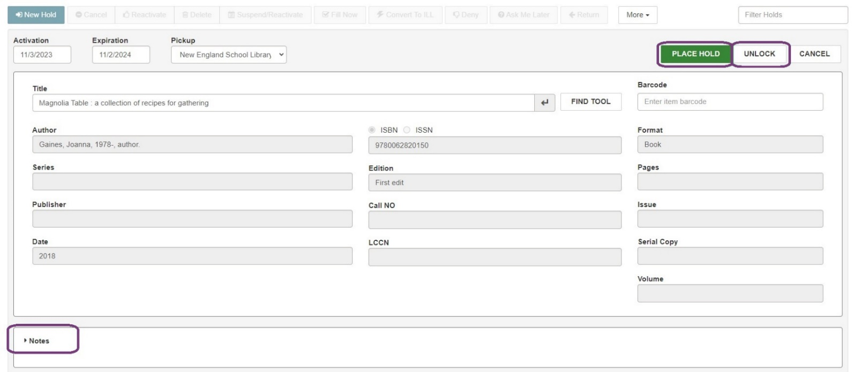

- The Hold will appear on the patron’s account under the Holds/Held tab.
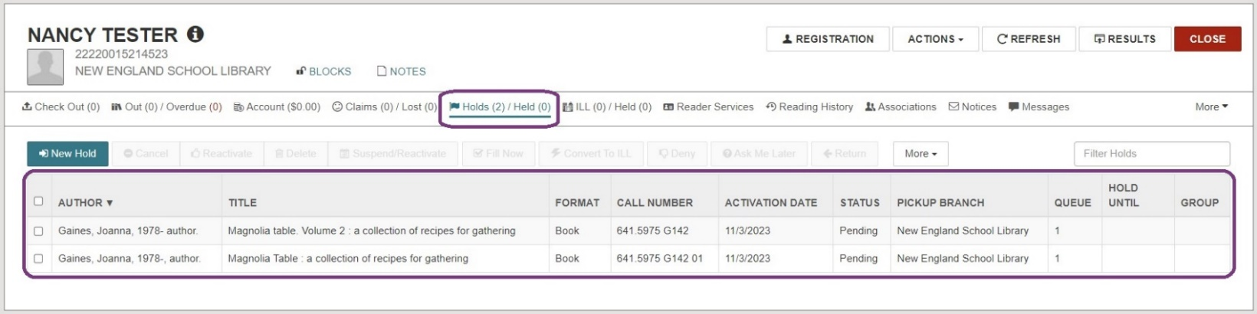

- To place multiple Holds at once for the same patron:
  - Click More from the Holds/Held tab, choose Multiple Holds, and the workform will appear.
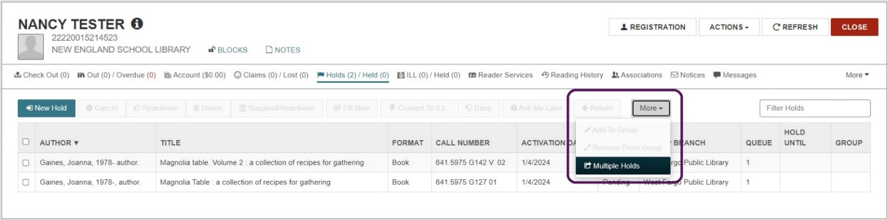
  - Select Add Titles to open the Find Tool and search for the titles the patron wants to request.
  - Click the checkbox next to each title the patron wants to place a Hold on to select it. Click Open.
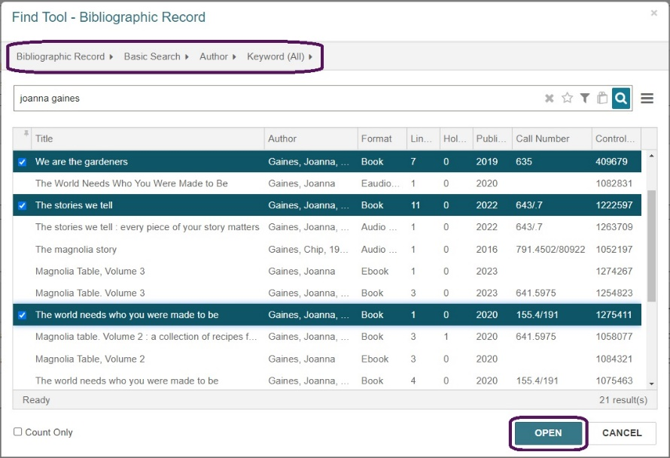
  - The titles will appear in a list, but the Holds are not placed until you select Place Hold. Click Add Titles if you would like to continue adding titles before selecting Place Hold.
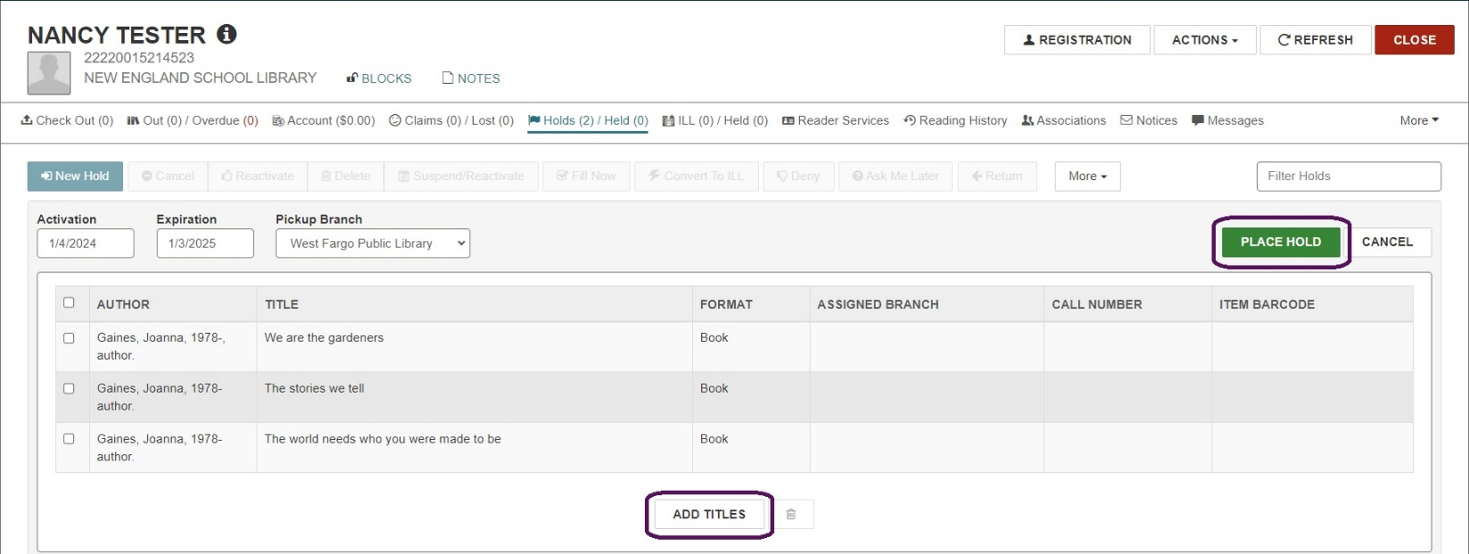
    - Example: Your patron wants to place Holds on multiple titles with the same author. You can conduct a search by author and select multiple titles from the results list.

- To place a Hold request on the same title for multiple patrons:
  - Create a patron record set that contains the patrons who want to request the title.
    - New Record Set Record Type: Patron
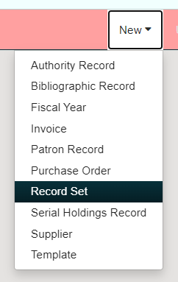
  - Give your record set a recognizable name. Use the Find Tool to add patron records, scan in barcodes individually, or add them from an Excel file. Click Save.
  - A message will appear indicating the record set was created successfully. Without closing the window, select the Actions drop-down menu and choose Create Multiple Holds.
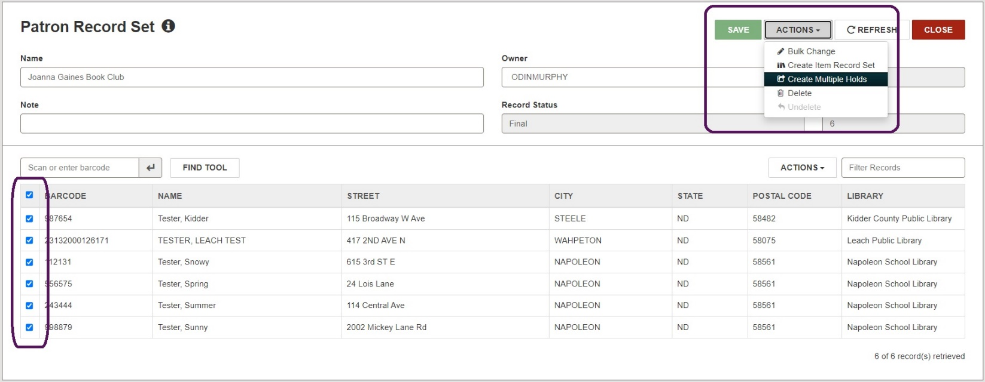
  - The Bibliographic Record Find Tool will appear. Search for and select the record you want to request. Click Open.
  - The Create Multiple Holds page will appear. Activation date, Expiration date, and Pickup Branch will be auto populated, but can be changed if needed. Click Continue.
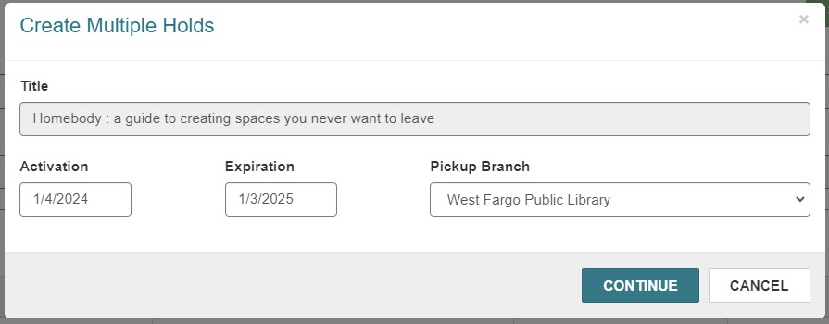
  - Leap will attempt to place the Hold requests and will display an override screen if a patron is blocked. A message will appear indicating how many holds were created successfully.

Placing a Hold from a Bibliographic Record (Title-level Hold)
- Use the quick search box or the Find Tool to locate a bibliographic record.
- Click Actions and select Place Hold.
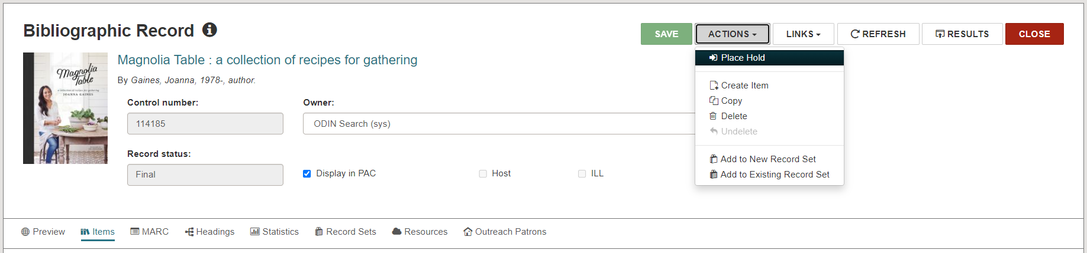

- The Find Tool will appear to allow you to search for the patron record to associate with the Hold. Alternatively, if the patron’s record is already open, you will be prompted to select one of the open records. Click Open.
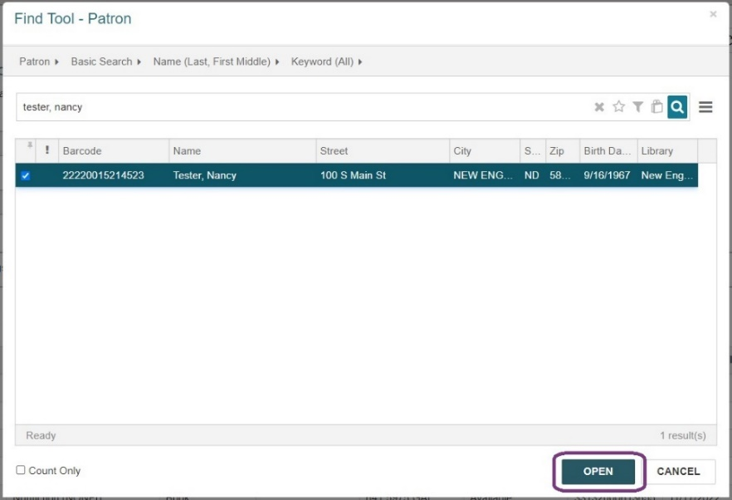

- The Hold workform will appear under the patron’s account with the bibliographic information populated. Add Notes at the bottom of the screen if needed. Select Place Hold and the title will appear under the Holds/Held tab of the patron’s record.
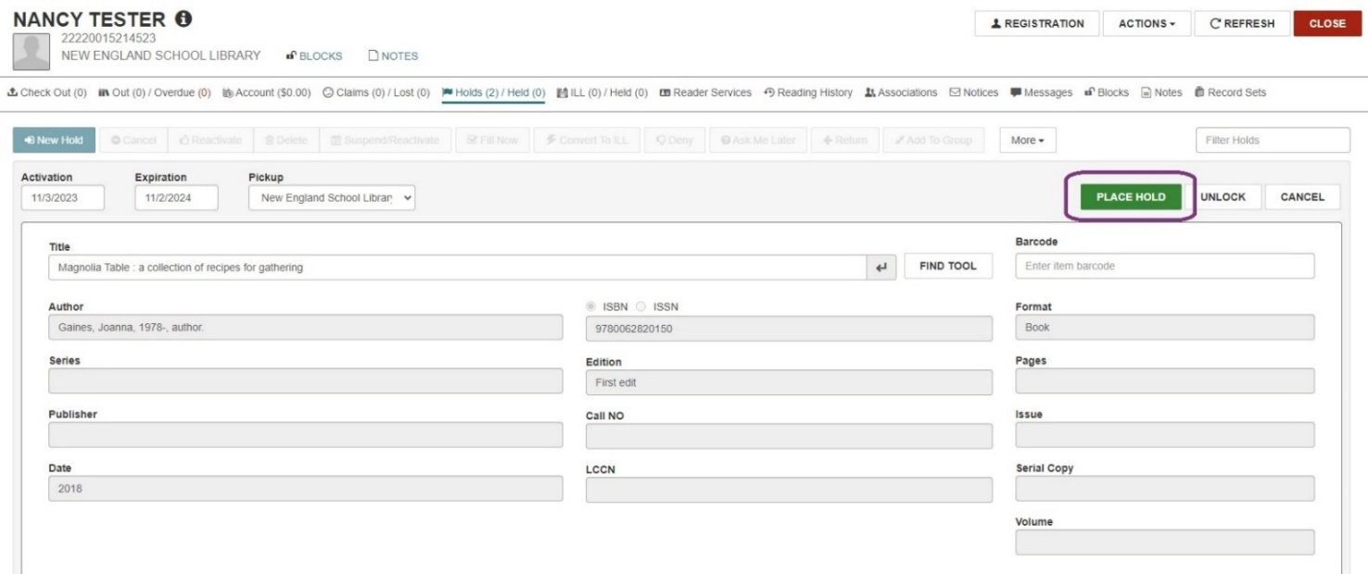
- To place an item-level hold, follow the same procedure, but place the hold from an item record rather than a bibliographic record.

Placing a Hold in the PAC:
- The PAC (Public Access Catalog) is the interface patrons can use to search for and place Holds on library materials.
- Patrons may use the Quick Library Search bar to locate a title under their library’s portal.
- If the patron is already logged in, they will have up to 2 options: PLACE REQUEST or ONE-CLICK REQUEST (if enabled). If they are not already logged in, only PLACE REQUEST will be visible, and they will be prompted to log in once they click it.

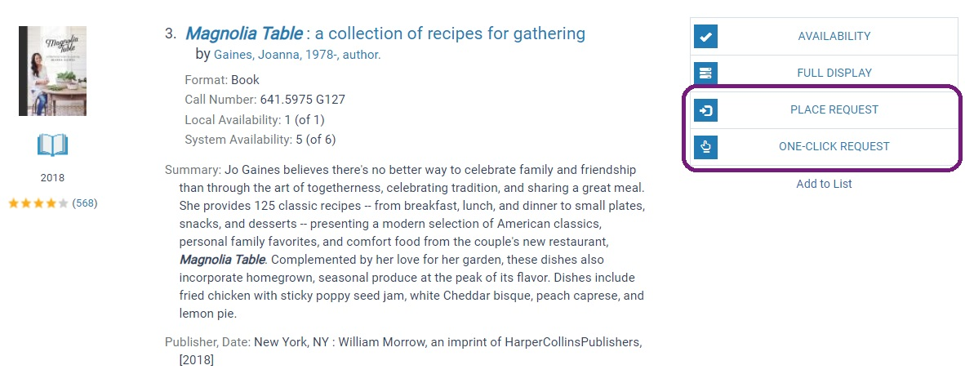

- PLACE REQUEST = A form will appear with the patron’s pickup library and activation date auto-populated along with a section for Notes. They can make changes or add notes if desired before submitting the request.

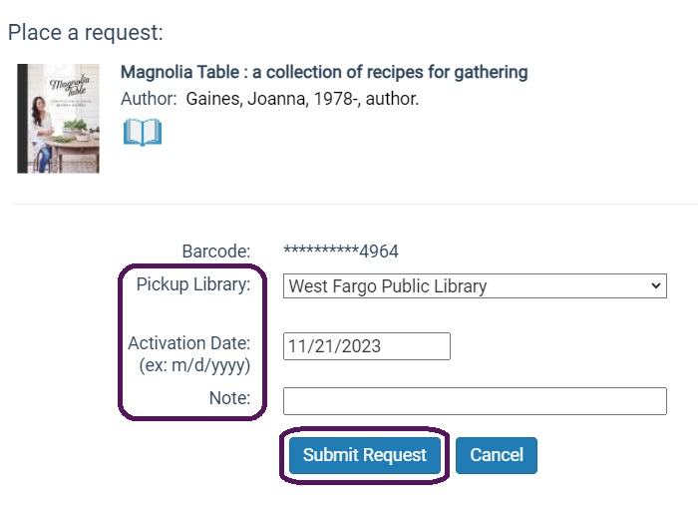

- ONE-CLICK REQUEST = The hold is placed without the interim screen and a message will appear indicating the hold was placed. To configure this option for your environment, please contact the ODIN Office.

- A logged-in patron may view and manage their Hold requests in the PAC by clicking on their name in the upper right corner and navigating to the Requests link under My Account. From this page, they can view, cancel, or suspend/reactivate their requests as well as change their pickup location.

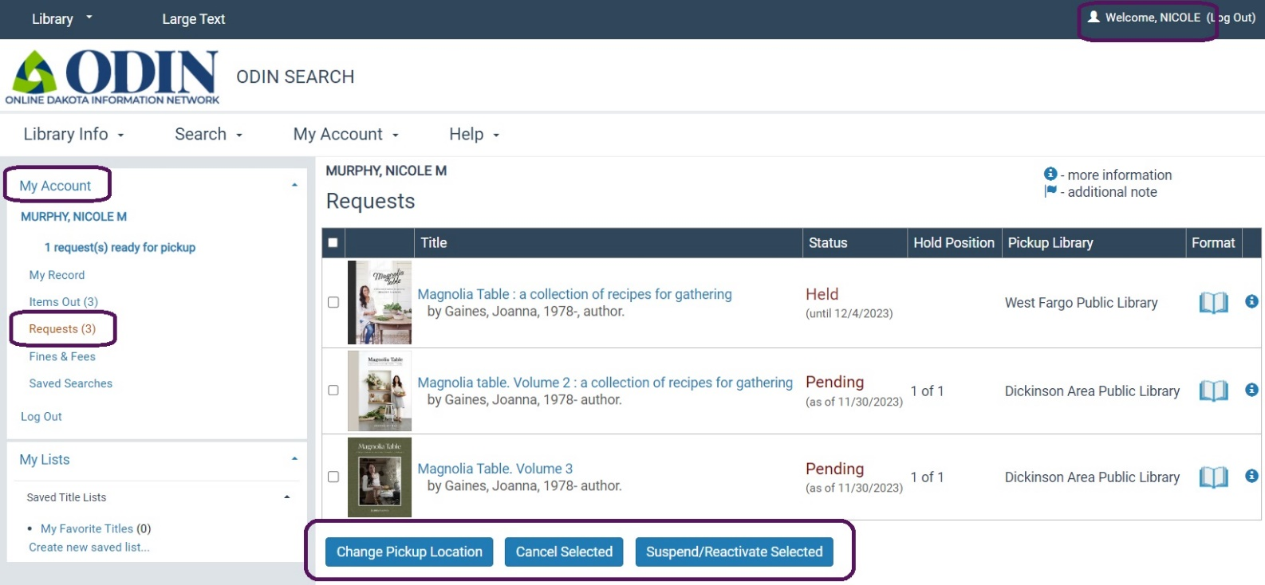

For additional information on managing Hold requests, please continue to the Managing Hold Requests in Leap module.

