POLARIS REMOTE APP DOWNLOAD INSTRUCTIONS

The Polaris Remote App is used to access the Polaris client in order to conduct Cataloging and other technical services activity. Those conducting Circulation activity will use LEAP – Polaris’ web application, which is at [https://polaris.odinlibrary.org/leapwebapp.](https://polaris.odinlibrary.org/leapwebapp) Only those users needing cataloging and technical services functionality need to download the Polaris Remote App.

Download the Polaris Remote App -- **Only those users needing cataloging, technical services and report functionality need to download the Polaris Remote App**.

1. Navigate to the **Remote Client tab** of <https://www.odin.nodak.edu/public-k-12-and-special-libraries>

1. Download the ODIN_RemoveApp.wcx as instructed – make sure to **RIGHT CLICK**:

1. Navigate to the Download folder on your computer, where you’ll see the file. Double-click on the file.

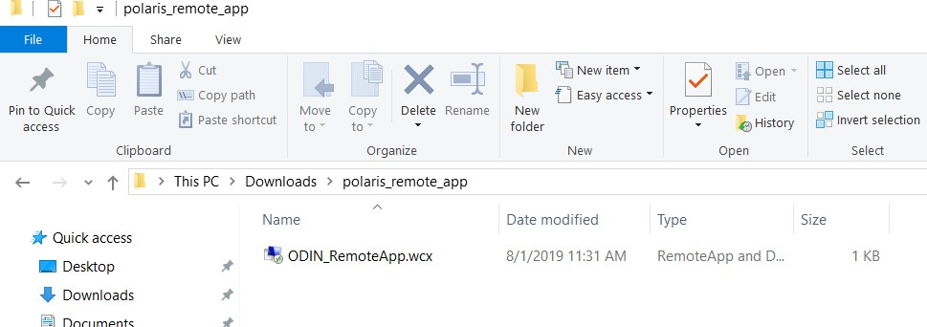

Alternatively, click on the download icon in your browser and select the file there.

1. You’ll be presented with the following screen to begin the setup of the remote app. Click ‘Next.’

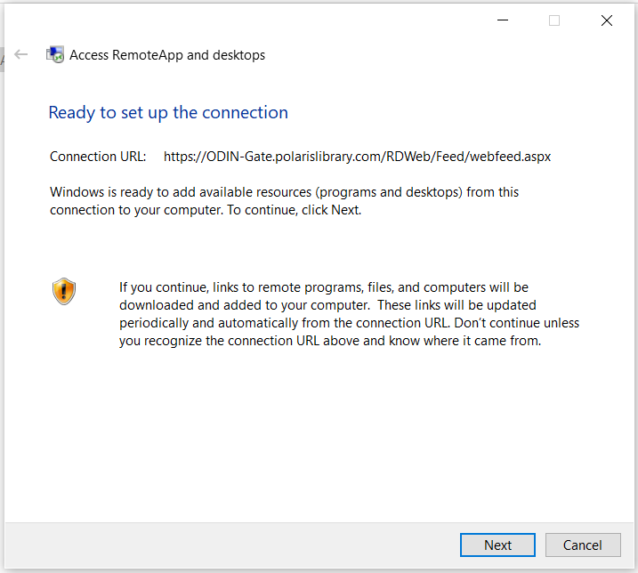

1. You’ll be prompted to login using the remote app credentials. The system automatically attempts to login with your current domain credentials, which is why you receive the error regarding credentials. Enter the domain plus remote app username (ODIN\USERNAME where USERNAME is the username for the remote app. **NOTE: This is *NOT* your LEAP/Polaris Client username) and password – it is your unique TS number (TS followed by 3 digit number).** Click The ‘Remember me’ box and click ‘OK.’ **EXAMPLE:**  ODIN\ODIN-TSnnn

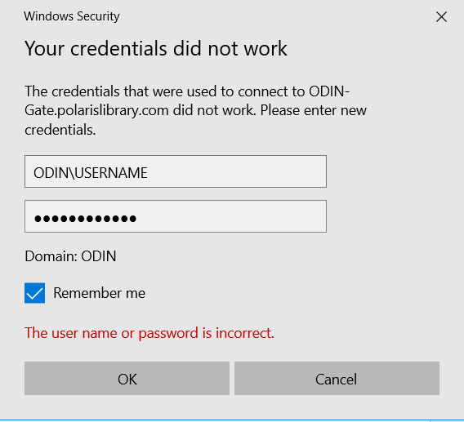

1. Once completed, you’ll be presented with a dialog box indicating the remote app has been

successfully set up on your computer. Click ‘Finish’ to complete the process.

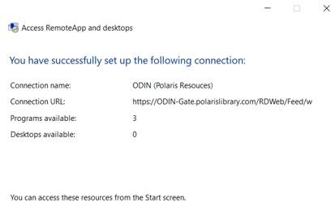

1. There are two programs/files you will want to regularly access, and it is best to create a desktop shortcut for them. One is the Polaris ILS program, and the other is the Logoff Polaris Server program. To access these files, go to the start menu and locate the ODIN (Polaris Resources) (RADC) folder. There you will find both the Polaris ILS and Logoff Polaris Server files. Right click on a file and you’ll see options to Pin to start or More | Pin to taskbar.

1. To access the Polaris client, first log in to the remote app. Click on Polaris ILS, and when

prompted, click ‘Connect.’ After the initial login, it typically takes approximately 10-20 seconds to

connect to the remote app.

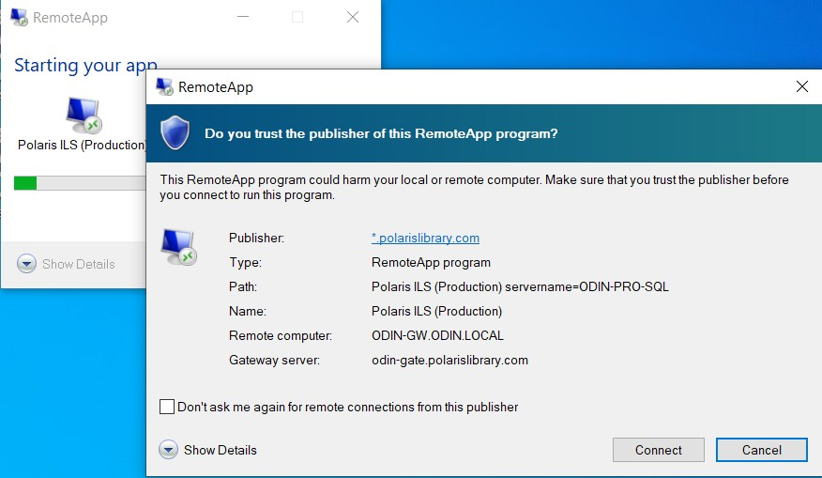

If you did not click ‘Remember me’ in step 5 of the installation, you will be prompted to enter your REMOTE APP credentials. Otherwise, once connected, you will be told to which database you are connected. Click ‘OK.’

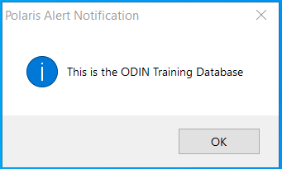

1. Once you are connected to the Remote App, you will be prompted to log in to Polaris. Enter your credentials that are used for logging into the Polaris client or LEAP. **NOTE: the system will ALWAYS copy your remote app username into the form. This must be deleted, and then you can enter your client user name.**

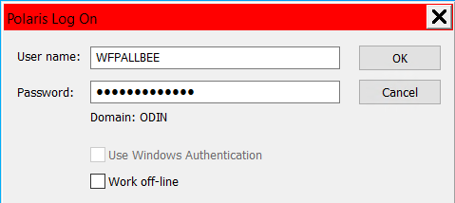

1. Disconnecting from the remote app. It is highly recommended that you disconnect from the remote app at the end of each day. If you continually initiate new remote app sessions without ending previous sessions, your file could become corrupted. To do so, click on the Logoff Polaris Server icon saved to your desktop or task bar in step 7. When you do so, you’ll be presented

with a dialog box for the remote app. Click ‘Connect’ to make the connection to disconnect from

the app. You will be signed out of the Remote App.

