ODIN – POLARIS
Inventory

Polaris can be used for inventory functionality. Items are scanned into the system, and then reports can be run to determine which materials are missing from the shelves or those that have a status other than ‘in.’ Alternatively, users may wish to run a shelf list report of materials and use that as a basis of comparison to what is on the shelf. Instructions for running the shelf list report is covered in another document.
To begin the inventory process, items must first be scanned into Polaris. Scanning the items will update the ‘inventory date’ in the item record, which will be used later when creating the missing items report. It is recommended to scan one collection at a time, and then run subsequent reports.

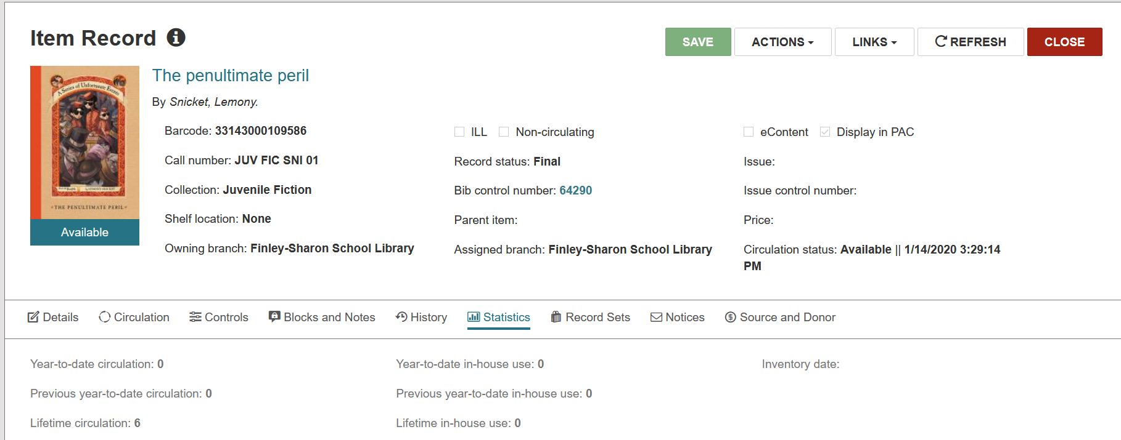

- Scanning items.
  - On the check-in screen, go to the Inventory tab. Scan items as if to check them in. You’ll note after each scan, the item appears with the Comment ‘Inventory update successful.’
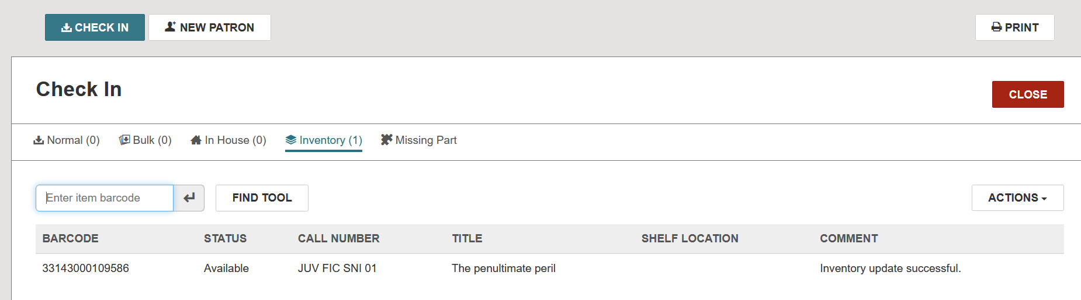

Note that once the item is scanned, the Inventory date is updated to the current date.
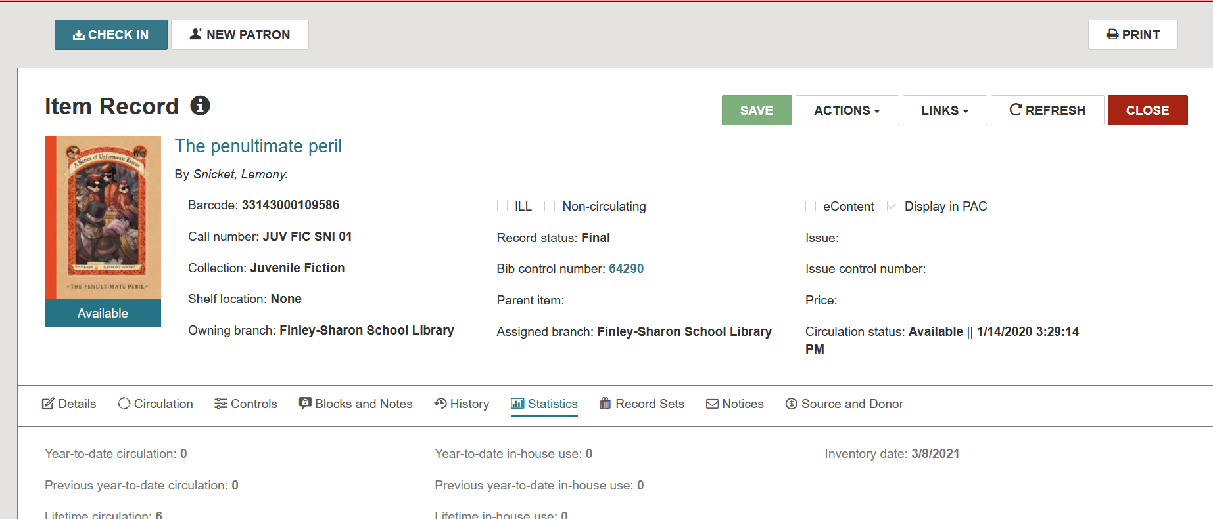

If a scanned item is checked out or has any other circulation status than available (such as Missing), a pop-up box will appear indicating as such. The inventory date is still updated, but the loan or any other status is *not* cleared. In the case of items on loan, you’ll want to check in the item and clear up any associated fines where applicable. In cases of items that have a missing or withdrawn status, you’ll want to update the item record | Circulation Status as appropriate.

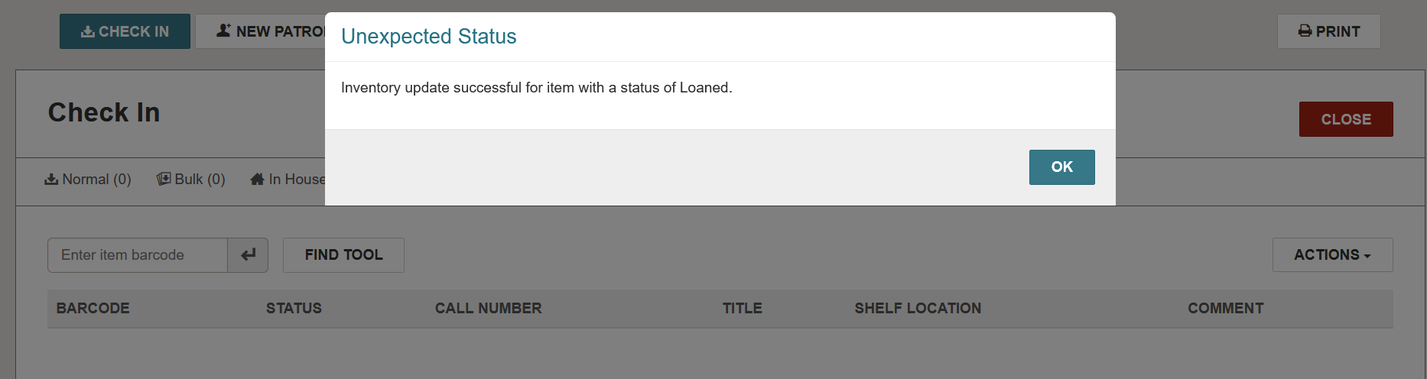
  - Alternatively, a file of scanned barcodes can be uploaded. On the Check In screen, go to the Inventory tab. On the far right is an Actions menu where you’ll find Load from File in the drop down list.
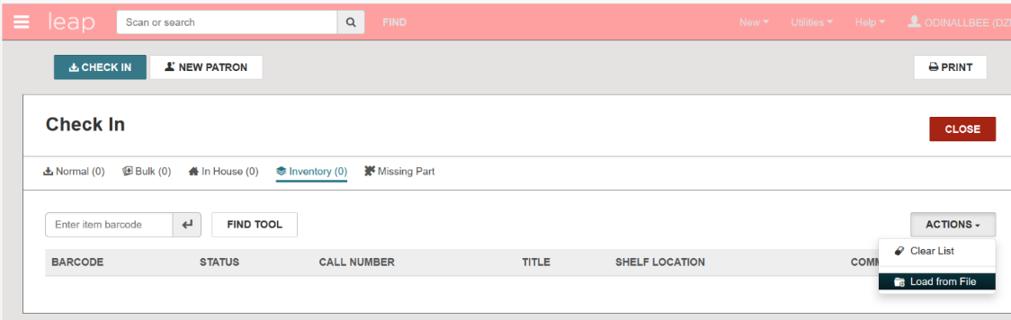

Use the Select File button to navigate to the saved file on your computer. Leap will accept .txt .csv or .xls/xlsx files. When uploading a spreadsheet, an additional box will appear asking you to designate the column containing the item barcode. If the Present inventory update status messages is checked, you will see a pop-up for any items that are on loan or have a circulation status other than available, though the pop-up does not include any identifying information. Click Load from File to upload the file.
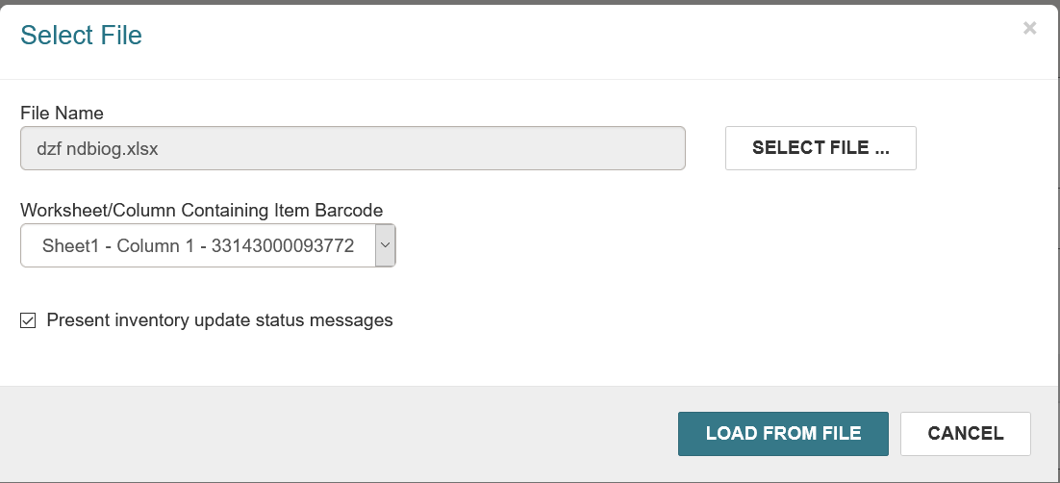

Similar to scanning items individually, if Present inventory update status messages was checked, popups will display for items that have statuses other than available. The popup will not contain any identifying information.
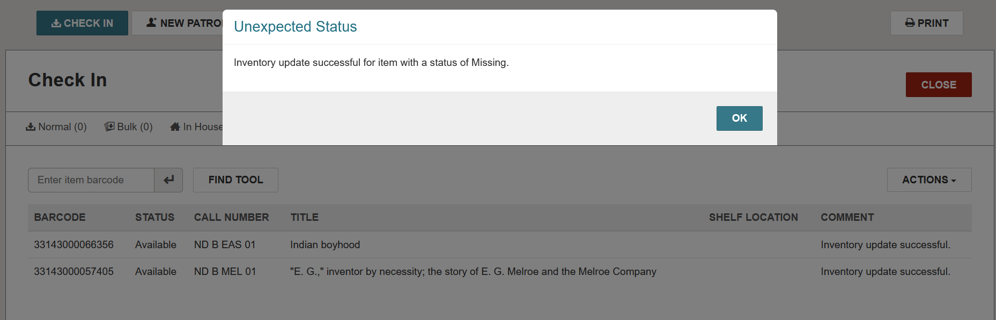

The list of items will be built, and you will be able to determine which items need further processing (on loan, missing, etc.)
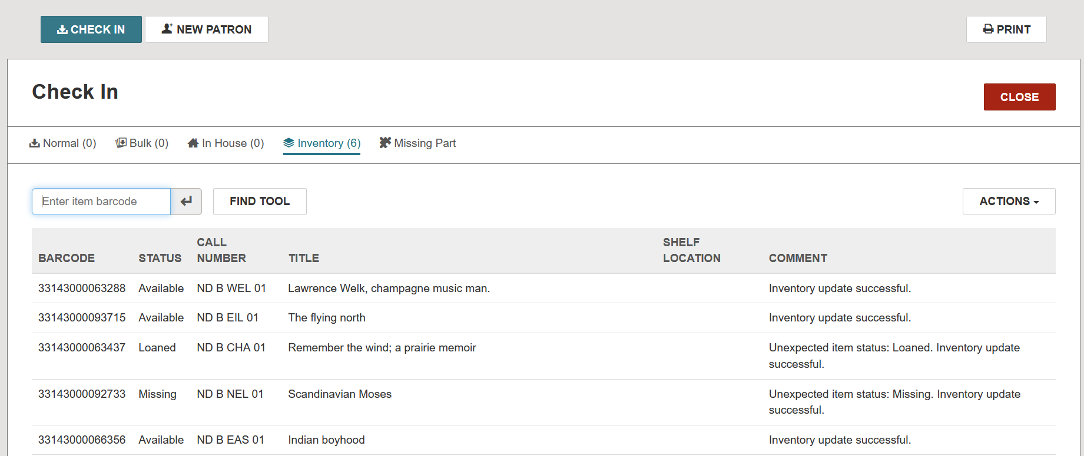

- Running Inventory Reports
After Items have been scanned, log in to the Polaris client to run the Inventory Exception – Incorrect Status report and the Inventory Exception – Misshelved report.
If you do not have access to the Polaris client, submit an ODIN Help Ticket and we will run these reports for you.
Navigate to Utilities | Reports and Notices to open the reports dialog box.
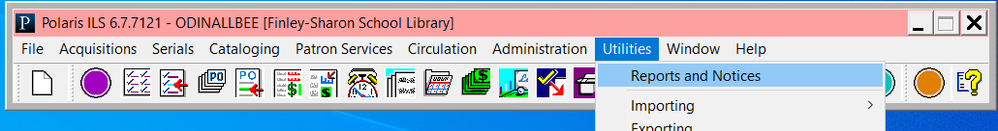
In the Reports dialog box, the inventory reports are found in the Cataloging | Item folder. Select the Inventory Exception – Incorrect Status report or the Inventory Exception – Misshelved Items report.
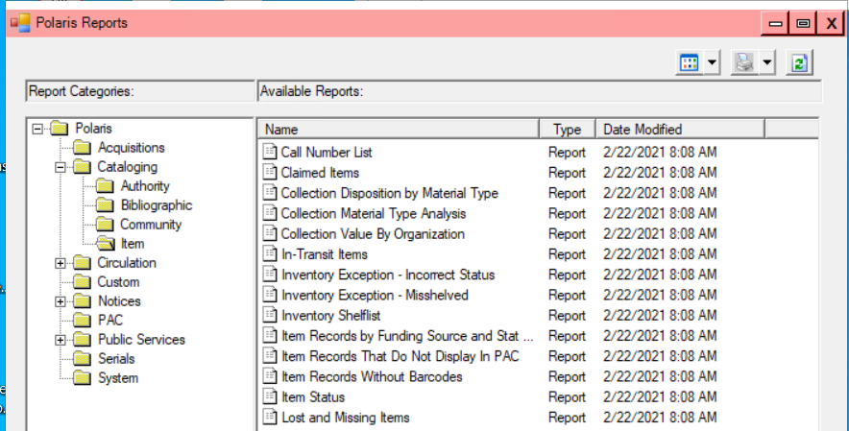
- Enter the starting/ending call number. NOTE: If the library uses prestamps, they must be included with the call number. For example, if Oversize items have the prefix of OS, the call number range should nclude OS such as OS 001 to OS 599.99.
- Select the library from the Organization List.
- Select the Cutoff Date as the DAY BEFORE items were scanned. The system automatically enters the time as midnight, so by selecting the day before, you’re effectively selecting the beginning of the day the items were scanned.
- Enter the starting/ending call number. NOTE: If the library uses prestamps, they must be included with the call number. For example, if Oversize items have the prefix of OS, the call number range should nclude OS such as OS 001 to OS 599.99.
- Select the library from the Organization List.
- Select the Cutoff Date as the DAY BEFORE items were scanned. The system automatically enters the time as midnight, so by selecting the day before, you’re effectively selecting the beginning of the day the items were scanned.

a. Inventory Exception – Incorrect Status report. This report lists all items with a circulation status other than ‘in’ from the range of items in which the inventory was conducted. If you did not follow-up with these items as they were scanned, you will want to run this report to obtain a list of those items.
- Enter the starting/ending call number. NOTE: If the library uses prestamps, they must be included with the call number. For example, if Oversize items have the prefix of OS, the call number range should include OS such as OS 001 to OS 599.99.
- Select the library from the Organization List.
- Select the Cutoff Date as the DAY BEFORE items were scanned. The system automatically enters the time as midnight, so by selecting the day before, you’re effectively selecting the beginning of the day the items were scanned.
Click submit.
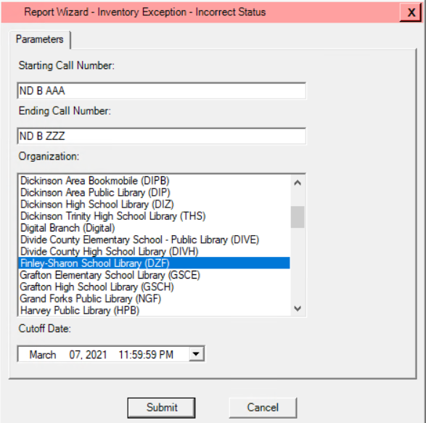
- Enter the starting/ending call number. NOTE: If the library uses prestamps, they must be included with the call number. For example, if Oversize items have the prefix of OS, the call number range should nclude OS such as OS 001 to OS 599.99.
- Select the library from the Organization List.
- Select the Cutoff Date as the DAY BEFORE items were scanned. The system automatically enters the time as midnight, so by selecting the day before, you’re effectively selecting the beginning of the day the items were scanned.
- Enter the starting/ending call number. NOTE: If the library uses prestamps, they must be included with the call number. For example, if Oversize items have the prefix of OS, the call number range should nclude OS such as OS 001 to OS 599.99.
- Select the library from the Organization List.
- Select the Cutoff Date as the DAY BEFORE items were scanned. The system automatically enters the time as midnight, so by selecting the day before, you’re effectively selecting the beginning of the day the items were scanned.

Output :
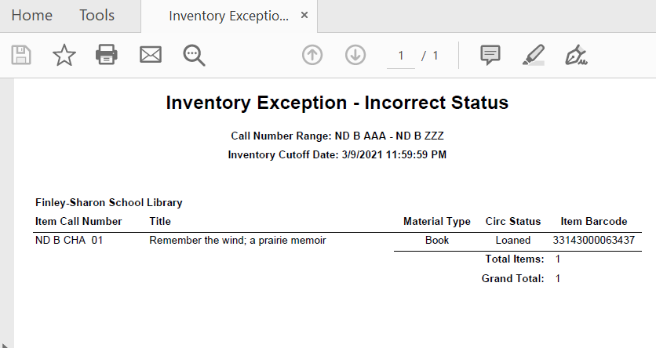

b. Inventory Exception – Misshelved report will provide a list of items that match your scan criteria, but were not actually scanned (i.e. items missing from the shelves).
- Enter the starting/ending call number. NOTE: If the library uses prestamps, they must be included with the call number. For example, if Oversize items have the prefix of OS, the call number range should nclude OS such as OS 001 to OS 599.99.
- Select the library from the Organization List.
- Select the Cutoff Date as the DAY BEFORE items were scanned. The system automatically enters the time as midnight, so by selecting the day before, you’re effectively selecting the beginning of the day the items were scanned.
Click submit.
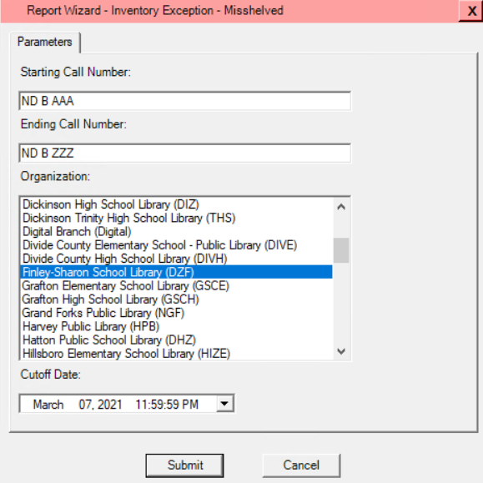
- Enter the starting/ending call number. NOTE: If the library uses prestamps, they must be included with the call number. For example, if Oversize items have the prefix of OS, the call number range should nclude OS such as OS 001 to OS 599.99.
- Select the library from the Organization List.
- Select the Cutoff Date as the DAY BEFORE items were scanned. The system automatically enters the time as midnight, so by selecting the day before, you’re effectively selecting the beginning of the day the items were scanned.
- Enter the starting/ending call number. NOTE: If the library uses prestamps, they must be included with the call number. For example, if Oversize items have the prefix of OS, the call number range should nclude OS such as OS 001 to OS 599.99.
- Select the library from the Organization List.
- Select the Cutoff Date as the DAY BEFORE items were scanned. The system automatically enters the time as midnight, so by selecting the day before, you’re effectively selecting the beginning of the day the items were scanned.

Output:
