ACAD Discovery/PrimoVE User Group Meeting – 3/15/24 via Teams

Discussion Items
- UPDATE: SMS options w/NDUS -- still being worked on - no new updates
- See end of document for available and upcoming Ex Libris sessions – May Feature Sneak Preview
- PSB scheduled for April 2024 release on Sunday, March 17 – have not seen any Release Notes published as of this morning.
- ELUNA 2024 Events – May 13-17 – information and option to register to view the Preview Session from 2/12/24 can be found: https://el-una.org/meetings/eluna-2024-annual-meeting/
- PrimoVE Showcase feature update
- Any feedback from March 1 walk through session by ODIN Office – Useful? Waste of time? Suggestions for next time? -- Sounds like it was a good session to hold and will look to have another for the May Feature Release.
- PrimoVE Enhancement Voting discussion – input for any you found useful – enhancement info

Member Updates:
- Bismarck State College - adding games in circ collection and weeding CDs
- Dakota College at Bottineau
- Dickinson State University
- Lake Region State College
- Mayville State University -
- Minot State University
- North Dakota State College of Science - nothing new to report
- North Dakota State University - GreenGlass weeding project; implementation of Rialto; Museum Collective initiative
- Trinity Bible College
- University of Jamestown –
- University of North Dakota - CFL - Shelby figured out how to make the Article Galaxy links show up:
Example article: https://und.primo.exlibrisgroup.com/permalink/01ODIN_UND/1sb5k4m/cdi_proquest_journals_2913490952
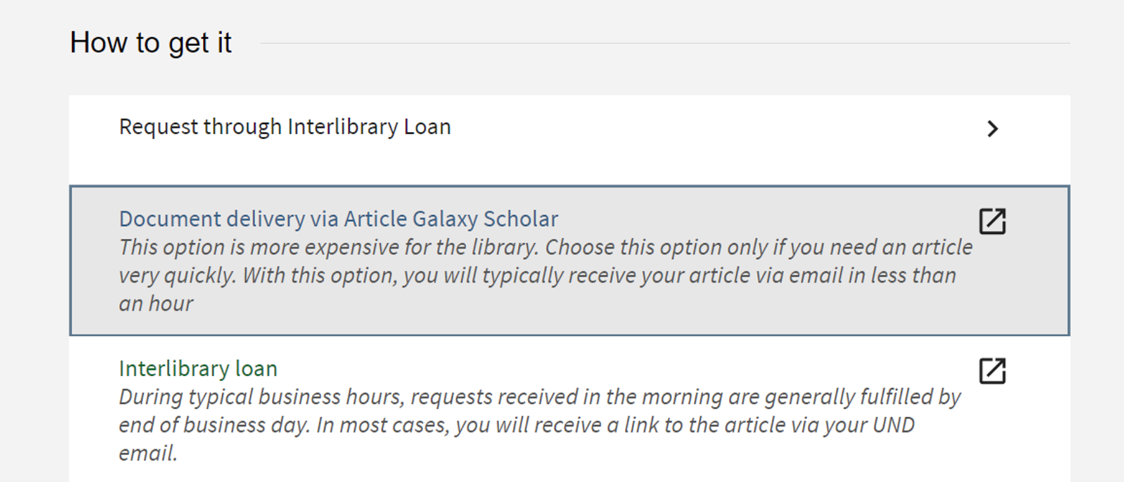
- UND – Law
- UND – Med
- Valley City State University
- Williston State College
- ODIN - ODIN WorkDays are coming March 18-22!

Future Topics:
- MONITOR: Email from Nili Natan (Primo Product Manager) sent to Primo Listserv 6/14/23. " We are working in Primo VE to make sure that there will be no difference when selecting the same type with the new Resource Type Filter Bar or Facet Resource type. We will update on this fix in the upcoming release notes so you will be able to test again and activate the Resource Type Filter Bar.”
- MONITOR: Display Documents Attributes for CDI Records from CDI-August Release: What's New with Primo Video – July 2023 has 8-minute segment with information at the 11:27 mark - https://www.youtube.com/watch?v=WQGZqcJWxDE - documentation also found at -https://knowledge.exlibrisgroup.com/Primo/Content_Corner/Central_Discovery_Index/Documentation_and_Training/Documentation_and_Training_(English)/CDI_-_The_Central_Discovery_Index/CDI_Document_Attributes
***** NISO voting/discussion in December --- may have to delay until after things are decided there.

Next Meeting: 4/19/24 11 AM
Primo links for all colleges can be found: https://www.odin.nodak.edu/academic
======================================================================

Ex Libris Sessions and Webinars
Primo VE Become an Expert Series: https://knowledge.exlibrisgroup.com/Primo/Training/Webinars/Primo_VE%3A_Become_an_Expert
- How Primo Works – Jan 11 – basic concepts and overview
- Search Configuration – Jan 18 – search scopes, profiles, slots, search configuration
- Search Interfaces – Jan 25 – configure optional features including search interfaces and a few features to enhance search results
- Display – Feb 1 – customize Primo display: brief/full display, text interface, sort/facet configuration, related records and library card account config.
- Delivery – Feb 8 – configuration for physical and electronic resources
- Local Data – Feb 15 – manage and display local fields, configure norm rules for fields used in display/search/facet areas, how to configure local resource types.
- Dedup and FRBR – Feb 22 - concepts and fundamentals
- Primo Analytics – Feb 29

Primo VE Roadmap Highlights: Session was held February 14th
https://knowledge.exlibrisgroup.com/Primo/Product_Materials/Roadmap/020Primo_VE_Roadmap_Highlights
Video: https://youtu.be/hp_cDadC2m0

Alma May 2024 Feature Release Sneak Preview:
https://knowledge.exlibrisgroup.com/Alma/Release_Notes/2024/March_2024/May_2024_Feature_Sneak_Preview
Nothing yet for PrimoVE May Release but should be posted here when there is:
https://knowledge.exlibrisgroup.com/Primo/Release_Notes/002Primo_VE/2024/2024_Primo_VE_Quarterly_Updates

