Power Search for Technical Services

How a power search is structured
- The find tool will create the power search for us, so we don’t have to memorize
- Power search is available for all record types
- Elements of Power Searches
  - Qualifiers
    - Examples TI = Title
    - AB = Assigned Branch
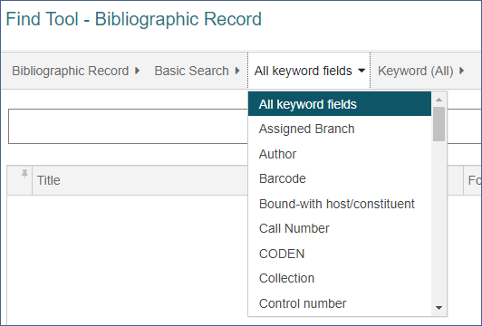
  - Relations
    - Examples ALL = Keyword (All)
    - ADJ = Phrase
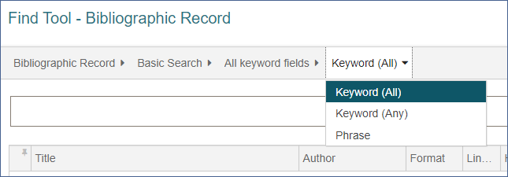
  - Database ID Numbers – can be used with qualifiers that have pre-defined lists
    - Examples: Assigned Branch, Collections, Material Type, Shelf Location
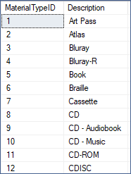
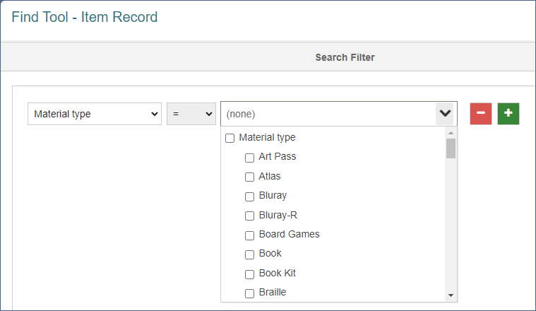

How to translate a Basic Search into a Power Search
- Build your search in Basic Search Mode – pick your qualifier, relation, and filters
- Then change the search mode from Basic Search to Power Search

How to create simple Power Searches
Here are the steps:
- Open the Find Tool to Bibliographic Record Search, or another type of search
- Set qualifier, for example, Title
- Set relation, for example, Keyword All
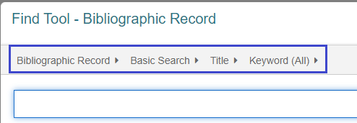
- Add filter(s), for example, Assigned Branch, and click Apply
- Change the search mode to Power Search
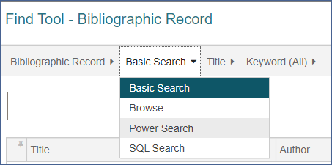
- The power search code appears in the search box
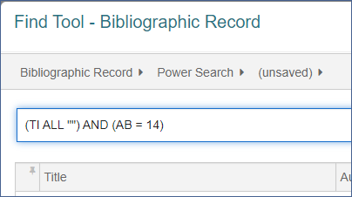
- To conduct the power search type in the title search words between the quotation marks
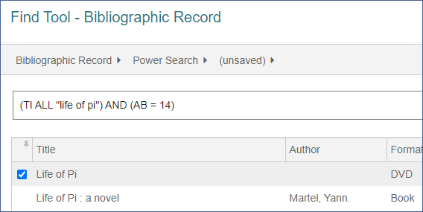

How to save, access, and use a Power Search
Create a power search as above. In this example, the search is an item record keyword search for available items assigned to the Lakota branch. Notice that it is an unsaved search.
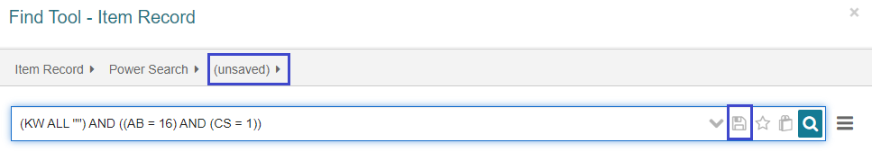
To save the search click the disc icon in the search bar and give the search a descriptive name.
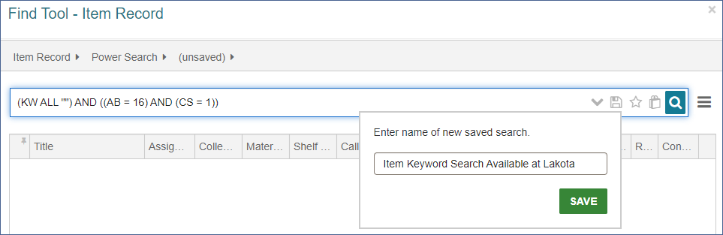
Now the search is available in the find tool. To find the search again, change the search type to Power Search, and click on the (unsaved) drop-down menu.
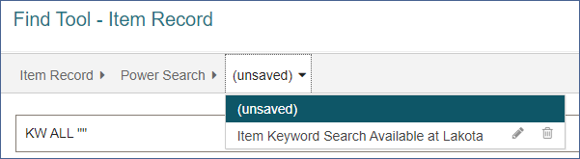
Save searches are linked to the user’s login. You can have different saved searches than your co-workers. As you can see, you can delete a saved search by clicking on the trash icon and rename the search by clicking on the pencil icon.
*NOTE: Copy and paste of searches may not work. It is best to create and save the power search in the Find tool.

Simple methods for modifying a Power Search

Modifying the search with Boolean Operators
When using the search filters for material type or collection, the default is equals, and you cannot change it. Using a power search, you can still use these filters to exclude material types or collections.
Example: (KW ALL "") AND ((AB = 90) AND (SHELF = {list}"DISPLAY", "NEW BOOK", "NEW DVD"{/list}))
This search is an item record keyword search, at a certain branch, and shelf locations Display, New Book, and New DVD.
Change the Boolean Operator to NOT to exclude items on these shelf locations.
(KW ALL "") AND ((AB = 90) NOT (SHELF = {list}"DISPLAY", "NEW BOOK", "NEW DVD"{/list}))

Combining two basic searches to construct a Power Search
The basic search is limited to one qualifier at a time. For example, you cannot search for a subject and an author in a single search. You can combine the two searches with a Boolean operator with power search.
Search 1: AU ALL "king, stephen"
Search 2: SU ALL "authorship"
Combined with Boolean AND: AU ALL "king, stephen" AND SU ALL "authorship"

Sample Power Searches
Item Record Searches
Find item records created by a particular staff person on a certain day.
Item Record creation date: CRD = "2022-02-16" - "2022-02-16"
Item Record creator: CRE = "ODINMASON*"
Combined: CRE = "ODINMASON*" AND CRD = "2022-02-16" - "2022-02-16"
Lost or missing items at a certain branch, by circ status date.
Circ Status: CS = {list}7, 10{/list}
Assigned branch (filter): AB = 110
Circ Status Date: CSD = "2023-01-01" - "2023-12-01"
Combined: (CS = {list}7, 10{/list}) AND (AB = 110) AND (CSD = "2023-01-01" - "2023-12-01")

Bibliographic Record Searches
Exclude electronic resources from search results.
Basic keyword search: KW ALL ""
Search for Type of material, eaudio, ebook, eresources, emagazine: TOM = {list}"aeb", "ebk", "elr", "emg"{/list}
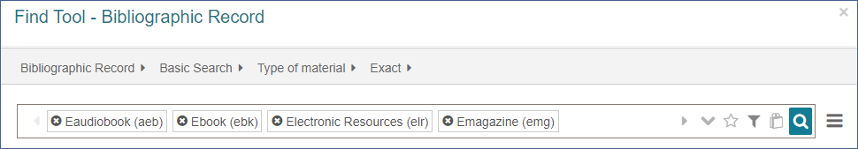
Combine the searches using NOT to exclude the electronic resources. Insert your search terms between the quotation marks: KW ALL "" NOT TOM = {list}"aeb", "ebk", "elr", "emg"{/list}

