IUG Member Exclusive Enhancement Process
In December 2023, the Innovative Users Group (IUG) and Innovative, Part of Clarivate announced an IUG Member Exclusive Enhancement Process.
How does this process work?
- Working Groups select up to 20 idea candidates per cycle and clarify the requirements. Nicole Murphy is a member of the Polaris Working Group!
- Product owners assign effort point values to each idea.
- IUG members vote to prioritize ideas for implementation. Each IUG member organization gets one vote. For consortia, individual member libraries can purchase their own IUG membership.
- Innovative commits to deliver enhancements within 12 months.
- Product owners will follow up with Working Groups to ensure that enhancements meet the requirements laid out in the ideas.
- You can find out more by reviewing this video.
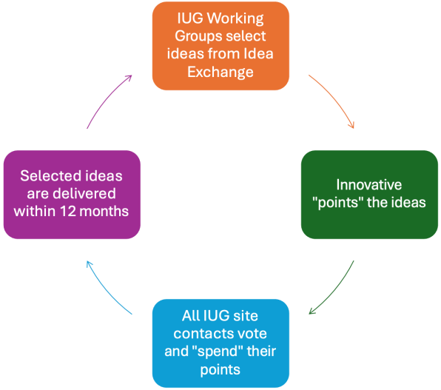

How does this process work with Idea Exchange?
- Ideas used in this process will primarily come from Idea Exchange submissions.
Timing
- The development of the following Polaris release begins immediately after a Polaris release. The next Polaris release is in April 2024, and the working group is working right now to prioritize ideas and get them scored so voting by IUG members can be completed before the April release.

Idea Exchange
Customers using any Innovative product are welcome to participate in Idea Exchange (ideas.iii.com). The process allows the Innovative community to provide input regarding priorities for new areas of development as well as enhancements to existing Innovative products. It also enables Innovative to take more timely action on user-contributed ideas.

From the Idea Exchange FAQ:
Q. How can I see my submitted ideas and other activities?
A. You can see your Idea Exchange activity by clicking your name or Settings link in the top right corner.
Q. How can I promote an idea I’ve posted to the Idea Exchange?
A. You are welcome to advertise your idea on any relevant mailing lists or forums. Copy the URL for the idea from the browser's address bar.
Q. What makes for a good comment?
A. Comments should add to the conversation by adding new details, considerations, or local experiences to the original idea.
It can be quite tempting to leave comments that simply say things along the lines of “I like this too” in order to increase the comment count. However, if that is the extent of your comment please simply vote for the idea or find a way to expand on just what it is that you like in the idea or what problem it happens to solve for your library…or both!
Innovative’s product owners are also especially appreciative of use cases (both for and against an idea). If you explain the circumstances around how a given idea will affect your library, that can be extremely helpful.

Q. What happens to ideas that are marked “Archived?”
A. Ideas more than two years old are automatically archived. Archived ideas remain available for consideration by Innovative product owners. Some archived ideas have been selected for future product releases.
Q. My idea was unsuccessful. What do I do now?
A. Don’t despair. Archived ideas are still reviewed by Innovative product owners and have even been selected for development despite being placed in the archive.
Depending on the reason your idea was archived, you may also wish to submit a new idea that addresses feedback your original idea may have received throughout the commenting and review process. For example, one fairly common issue that can lead to an idea failing a review is it being too broad in scope. If that is the case you can try submitting one or more ideas that break your suggestion into more discrete pieces that might be able to be more easily developed.

Q. What do the Idea Statuses mean?
A. Idea Statuses can refer to the following:
- No Status – Status has not yet been assigned
- Under Review – Innovative is reviewing the idea
- Planned – Innovative is planning to implement the idea
- Completed – Innovative has implemented the idea
- Already Supported – The idea is already supported in the product
- Closed – The idea has been closed
- Future Possibilities (Idea Lab) – The idea was migrated over from Idea Lab (the previous idea platform), where it had made it to the Future Possibilities stage.
- Product Review (Idea Lab) – The idea was migrated over from Idea Lab (the previous idea platform), where it had made it to the Product Review stage.
Q. How does the Idea Exchange relate to Product Roadmaps?
A. Idea Exchange is separate from Product Roadmaps. The Product Roadmaps show features that Innovative is committed to adding to the product in a future release. Product Owners manage the Product Roadmaps which can include features submitted through Idea Exchange or other channels. Providing feedback via the Product Roadmap helps to clarify the final capabilities as the design and development teams get ready to implement them.

