Two methods to create serial issues

These methods are for libraries not using acquisitions in Alma.
Method 1: Easy
- Search for the serial title in Alma. Search by physical title and title or ISSN.
- Click on the Expand all double-arrow drop-down.
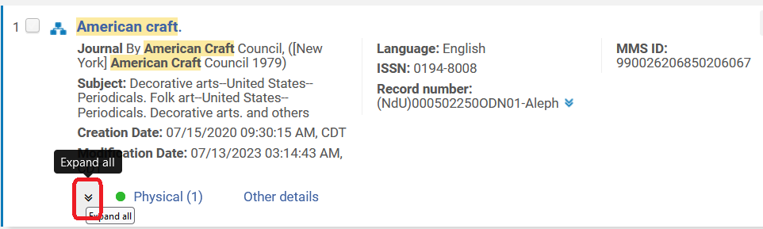
- Click on the Items link.
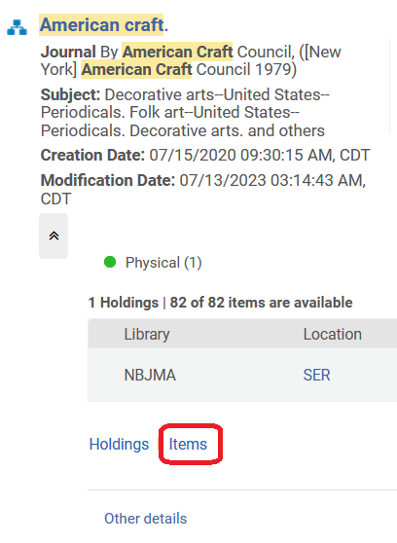
- Find the most recent issue in the list. Click the row action menu next to it, and select the menu option, “Duplicate.”
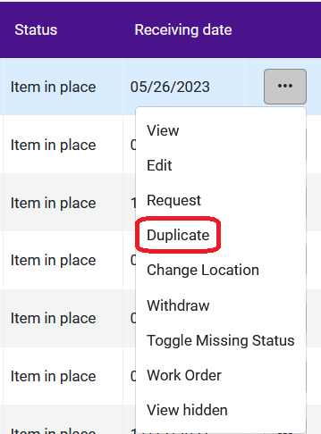
- Information will be pre-filled. Update the barcode, enumeration, chronology, and description fields.
- Click Save.

Method 2: Predicting issues and scanning in to receive
- Find the title in Alma, as above.
- Open the title in the metadata editor, and click on the View Related Data menu, select View Inventory.
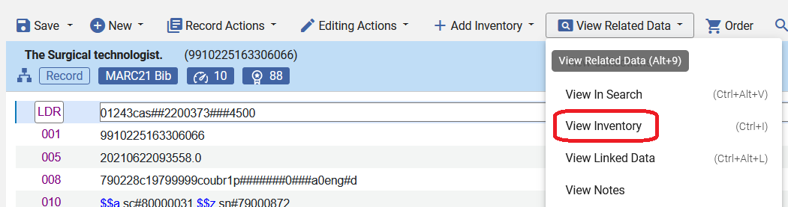
- Click the Edit button to edit the Holding record for the title.
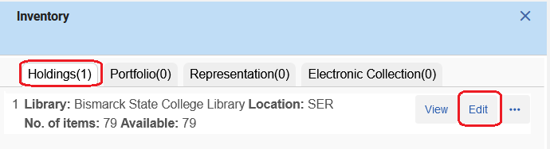
- Here is the holding record before adding a prediction pattern.
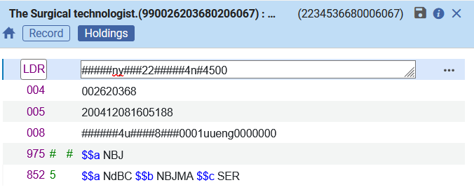
- Click on the Editing Actions menu, and select Expand from Template.
- Select the template that best matches the serial you are working on. In this case, the serial is very regular, one issue each month.
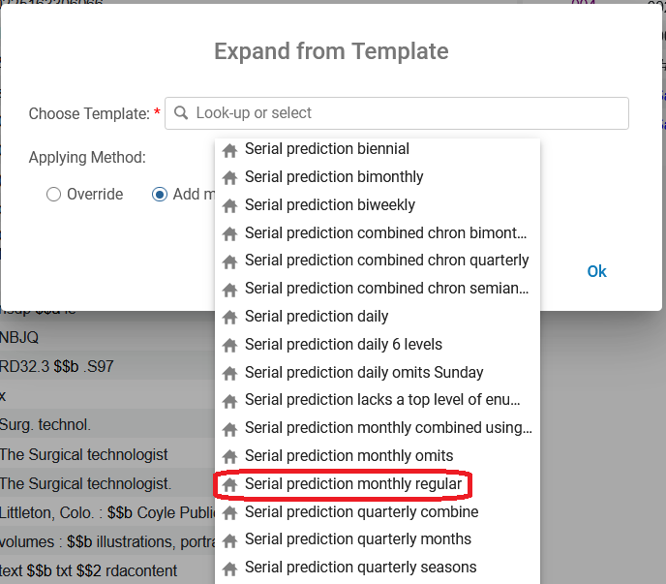
- There are three choices for adding the template:
  - Override – this will replace any existing matching fields of the record with the template fields.
  - Add missing – the fields of the template will supplement only the template’s fields missing in the record.
  - Add all – this will add all the template’s fields to the record, keeping the record’s existing fields, even if matched.
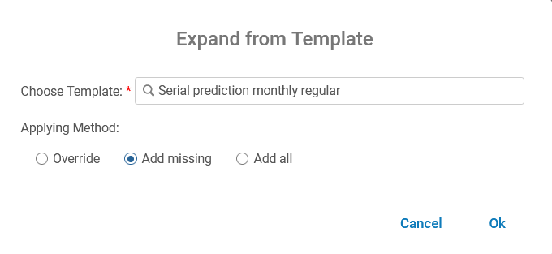
- Click OK and the prediction is added to the holding record in the 853 field (or an 854/855 field depending on the template). A 590 is also added with a default message from the template. (This does not appear in Primo VE, so it is harmless. Also, it can be deleted.) Here’s what it looks like:
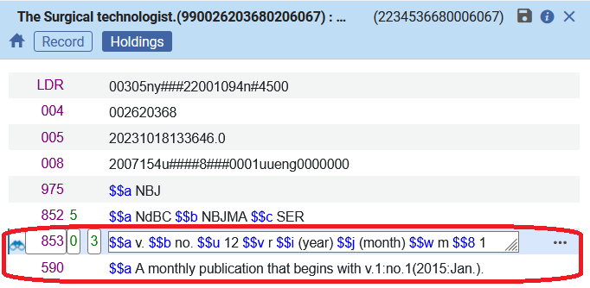
- Next, add the information for the first predicted issue. Click to activate the 853 field, then click on the Record Actions menu, and select Next predicted item’s information.
- This box appears, fill in the issue’s information. Click Close.
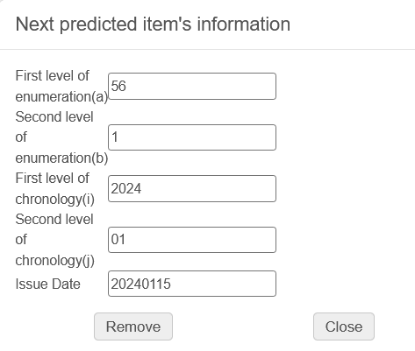
- Now you can view and open the predicted issues by clicking the menu Record Actions > Open predicted items. Each predicted cycle is for one year. If the prediction looks correct, click Save. If the prediction does not look correct, click Discard and edit either the holding record or the next predicted item’s information.
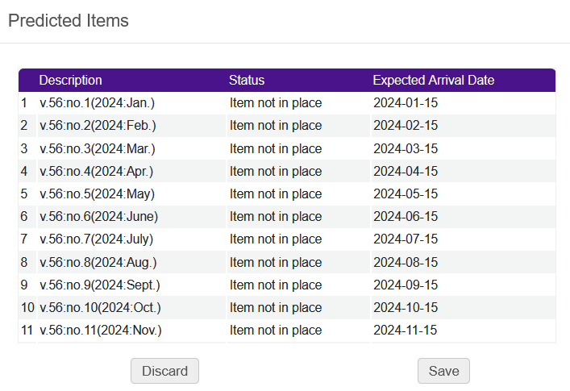
- When you return to the item list for the serial, you will see the predicted issues there:
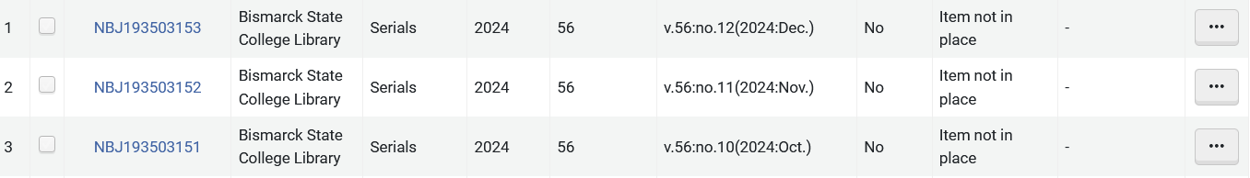
- The Get It area in the Primo VE view is also updated.
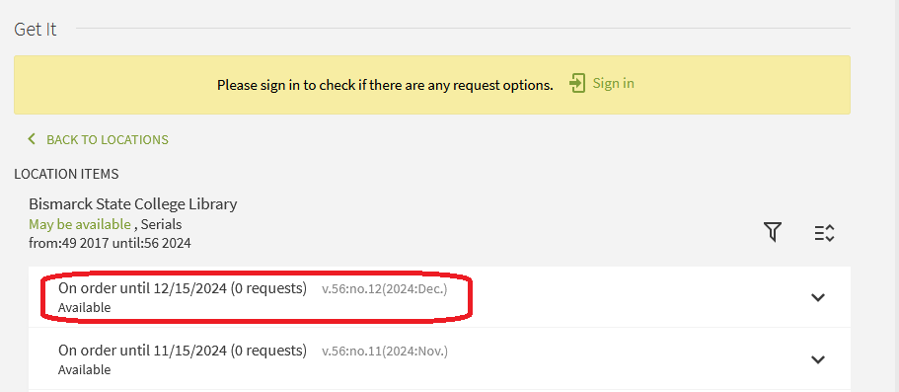
- Once the holding record is set up, you can also open predicted issues from the item list. Click Manage Selected and click Open Predicted Items.
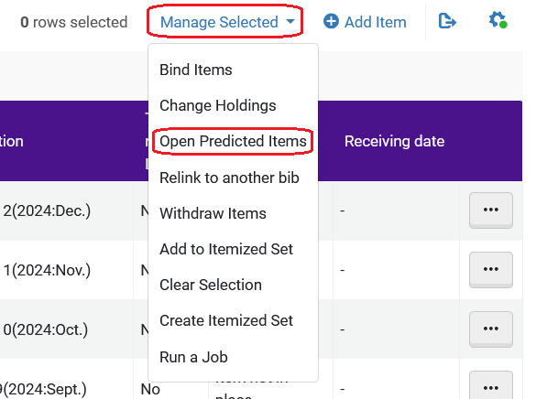
Receiving Predicted Serial Issues
- To receive a predicted issue, find the issue in the item list and copy the barcode.
- Navigate to the Acquisitions menu, and under Post-receiving processing, click on Scan in items.
- Click the Change Item Information tab to make it active. Set the change type to “Permanent” and set the location to the location where your library stores serials. Paste the barcode in the Scan in the barcode field. Click OK.
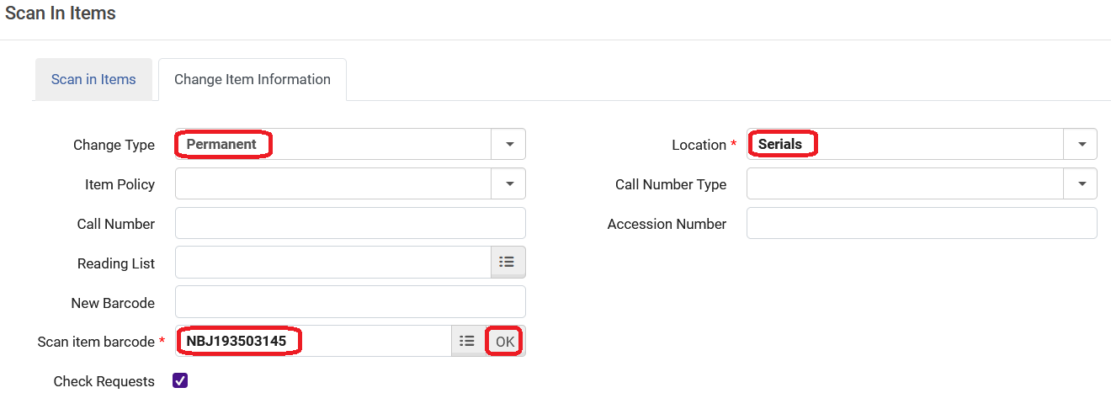
- A message pops up confirming you want to change the item’s information even though the item was not received by the acquisitions department. Click Confirm.
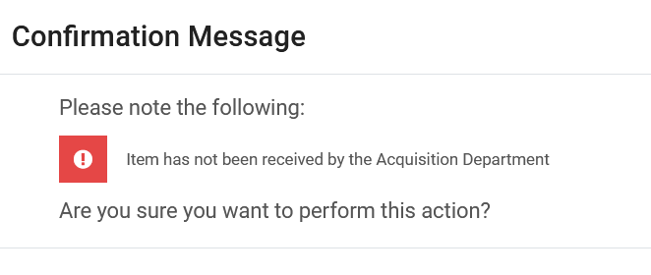
- The issue appears with the “Item in place” status after a reshelving period.
