**Polaris LEAP Cataloging**

**Deleting Items**

**Basic Information for deleting items via Polaris Cataloging in Leap.**

1. **Deleting item records for NON-OCLC USERS**
2. After logging into Leap, conduct a search for the item to be deleted. The best search to yield a match will be a barcode search. Instead of using the find tool, a barcode can be entered into the quick search box.

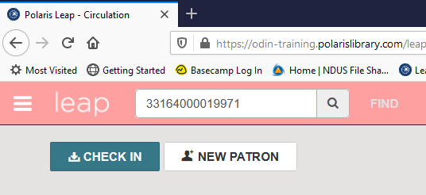

1. In the item record, then go to Actions and select Delete.

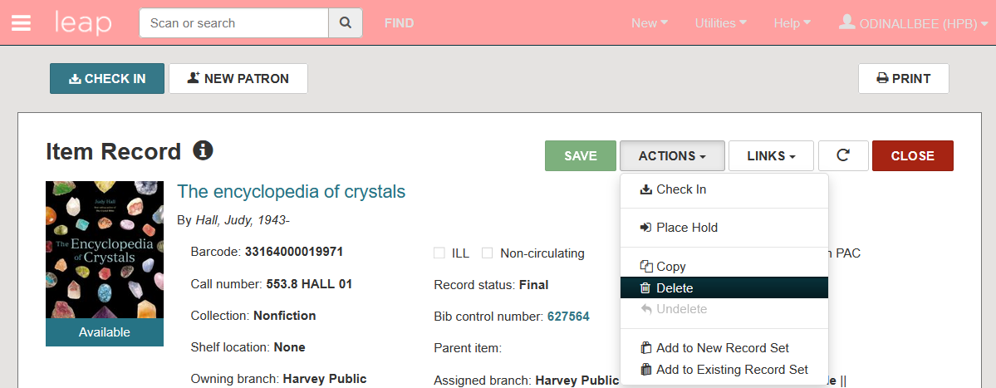

3. You will be prompted to confirm the deletion. Click Continue.

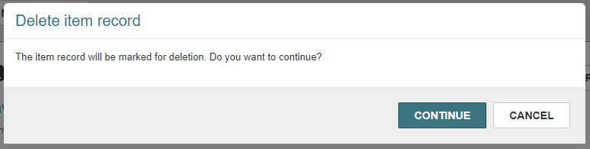

4. The item is deleted.

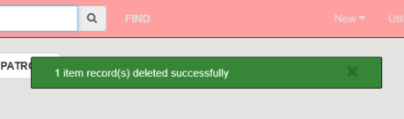

1. If Polaris detects the item being deleted is the last item that is attached to the record, you will be asked if you also wish to delete the bib record. Click Delete to delete both the item record AND the bibliographic record.

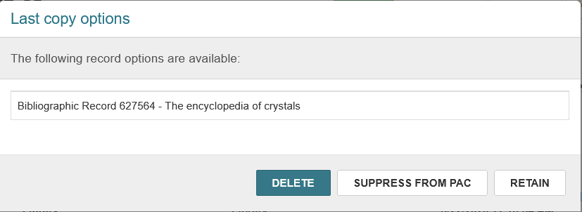

1. Note: If the bibliographic record is open while deleting the item record, and you are prompted to delete the bibliographic record, it will not be deleted. In this case, use the Action menu in the bibliographic record to delete it.

1. **Deleting item records for OCLC USERS**
2. Conduct a search for the record to be deleted using the FIND TOOL. Instead of searching the item database, conduct a search in the **bibliographic** database for barcode.

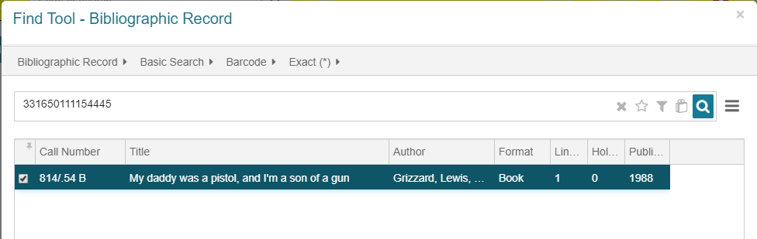

1. Look at the item records, and check to see if you are deleting the **last copy** owned by your library.

1. If you are deleting the last copy owned by your library, click the MARC tab to gather information – such as the 035 OCLC number – in order to delete the record from OCLC later.

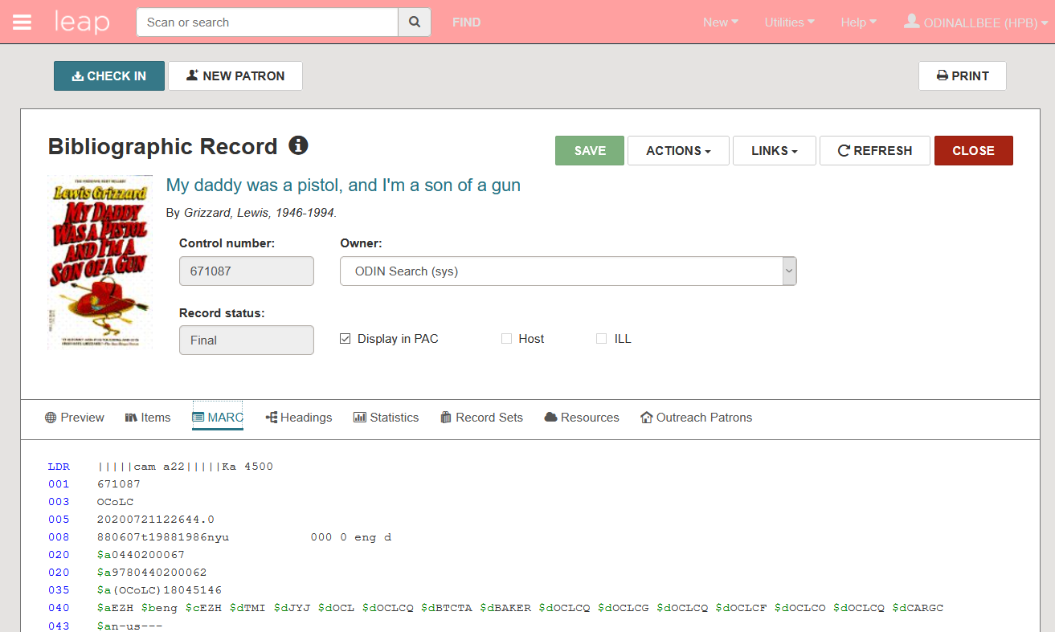

1. Close the bibliographic record, and delete the item record as per section I, steps 2-6.

