ACAD Discovery/PrimoVE User Group Meeting – 08/18/23 via Teams

Discussion Items
- August 2023 Feature Release and PSB (Premium Sandbox) Refresh https://knowledge.exlibrisgroup.com/Alma/Release_Notes/2023/July_2023/August_2023_Feature_Release_Sneak_Preview
  - Recording for the Letter Editor UI Improvements:
    - https://www.youtube.com/watch?v=SHzXviL-qfk
  - PSB refreshed this past weekend – next refresh Feb 2024
- Display Documents Attributes for CDI Records from CDI-August Release -https://knowledge.exlibrisgroup.com/Primo/Content_Corner/Central_Discovery_Index/Documentation_and_Training/Documentation_and_Training_(English)/CDI_-_The_Central_Discovery_Index/CDI_Document_Attributes
  - ODIN will monitor for more information; ask ExL
- Databases – EBSCO and ProQuest update (activated in NZ completed)
  - EBSCO: Exploring Race and Society: https://research.ebsco.com/c/zx53p3/topics
    - New ‘free’ resource
    - Has been added to the list in EBSCO for everyone
- SMS options
  - Discussions with NDUS
  - Primo Opt-in/out (2024): https://ideas.exlibrisgroup.com/forums/308176-primo/suggestions/38664517-option-to-allow-patrons-to-opt-in-opt-out-of-sms
- Discovery Import Profiles
- Ethnic Newswatch is not working for UND in Primo
  - Hybrid electronic collection
  - Waiting for Reindex – hopefully fixed by next week
- ExL tool that does suggestions/Promote topics/guides
  - Resource recommender?
  - Investigate and put on agenda for September
  - Pulling a ‘saved search’ at the top of a page
  - Example:
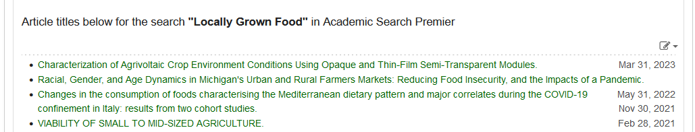

Member Updates:
- Bismarck State College - we are preparing for the first day of school with new collections and creating new student programs
- Dakota College at Bottineau
- Dickinson State University
- Lake Region State College
- Mayville State University - Libguides updates – expanding use to include Primo Search natively and make as primary library website
- Minot State University
- North Dakota State College of Science - Serial deletion project; Archival photo project; LibGuide link clean-up; library instruction videos; student worker interview(s); CR clean-up; other archival processing
- North Dakota State University
- Trinity Bible College
- University of Jamestown – wrapping up a search for a fully remote (part-time) librarian position, summer reading challenge between staff and faculty wrapped up (happy hour party in the library), getting ready for the start of classes on the 28th
- University of North Dakota - CFL - Will and TTADA finally figured out the LibGuide/Blackboard course integration for the library links. Several librarians had “outreach” roles added that will involve planning events for faculty/staff, students, and the community. Still trying to hire a systems librarian and opened a marketing position. (not related to PrimoVE, but the flood calls database is in alpha testing ) JSTOR added a SAML authentication option; Will is going to look into.
- UND – Law
- UND – Med
- Valley City State University
- Williston State College
- ODIN - First round of interviews for ODIN Director were completed this week. Search Committee is in the process of identifying finalists for 2nd round. Will have a booth at NDLA in Fargo – planning on having one-on-one sessions available to schedule, more details to come in September. Liz has added video recordings to the Discovery Collections training document on the ODIN website. One on how to create a Discovery collection, and another on how to create a Discovery collection based on a logical set. https://www.odin.nodak.edu/training/resource-management/setting-discovery-collections
Future Topics:
- MONITOR: Update on 651 Geographical Name ticket – possibly addressed in August release
- MONITOR: Email from Nili Natan (Primo Product Manager) sent to Primo Listserv 6/14/23. " We are working in Primo VE to make sure that there will be no difference when selecting the same type with the new Resource Type Filter Bar or Facet Resource type. We will update on this fix in the upcoming release notes so you will be able to test again and activate the Resource Type Filter Bar.”

Next Meeting: 09/15/23 11 AM
Primo links for all colleges can be found: https://www.odin.nodak.edu/academic

