How to create local bibliographic records for equipment

- In the metadata editor, make sure you are saving your records locally. Select the New menu and click on Placement Options.
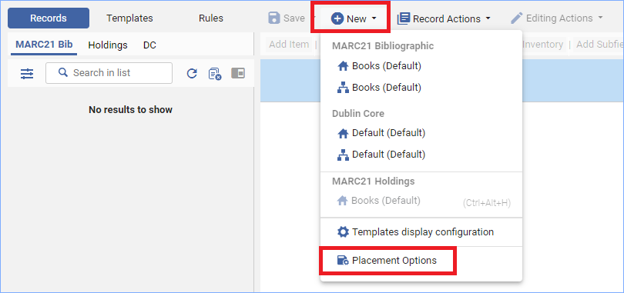
- Select “Local” for the Placement of new records and templates. Click Save.
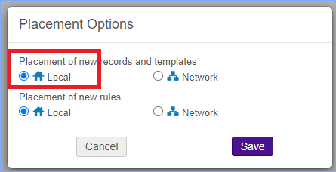
(Remember to change this back to “Network” before cataloging regular library items.)
- On the New menu, under MARC 21 Bibliographic, click on Books (Default)
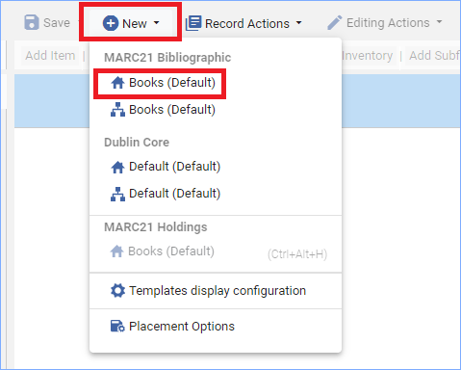
- Fill in the information you want in your bibliographic record.
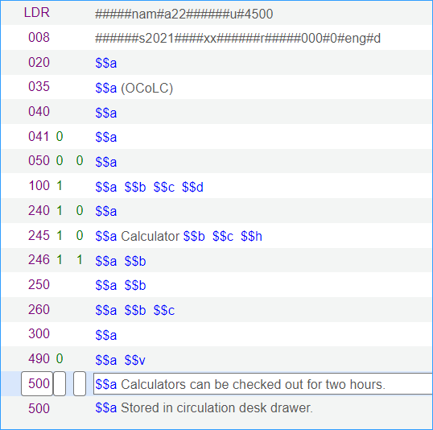
- Click Save to save the record.
- To add a Holdings record, click the +Add Inventory menu, and under Add MARC21 Holdings click Books (Default)
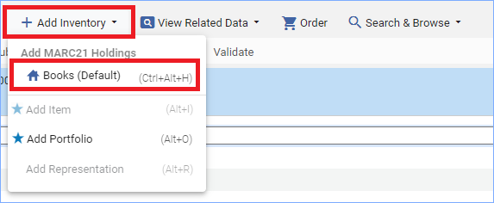
- If you are not using a standard call number scheme, make the first indicator 8 in the 852 field. Click CTRL-F to open the form editor and use the drop-down menus to fill in the subfields for the 852 field.
- You can place a call number/location in $$h and $$i if needed. Click Save.
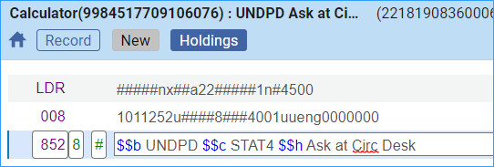
- Click the +Add Inventory menu, and click on Add Item
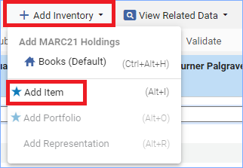
- Fill in the item record form, and save the record
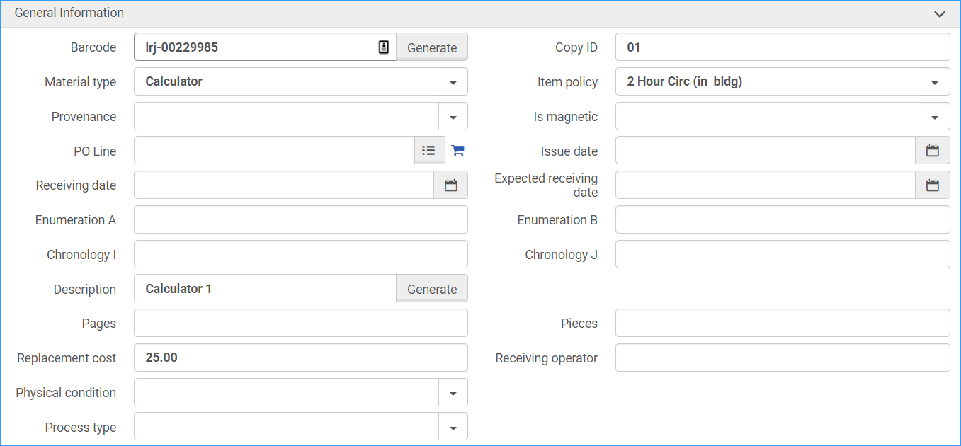
- If you have more equipment to add to this holdings record, click +Add Item at the top of the Items list.
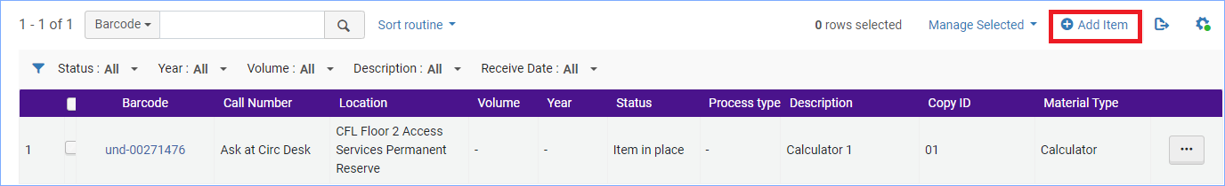
- Change the description and copy numbers to indicate this piece of equipment is different from the previous one, click Save.
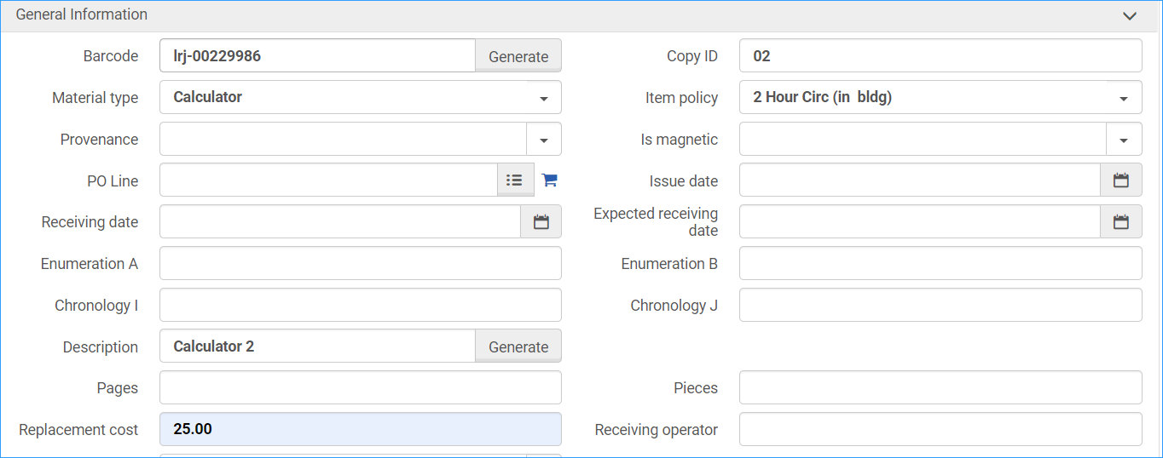
- In the metadata editor, release all records from the MARC21 Bib tab and the Holdings tab.
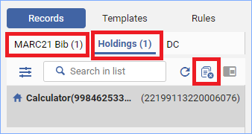
- Here’s how the record looks in Alma:
