Resource Sharing User Group Meeting Agenda
Wednesday, June 28th, 2023
Chair: Joan Miller
Updates

May Feature Release (May 2023) Alma Feature Release – May 2023

- Additional Optional Fields Can Be Added to Resource-Sharing Task Lists – Other Customization
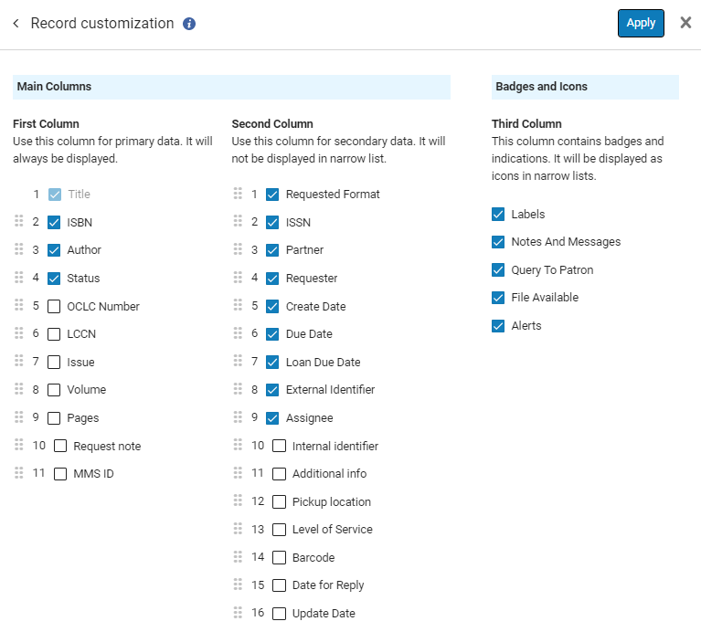

- Borrowing Requests with "Ready to Be Sent" Status in Tasks List
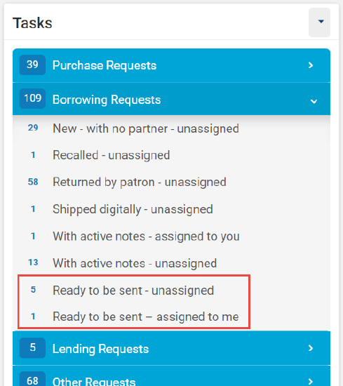

- New Layout for Resource-Sharing Task Lists Is Now the Exclusive Option

- Enhanced Notes Section in Resource-Sharing Task Lists
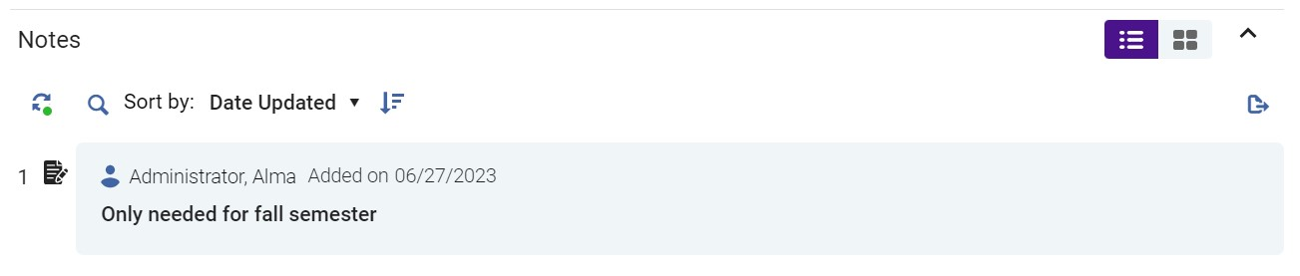
- Unused Labels Automatically Removed from Resource-Sharing Task Lists

- Ship Digitally Directly from Download Electronic Resource Screen
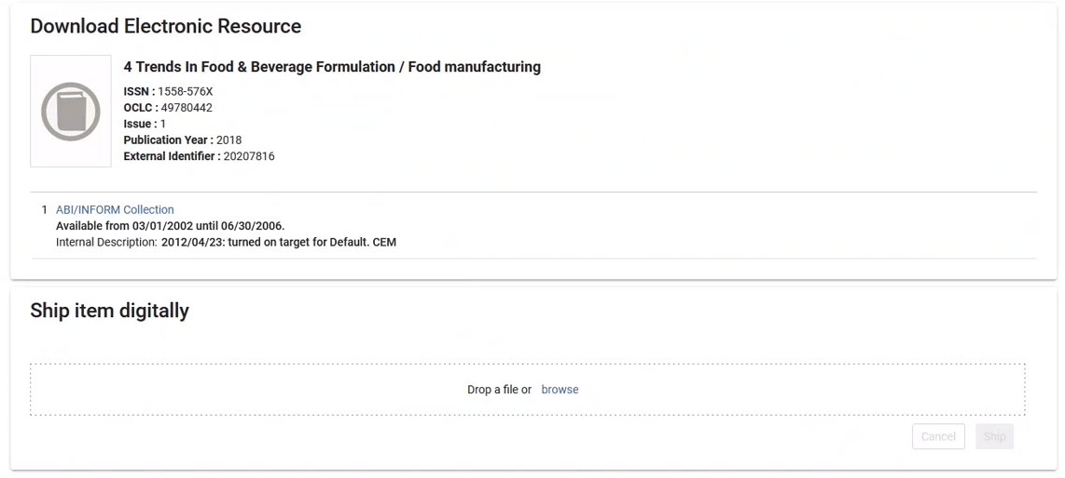
- Titles with physical holdings now display the Holdings information (name, shelving location, call number, and availability) in the right pane.
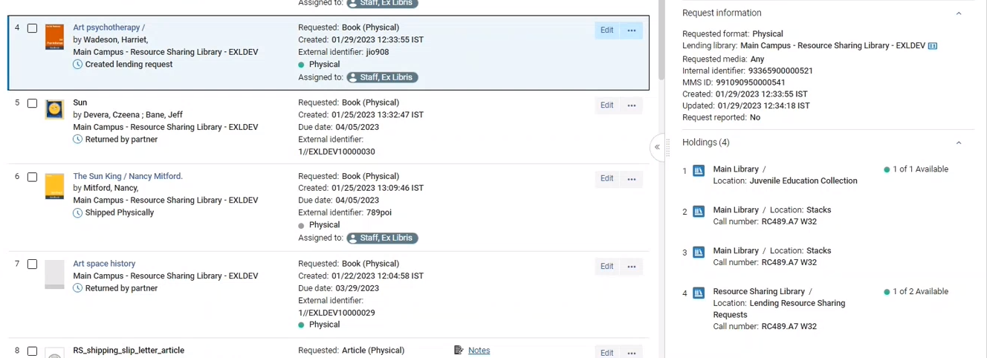

Library Updates

- NDW: LibGuides (work on two new and link clean-up), Moved REF collection to new location; Prep for fall semester
- NMI: Inventory and shifting, second video tutorial – setting up the Libby app
- WSC: This is Katie’s last resource sharing meeting as she is transitioning to a new role in August. No update on replacement yet.

Anything else you would like to discuss or address?

- Primo Round 2 Enhancement feedback due on June 29th, 2023
- Contact Nicole or submit a ticket to ODIN 😊

Next meeting is scheduled for Wednesday, August 30th at 9am CST.

