Alma Analytics Tips

This document has instructions on:
- The new analytics interface
- Analytics Tips:
- Copy a report from the Community
- Delete a filter
- Delete a column
- Add Columns
- Arrange the Columns on the Results tab
- Give the Report a Title
- Add a Row Count to the Top of a Report
- Hide a Column
- How to Concatenate Fields
- How to change the format of Date/Time and Currency
- How to Sort a Report by Months
- Useful Filters – How to Add a Filter
- How to Add Grand Totals to a Report

About Alma Analytics
- Design Analytics role- enables the user to create analytics reports
- Analytics Administrator role- enables the user to configure analytics and share analytics reports with other staff.
- Creating and running analytics reports doesn’t change the data in Alma or impact system resources.
- All reports in Analytics are based on yesterday’s data.

The new Analytics Interface
The new UI only applies to the Alma side of Analytics, it is about sharing reports not creating them.
Click on the Analytics Menu
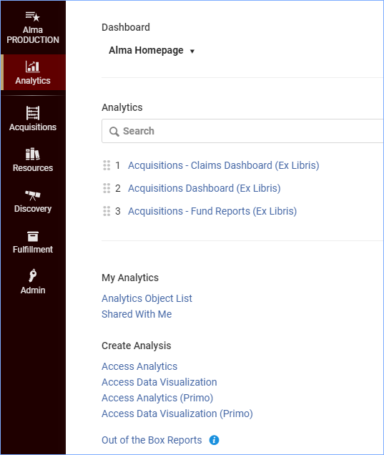
- The search box searches the favorites list
- The favorites list appears below the search box
- The Analytics Object List is where analytics reports are shared
Click on Analytics Object List
On the right of each object, the menu allows you to add/remove an object from your favorites, and you can remove the object from the object list.
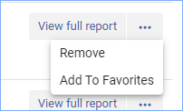
You can search, sort, and filter the object list with options at the top.
Click on View full report to open the report in analytics.
To add a report to the object list, make sure the report is saved within the Institution Folder.
- Click +Add New Alma Analytics Object and select the proper folder and file. Click Save.
- It can take a few minutes for the new report to be added to the list.
- Click on the report, and it opens the split view- the list on the left and information on sharing the report on the right.
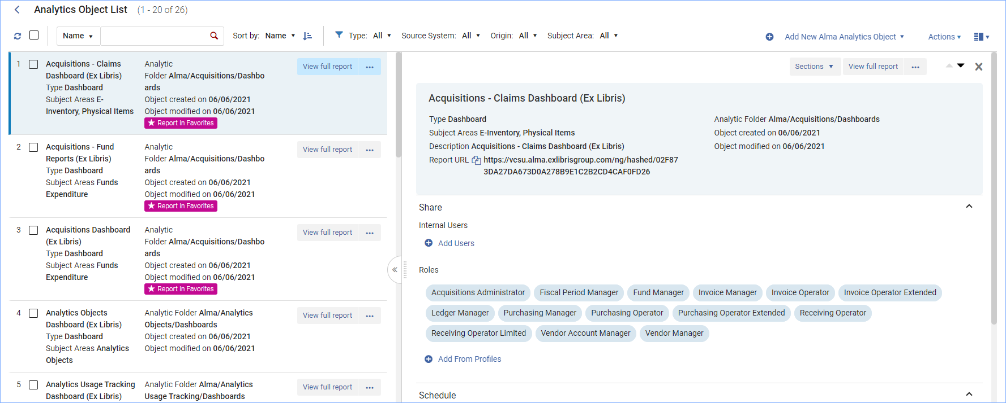
You can view different areas of information about the report by clicking on the Sections menu.
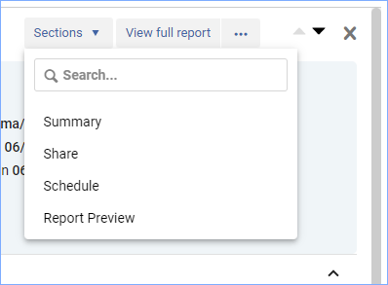
Summary – Area at the top with information about the type of report, when it was created, what folder it is in, and a description.
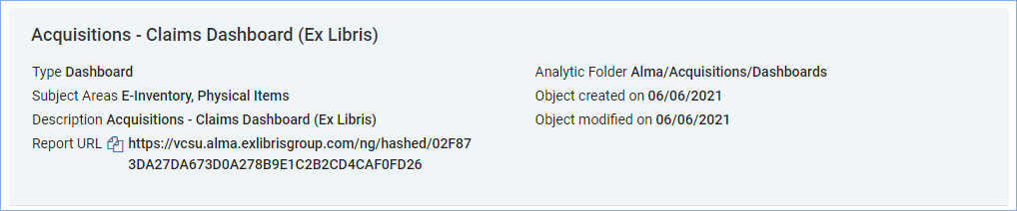
Share – This section is where you can add users from Alma, add roles which allows users with those roles to view the object.
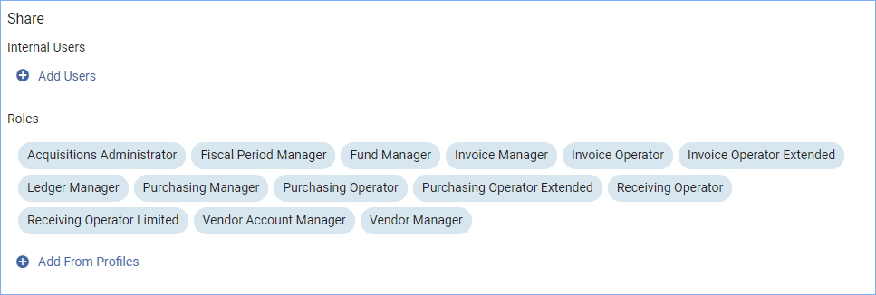
Schedule – activate the slider to schedule the report. Here you can add the recurrence schedule for running the report.
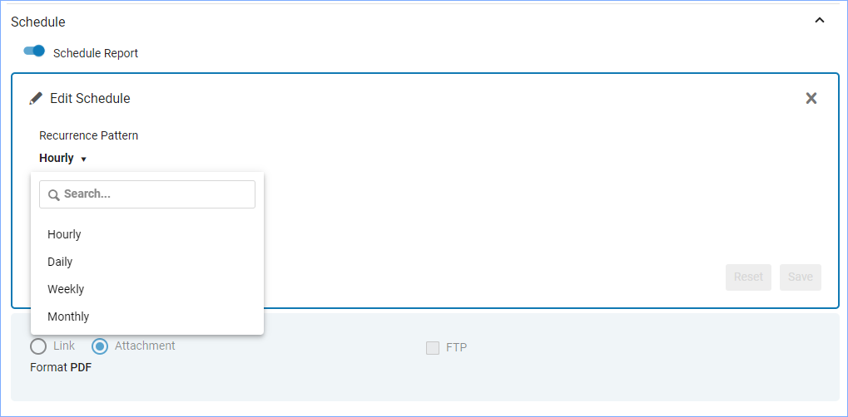
Report preview – This section has a preview of the report embedded in it. At the top you can click “View full report” to view the report in analytics.
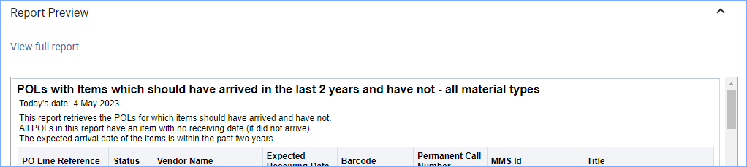

Analytics Tips

Copy a report from the Community
Click the Analytics menu and click Access Analytics.
Click on the Catalog menu
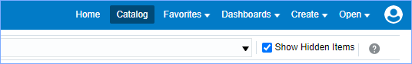
On the left is a folder navigation tree. You can explore these folders to find a report to copy into your own folder and edit for your needs.
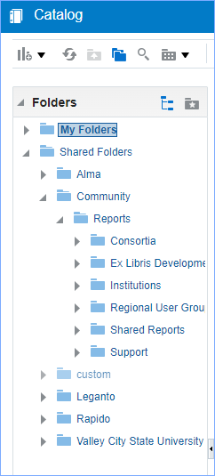
To copy a report, click on More and select Copy.
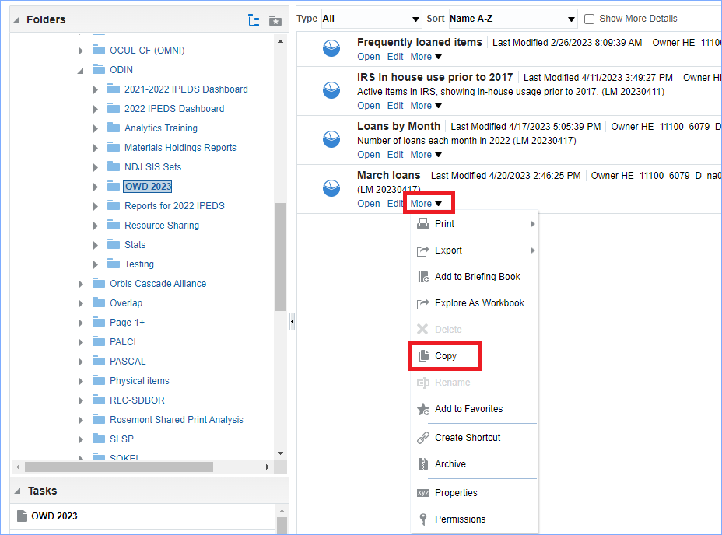
Paste it into My Folders. Do not open the report and edit it in the original folder. Once you have saved it into your own folder, then edit it.
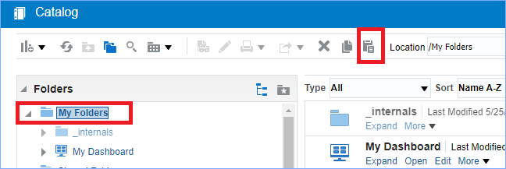
Often when you edit a copied report you will see errors when you edit it:
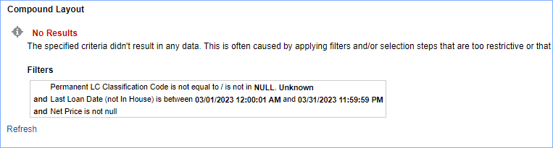
This message indicates that there are no results and that it may be because filters are applied.
Click on the “Criteria” tab to examine the filters. Filters appear below the selected columns area.
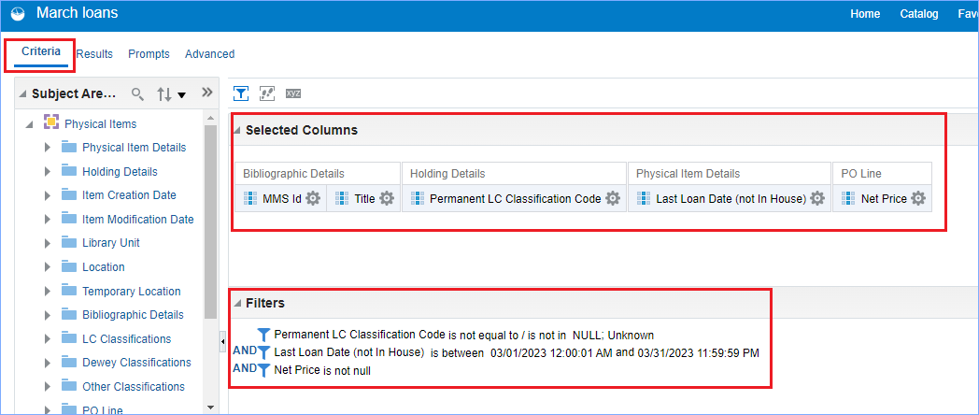
In this example there is a filter on the LC Classification Code not to display “null” or “unknown.” Also, this library doesn’t use LC call numbers, so all the call numbers display as “unknown.”
Remove this filter and column and add a new column for Permanent Call number.

Delete a filter
To delete a filter, hover over the filter, and options to edit, copy, paste, and delete appear. Click the X to delete the filter.

Delete a column
To delete a column, click the settings icon, and select Delete.
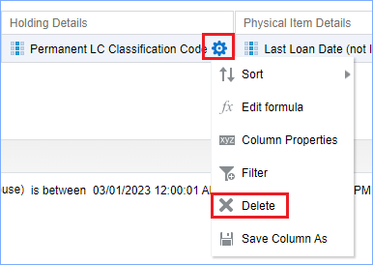

Add Columns
To find columns, you can explore the folders in the subject area on the left side of the screen, or you can use the search.
To search, click the magnifying glass, and start typing in the box below.
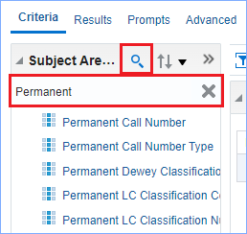
When you find the column, just double-click it to add it to the Selected Columns area.

Arrange the Columns on the Results tab
If your columns are appearing out of order, you can rearrange them on the Results tab. Hover over the column to move, and a tab appears, click, and drag it to the correct position.

Give the Report a Title
Click the pencil icon to edit the top pane of the report and give it a title.
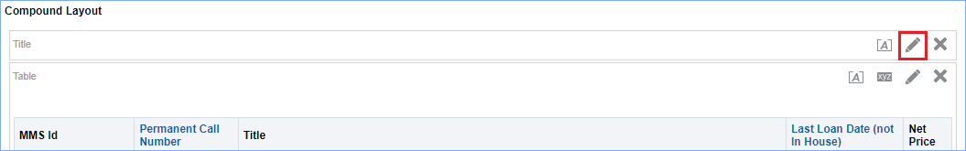
An editing pane appears. Uncheck the “Display Saved Name” box. Enter a title and a subtitle. Click Done.
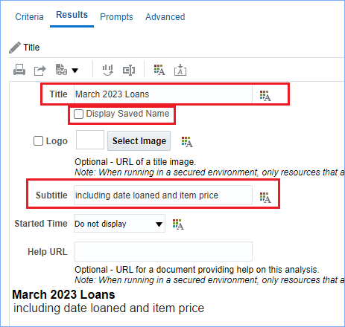
Here is the report with a title:
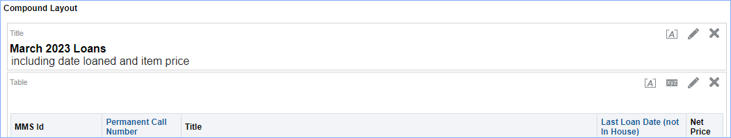

Add a Row Count to the Top of a Report
Click on the Criteria Tab. Add any column to the Selected Columns area. In this example I added the “Accession Number” column.
Click on the settings icon and select “Edit Formula.”
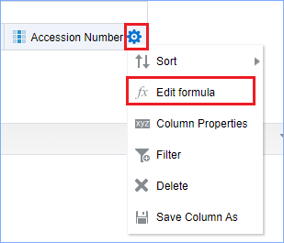
- In the Column Formula box, delete the existing formula, and add: MAX(RCOUNT(1))
- Check the Custom Headings box.
- Add “Row Count” in the folder heading and column heading boxes. This way anyone using the report in the future will know what the column is for.
- Click OK.
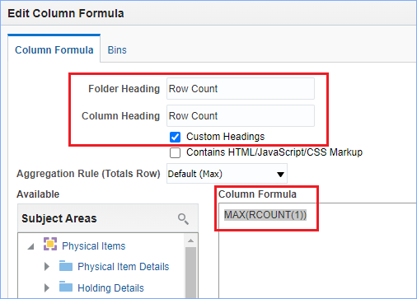
The column now has a yellow ruler icon.

Hide a Column
It isn’t necessary to have this column display in the report, so we will hide the column. Click on the settings icon and select “Column Properties.”
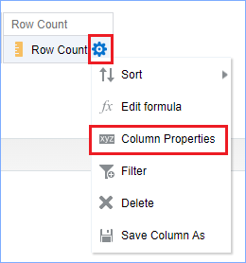
Click on the “Column Format” tab and check the box “Hide.” Click OK.
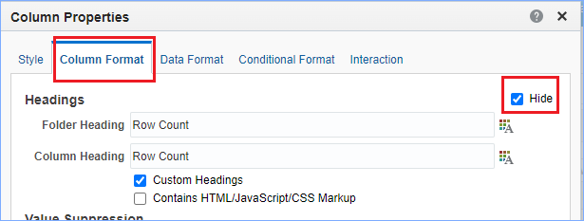
Count how many columns over the “Row Count” column is. Now we return to the Results tab. In this example, Row Count is the sixth column.
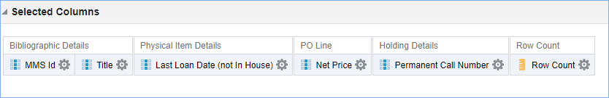
Now, click on the Results tab.
In the lower left side of the screen there is a “Views” area. Click on the graph icon and select “Other Views” then select “Narrative.”
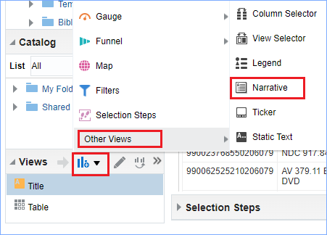
- In the Narrative box enter “@6 Rows” (without quotes.)
- In the Rows to display box enter 1
- Click Done
Note: you can enter any text you like. The “@X” will be the number of rows.
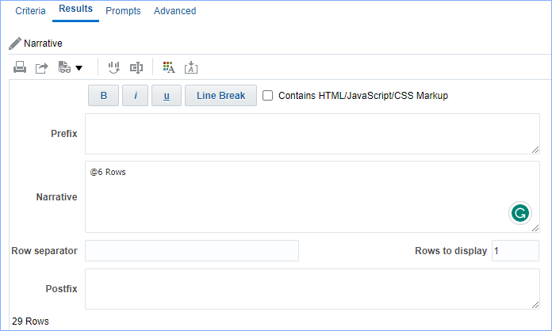
Click and drag the narrative view pane to the desired location in the report.
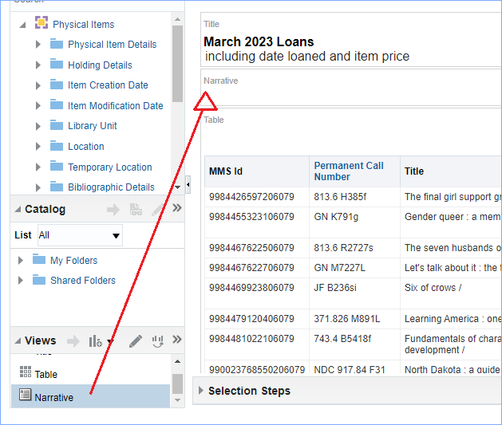
The row count is centered by default. If you would like to have it aligned to the left, click the [A] icon of the Narrative pane, in the drop down for “Horizonal Alignment” select “Left” and click OK.
Now the row count appears in the top left.
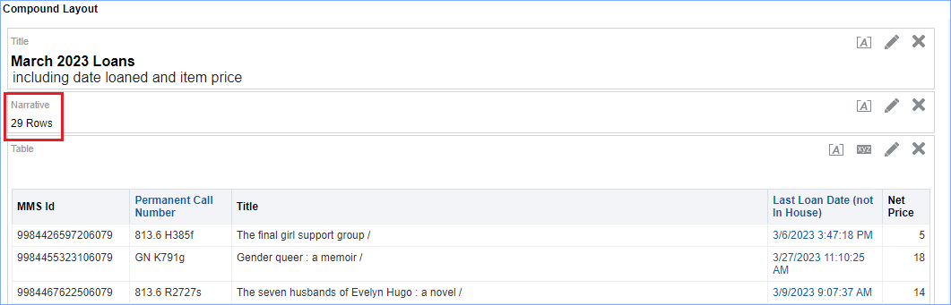

How to Concatenate Fields
In the image of the example report, you can see a column of titles. We are going to concatenate this field with the author field, so both fields appear in the same column.
- Click on the criteria tab.
- Click on the settings icon under the Title column and select “Edit Formula.”
- In the left column of subject areas, find the Bibliographic Details folder, and double click on Author column, then click on the right-arrow to add it to the Column formula box. It will look like this:
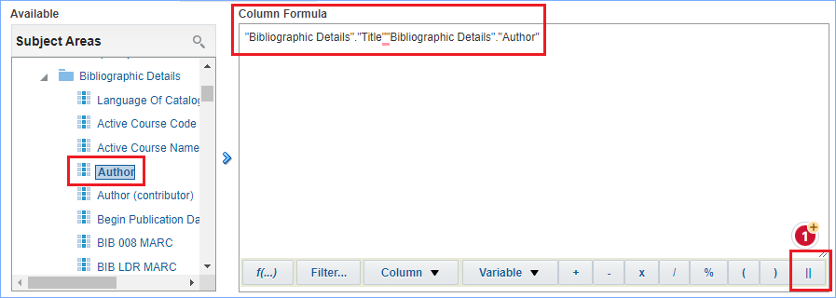
- Next place the cursor between the two sets of quotes between the two fields.
- Click the double pipe button to insert that. Then type a single quotation mark, a space, a single quotation mark, and the double pipe button. It will look like this:
Note: For this example, we are using a space between the two fields, but you can place other characters as well. It just needs to be between the two single quotes.
- Next change the text for the Column name. Check the box for Custom Headings, and change the Column heading to “Title & Author.” Click OK.
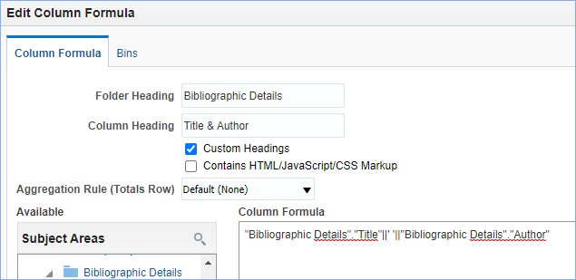
Now the report looks like this:
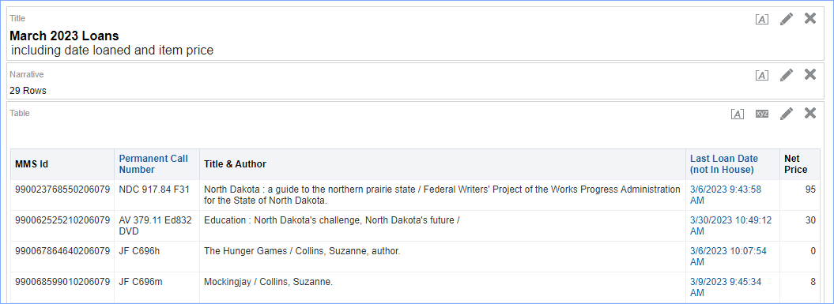

How to change the format of Date/Time and Currency
As you can see in the image above, the Last Loan Date column includes time, and the Net Price column is very basic.

- Click on the Criteria tab.
- Click on the settings icon for the Last Loan Date column and select “Column Properties.”
- Click on the Data Format tab.
- Check the Override Default Data Format box.
- In the Date Format drop-down, choose a format you like, or choose “Custom.”
- If you choose Custom, you can use this format for the date:
MM – month
DD – day
YYYY- year
- Click OK
Here’s an example:
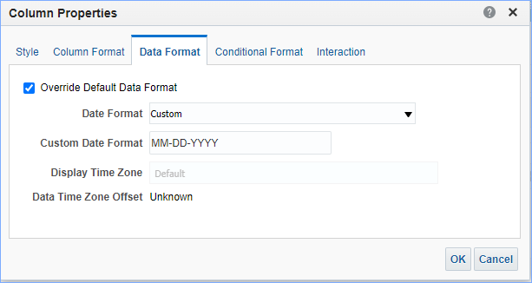
For Currency-
- Click on the settings icon for the Net Price column and select “Column Properties.”
- Click on the Data Format tab.
- Check the Override Default Data Format box.
- From the Treat Numbers As drop-down box select “Currency.”
- In the Currency Symbol box select English – United States.
- Click OK.
Now click the Results tab to view the report. Here it is with the newly formatted data and currency.
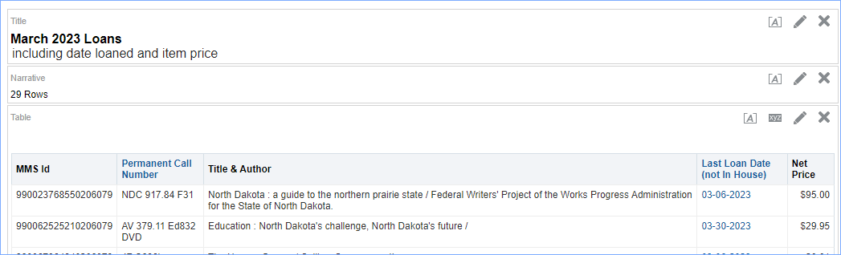

How to Sort a Report by Months
The default sort is alphabetical in this report:
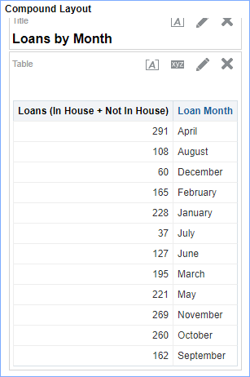
- Click on the Criteria tab.
- Use the search to find the column, “Loan Month Key.” Double-click it to add it to the Selected Columns area.
- Click the settings icon on the Loan Month Key column and select Sort > Sort Ascending. A blue arrow pointing up appears.
- Next, Click the settings icon and select Column Properties. Click on the Column Format tab and click “Hide” to hide the column. Click OK.
- Click on the Results tab to view the report. The report is now sorting in chronological month order.
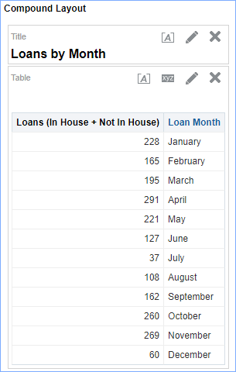

Useful Filters – How to Add a Filter
- To add a filter to a column, click the settings icon and select Filter.
- Use the Operator drop-down to select the action and use the Value drop-down to select the value. Example:
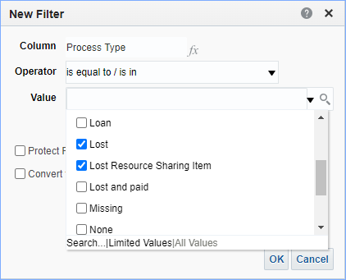
- Lifecycle – to exclude deleted records. Useful in Bibliographic records, physical inventory, and e-Inventory.
- Resource Type – to specify certain resources
- Location Name – to exclude resource sharing requests from results, use not Borrowing/Lending Resource Sharing Requests.
- Process Type – to exclude or include items in certain process statuses.
Tip: If there are too many values for the filter to display, click on “More/Search” in the filter:
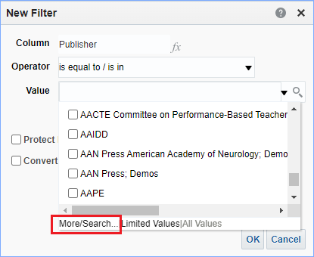
Now you can search for the value you want to filter on.
Then highlight the values and click on the arrows to add to the filter. Click OK.
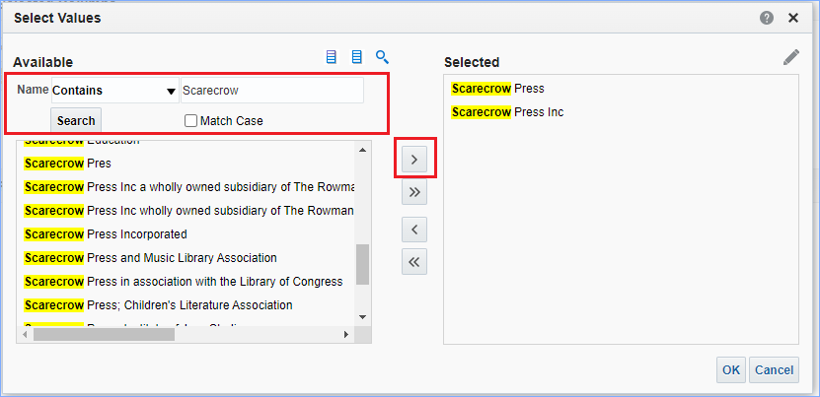

How to Add Grand Totals to a Report
If you have a report with a Count in it, you can total that column.
On the Results tab, click on the Edit icon in the Table pane.
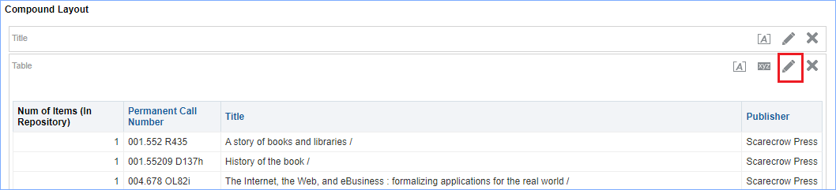
The Layout view appears. Click the Sum icon in the “Columns and Measures” area and select “After.” Click Done.
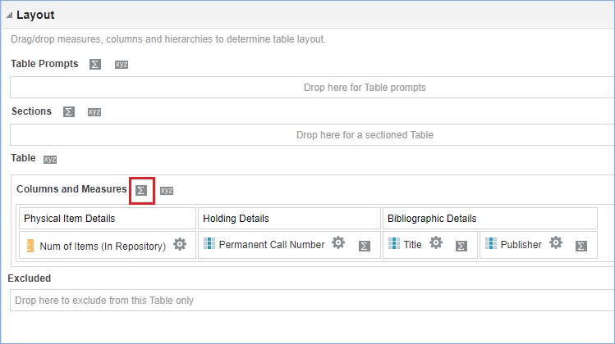
Here is the bottom of the table showing the total:
