May 8, 2023 – Academic Cataloging Group Notes

Comments/Questions?
- NDSU has been contemplating whether to turn on direct linking in Primo. You can activate at the brief record level or the full record level, and there are other customizations you can do like not show the direct link under certain conditions, such as an authentication note that you want the user to see. NDSU is thinking of doing a conservative version of it. UND activated it as well and tried to limit by vendor, but not sure that is working correctly.

Old Topics:
- ODIN Workday recordings are available on the ODIN website: https://www.odin.nodak.edu/about/odin-workdays
New Topics:
- We need a new chair for this group! Please let me know if you’d like to serve.
- Would it be helpful to have ODIN add (Activated by ODIN) to the electronic resources activated in the Network Zone? We noticed that CARLI is doing this:
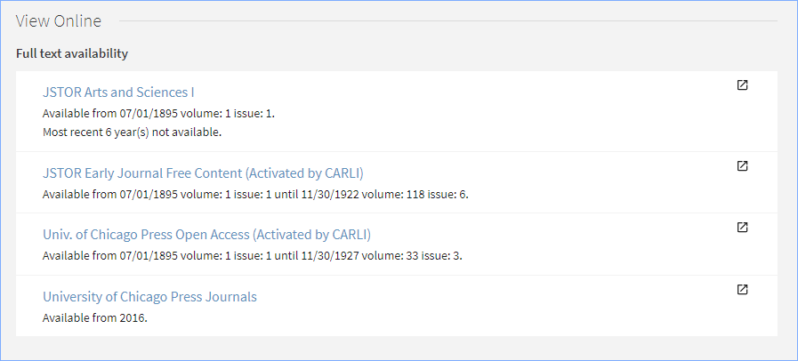
The group discussed this and supported it. Agreed that it must go to the Discovery group next.
- Alma May release:
  - Quick links in the Metadata Editor video: https://www.youtube.com/watch?v=8VwYgrG3ZSY (1:17 minutes)
  - Bibliographic ranking in Metadata Editor and Record View – for more information on how records are ranked: https://knowledge.exlibrisgroup.com/Media_Repository/Alma/Resource_Management/Bibliographic_Rank_Algorithm
  - Not Contains or Not Equals were added to Alma Titles and Inventory search indexes where Contains or Equals currently exist (NERS Enhancement)
  - New and Generic physical items material types – HathiTrust Material, Fascicule, Microphone, Locker, Musical Instrument, as well as 15 generic options to customize to your requirements.
  - Overlap Analysis Job Supports Physical in addition to Electronic Titles video: https://youtu.be/WrJIqzrkWDQ (2:18 minutes)
  - From Primo release notes- Support customization of resource type mapping. This is adding additional conditions to existing resource types, including local marc fields.
Open Discussion:

Next Meeting:
Scheduled for 2nd Monday of each month or as needed.
Monday, June 12, 2-3 pm CT - Submit any agenda items to Liz.Mason@ndus.edu, Tina.Gross@ndus.edu, or to ODIN-ACAD-CAT@listserv.nodak.edu

