ACAD Discovery/PrimoVE User Group Meeting – 05/19/23 via Teams

Discussion Items
- Primo Enhancements – first round completed – now ExL assigning development points – spreadsheet found on ODIN website page -2023 Alma and Primo Enhancement Requests - if second round of voting is necessary, it will take place June 4-18. We may have to move the next meeting to earlier in the week (or June 9th) if discussion is needed. FYI – Alma enhancements are also being assigned development points. The second round of voting is scheduled for June 12-15.
- ODIN WorkDay - April 24-28 – Academic Sessions - any feedback?
- Direct Linking – from brief search results (available since Nov 2018) and/or full records (available since Nov 2022 release (https://knowledge.exlibrisgroup.com/Primo/Release_Notes/002Primo_VE/2022/010Primo_VE_2022_Release_Notes)
NDSU activated yesterday (with restrictions enabled) so may have info to share next time. UND had activated previously but needs configurations. Looking forward to updates from both libraries next meeting.
- Did anyone use the 651 Geographical Name? Seems to only be targeting the government aspect rather than location. A ticket has been submitted and the issue is being investigated.
- ALMA semi-annual reindexing in May – see list (Semi-Annual Re-Indexing section) in: https://knowledge.exlibrisgroup.com/Alma/Release_Notes/2023/Alma_2023_Release_Notes?mon=202305BASE
- Electronic collections activations - Liz bringing from CAT User Group for discussion – Would it be helpful to have ODIN add (Activated by ODIN) to the electronic collections activated in the Network Zone? Suggestions for wording due to Liz by May24th. We noticed that CARLI is doing this: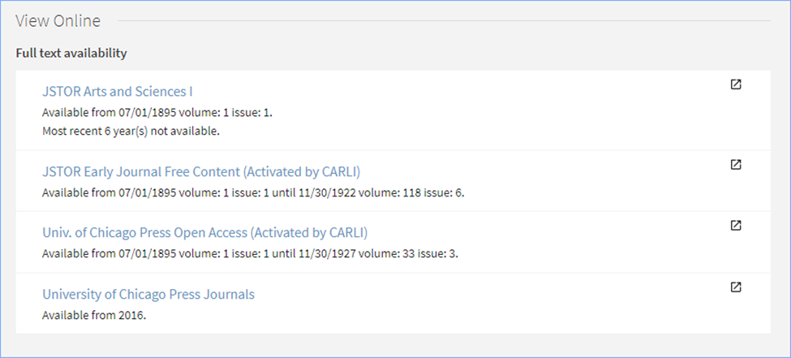
- Discovery Collections – Liz will schedule a work session to walk through and Q&A.

Member Updates:
- Bismarck State College
- Dakota College at Bottineau
- Dickinson State University
- Lake Region State College
- Mayville State University
- Minot State University
- North Dakota State College of Science – Serial delete project; moving books in stacks (Lv.2 & Lv. 3) to Lv. 1; ChatGPT/AI LibGuide; archival photo id
- North Dakota State University
- Trinity Bible College
- University of Jamestown - some small weeding projects this summer but nothing major; going to use LibGuides for online component of physical displays (not Collections)
- University of North Dakota –ND MB ACRL Chapter Symposium was Monday,
- UND – Law
- UND – Med
- Valley City State University
- Williston State College
- ODIN – Director position being worked on and expected to be advertised in late May or early June.

Future Topics:

Next Meeting: 06/16/23 11 AM

Primo links for all colleges can be found: https://www.odin.nodak.edu/academic

