Hello, everyone!

So Abdo did this fun thing where they released some encyclopedias with some saying “for kids” in the title, but they appear to be the same books. They have the same ISBNs as well. We happened to purchase a copy of each for three of the titles. See example below.

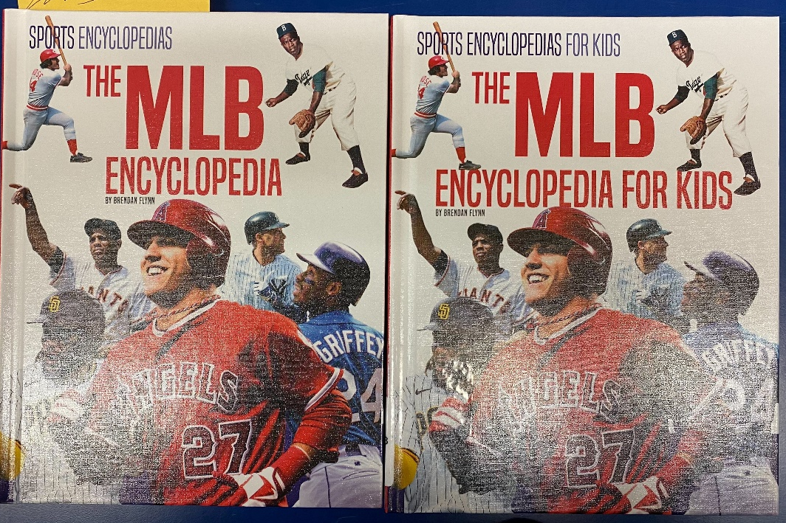

For two of the titles (NFL and MLB) we have two different bib records, but the OCLC numbers are the same on them.

This is ISBN 9781532196928. Each of these has OCLC number 1273915653. The record in OCLC says “The NFL encyclopedia” currently.
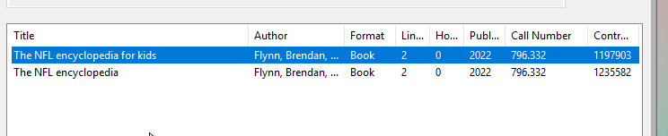

This is ISBN 9781532196904. Each of these has OCLC number 1273912939. The record in OCLC says “The MLB encyclopedia” currently.
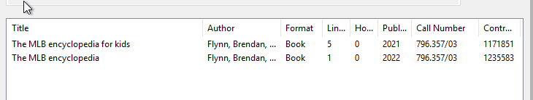

The third title, The NBA Encyclopedia, has 2 different records with 2 different OCLC numbers in our system already. That is ISBN 9781532196911.

The problem with the other two is that there aren’t very good records in OCLC for the ones that say “for kids.” Do we just leave them like we have them in our system already with 2 different bib records with the same OCLC number, or do we do 2 different records with 2 different OCLC numbers? The ISBNs and the content in each title are the same.

