Resource Sharing User Group Meeting Agenda
Wednesday, December 28th, 2022
Chair: Joan Miller
- Updates
- Digital Article File size error 10MB

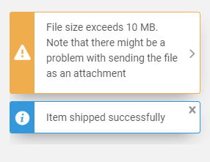

- Alma/OCLC Automated Lending String

- Resource Sharing Directory

- Library Updates

- Resource Sharing User Group meeting schedule moving forward.
- Anything else you would like to discuss or address?
- Next meeting is scheduled for Wednesday, February 22nd at 9am CST

