Search > Browse > Browse by: Subject that begins with Erotic Fiction:

Narrow your search:
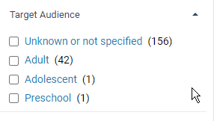

Click on Preschool: the title below is the result
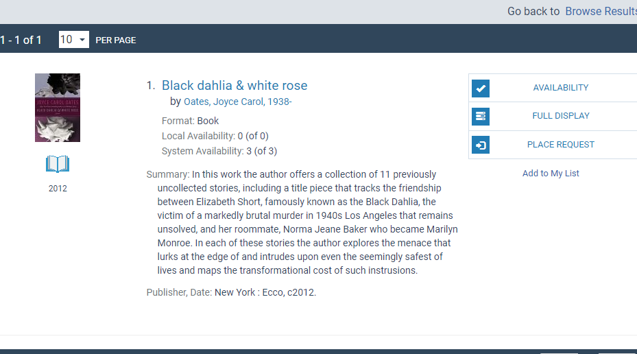

Click on Adolescent: this is the result
