Primo VE November 2022 Features:

Share Export Action
**** This configuration is disabled by default. ****
The Share export action has been added to the Brief Display, Full Display, and My Favorites pages to allow users to share
records with other users using social media applications.
After selecting the Share action, users can share the permalink using the following social media applications: WhatsApp,
Facebook, Twitter, and LinkedIn. In addition, users can save record's permalink to the clipboard by selecting Copy.

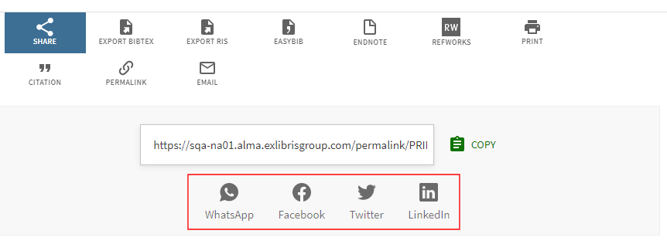

Give Us Feedback Improvements
The following enhancements have been added to the Report a Problem tool:
1. Support the configuration of whether the following fields are mandatory or optional on the Give Us Feedback form:
email address and description.

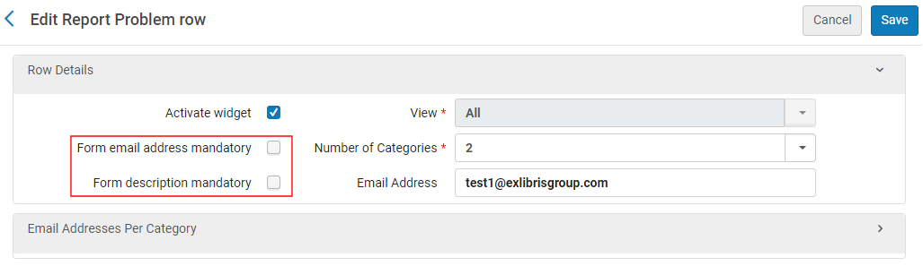

2. Support the configuration of feedback managers per category. If an email address is not specified at the category
level, ensure that a default email address is configured in the Row Details section.
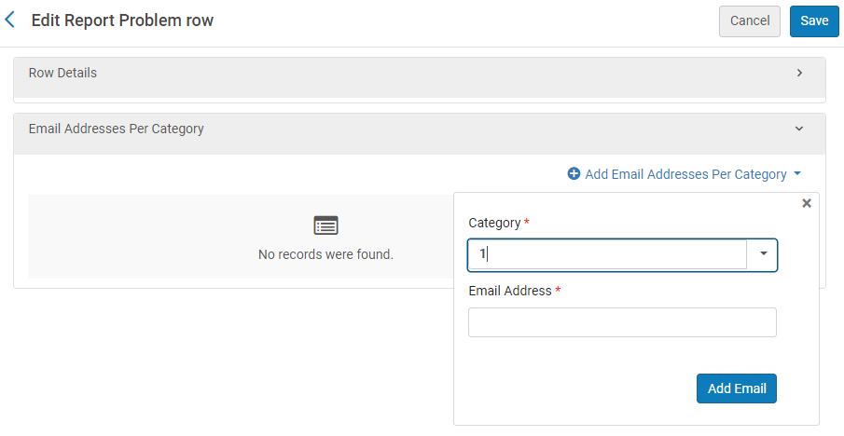

3. In your customization package, support the customization of the Feedback icon and Send button, and in addition,
support the ability to add links to the Give Us Feedback dialog box via directives.
For more details, see Configuring the Feedback Tool for Primo VE.

Provide Warning Message when Guests Add to Favorites (Idea Exchange)
**** This enhancement is disabled by default
Guest users will now receive a message when adding records to favorites to let them know that these records are
temporary and last during the session only. By signing in, users can save the favorites between sessions. For mobile devices, the message appears at the bottom of the page.
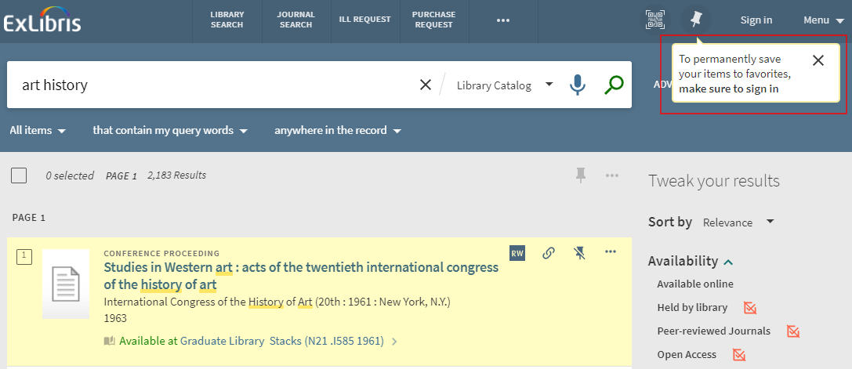

Provide Direct Linking from Full Record
**** This functionality is disabled by default.
As with the availability link in the brief results, users can now go directly to full text from the full record instead of being
taken to the View Online section to choose from the listed providers. When this functionality is enabled, users are typically taken directly to the full text of the first entry in View Online section.
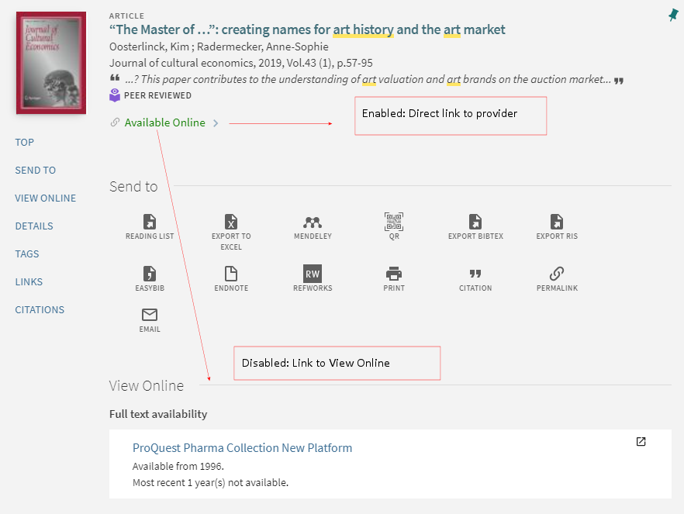

Allow Configuration of CDI Linking Preferences
You can now set the preferred order of links to the electronic full text in CDI (Link in Record and Quicklinks) if more than
one link is available. Prior to this release, this configuration option was available only for links using the link resolver. Note that this setting is separate from the link resolver settings because preferences are configured at the collection level for the link resolver, while they are configured at the platform level for CDI. The new CDI linking preference options are configured on the Central Index and proxy set-up page (see Configuring Central Index and Proxy Settings for Primo VE) and apply to single link display (Link in Record links and Quicklinks) as well as multiple links display (see Display All Links setting). If no preference is set, the default provider preference is alphabetical by provider.

For recording of the What’s New with Primo – October 2022: https://www.youtube.com/watch?v=0Vdr-n11T0Y

Additional Enhancements
Allow all publication dates to be indexed – All publication dates are now indexed from MARC fields 264 $c and 264
$c for simple search, but they cannot be searched or sorted as publication dates and do not have facets.

**** This change will go into effect when the Primo VE semi-annual indexing is completed in January

Display Volume, Issue, and Pages in Citations – For local records, host enumerations (volume, issue, and pages)
that are included in the MARC 773 $g subfield are now included in the respective PNX fields (addata/volume, addata/
issue, addata/spage and addata/epage) and displayed in citations via export actions. Note that this functionality is
already supported for CDI records.

To support this functionality, the MARC 773 $g subfield must be formatted as follows for local records:
◦ Extract Year, Volume, Issue information to include in the PNX addata/date, addata/volume, and addata/issue fields
◦ Extract page information (start/end pages and total number of pages) to include in the PNX addata/spage, addata/
epage, addata/tpages fields

**** This change will go into effect when the semi-annual indexing of the Repository is completed in December

Upgrade to Angular 1.8 in Primo/Primo VE – This upgrade may impact your Angular customizations in Primo and
Primo VE and may require you to adjust the customizations accordingly prior to the upgrade to ensure a smooth
migration to Angular 1.8. In advance of this release, please carefully review the following document to ensure that your
Angular customizations are ready for the Angular update:
Preparing for the Upgrade to Angular 1.8 in Primo/Primo VE

Resolved Issues
• SF: 6460607 - Public note direction was displayed incorrectly. This has been fixed.
• SF: 6449210 - When no URL was defined, the Resource Recommender banner was clickable. This has been fixed.
• SF: 5328398 - For mobile devices, the 'Sent to' menu was covered by the search menu. This has been fixed.
• SF: 6408813 - The Report a problem widget could not be customized. For more details, see Give Us Feedback Improvements. This has been fixed.
• SF: 6316942 - The Collection name was truncated in the "More from same collection" section. This has been fixed.
• SF: 6342301 - For mobile devices, the container for Advanced Search was not fully flexible. This has been fixed.
• SF: 6333795 - For mobile devices, the Advanced search UI placeholder was broken. This has been fixed.
• SF: 5329810 - An incorrect aria label displayed for next page arrow (link) in the pagination region. This has been fixed.
• SF: 6460514 - Different behavior between exclude and select > exclude > apply. This has been fixed.
• SF: 6441153 - searchInFulltextUserSelection did not work in the Primo VE Search API. This has been fixed.
• SF: 6436395, 6445352, 6490544 - Thumbnails for external records could be either from Google/Syndetics or customer's own but not both. This has been fixed.
• SF: 6295123 - Bound with label was not displayed in Location items, only in Location. This has been fixed.
• SF: 6321739 - Service page did not return network portfolios, which was affecting IP recognition. This has been fixed.
• SF: 6395426 - Resource Configuration was not importing URL from Excel sheet. This has been fixed.
• SF: 6246649 - Expired users were able to log on to Primo VE via LDAP. This has been fixed.
• SF: 5323802, 6239509 - Item level Public Note not compatible with HTML script. This has been fixed.
• SF: 5324912, 5326481 - In View Online links to CREDO records were broken. This has been fixed.
• SF: 5322384, 6233124 - The display_856_in_the_holdings_as_viewit parameter worked only if the record was part of a collection. This has been fixed.
• SF: 5307382, 6222054, 6408403, 6425708 - The permalinks redirect failed when using MMS ID instead of IE ID. This has been fixed.

