September 22 -- PKS Cataloging Group Meeting Notes

Agenda:

New items:
- What is new in your library? Questions?
  - Dickinson Public Library – Rita is retiring in December, the deadline for applications is October 19th.
  - Grand Forks Public Library – business as usual, Lori was having problems with the large type, but they are working on it. They had grand opening of the new musical park. Unfortunately, had cold rainy weather for it.
  - North Dakota State Library – have new staff, a new public library specialist and in a couple weeks they will have a new materials coordinator.
- Upgrade to Polaris 7.3 to be installed on training server Oct. 11. There is a What’s New in Polaris 7.3 webinar on October 5th at 1pm. Register at https://www.iii.com/event/webinar-whats-new-in-polaris-7-3/ Also, view the product board: https://portal.productboard.com/iii/6-innovative-product-status-board-new/tabs/23-polaris The main things for cataloging is additional duplicate detection options have been added to Leap.
- New libraries update: Elgin Public Library – bib records are in Polaris and they are in the process of barcoding. Kidder County and Maddock Community – there is a contractor doing their cataloging and record are coming into Polaris for them.
- Holdings statements- Stacey noticed holdings statements that appear to be misleading.
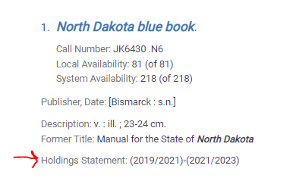
- Update: the holdings statement is created by a job each night, so you won’t see it update immediately when adding issues. It creates the holdings statement based upon the first retained issue and ends with the latest, and it does not reflect gaps in coverage.
- Tested on training: Created a check in pattern for first issue, created predicted issue for 1942, and checked it in.
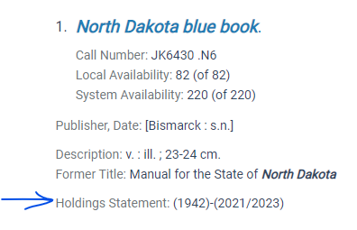
- Stacey would like to know if the holdings statement can be suppressed (field 999). Liz will investigate it. Another concern is whether it would need to be suppress for everyone or just the State Library.
- ZMARC Authorities files were delayed for about a month. We got word that, “LC updated their firewall to allow our ZMARC server to communicate with it and download MARC Authority update files.” On September 19 we received a large file of backlogged files and loaded them into Polaris.
- ISBN merging issue- on Friday 9/16 I had received a ticket about imported records having multiple items and missing bibs, and it turned out that the bibs had erroneous ISBN numbers in them, so they were matching and putting their items all on one record and rejecting the incoming record. It appeared to only be happening with Large Print records from Baker and Taylor.
- Bobbi- Came across something perplexing- when she catalogs DVDs she looks up the on-order record. She tries to find them by title, but she can’t. She must search by control number. She only has this problem with DVDs. The title is in the on-order record, but it isn’t searchable. Liz asked Bobbi to put in a ticket and include an example.

Next Meeting: November 17, 2022
Scheduled for 4th Thursday alternating months or as needed
Please send any agenda items to Liz.Mason@ndus.edu (or to this list).

