Assigning an item to a temporary location

Go to the Scan In Items menu -> Fulfillment > Resource Requests > Scan In Items
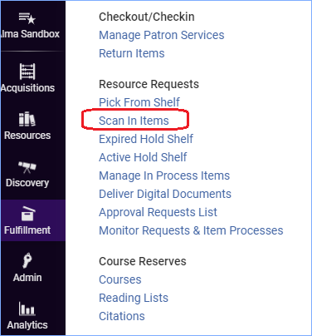

- Change to the tab “Change Item Information”
- Make sure the Change type is “Temporary”
- Enter the Location
- Due Back – This field is optional. There is a job that runs each night that will identify items that are due to be returned to their permanent location.
- Scan in the Item barcode and click OK
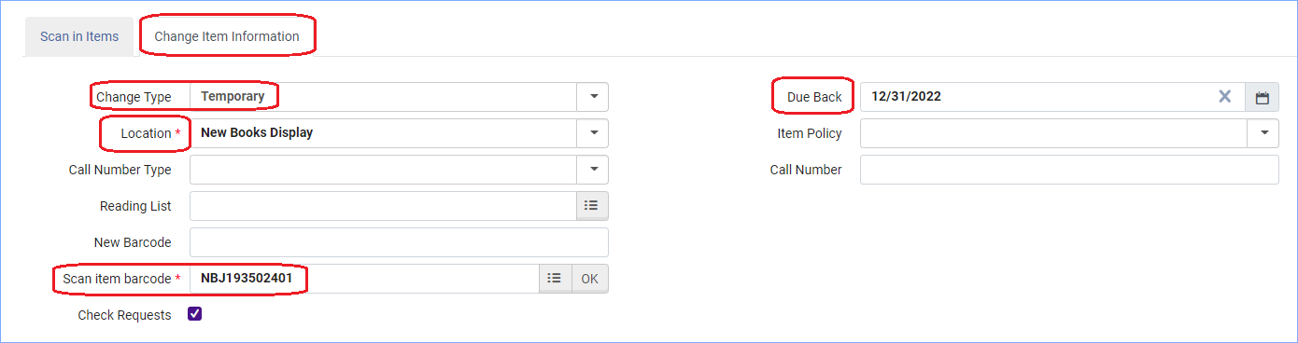
Now in Primo the item shows in the new location:
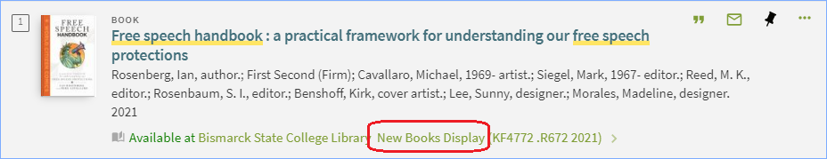

If you use the Due Back field, you will want to check the report that runs each night that indicates when items are to be returned to their permanent location.
Go to Fulfillment > Advanced Tools > View Restore Request Jobs
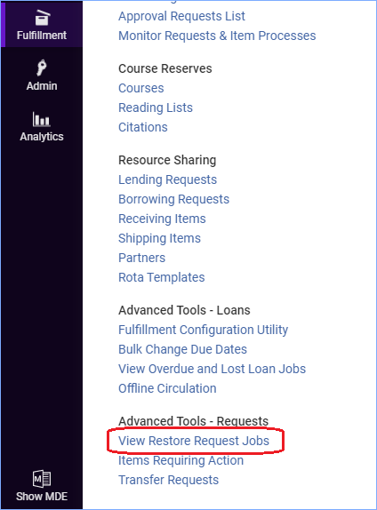

Returning an Item back to its Permanent Location

Go to the Scan In Items menu -> Fulfillment > Resource Requests > Scan In Items
- Change to the tab “Change Item Information”
- Select Change Type: “Restore”
- Scan the barcode into the Scan item barcode box and click OK.
