ACAD Discovery/PrimoVE User Group Meeting - 09/16/22 via Teams

Member Updates:
- Bismarck State College – building collections on tech, education, LGBTQA+, and other topics; busy with instructional sessions; building digital escape rooms; waiting on chat approval for campus
  - QR codes 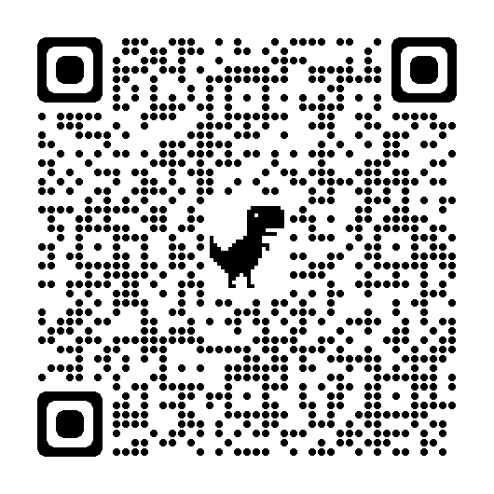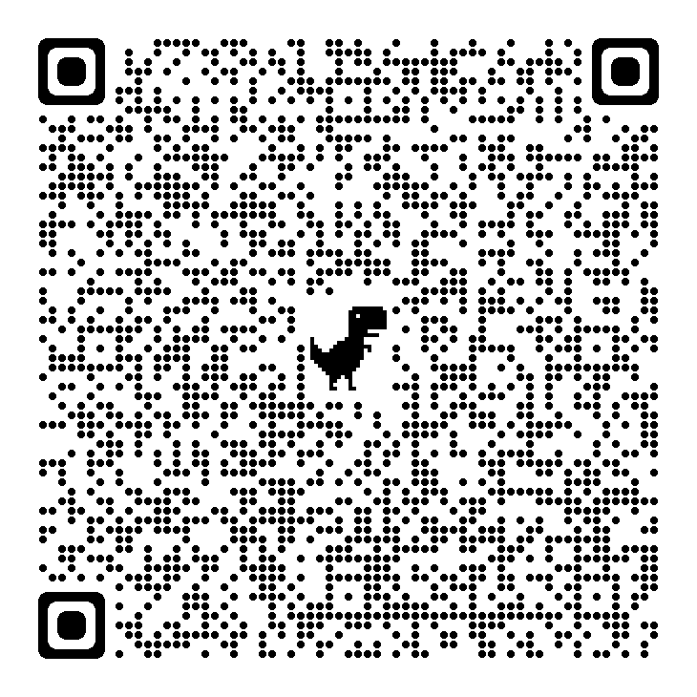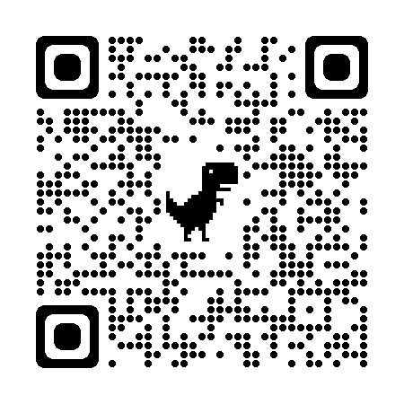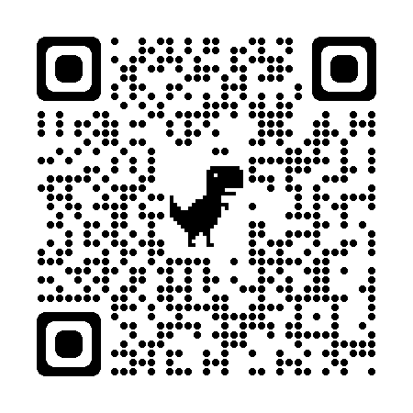
- Dickinson State University – Monica is gone! My last day at DSU was 9/9/22. You can find me working remotely at the State Library.
- North Dakota State College of Science – Final stages of weeding project (to be completed by Dec. 2022), using Collection Discovery & Resource Recommender to promote: HUM 211 course/2023 NDSCS trip to Japan & related library resources (online & physical)
- North Dakota State University – Engineering Librarian, Steve Jeffery, moved to Nebraska. We will also be implementing Meescan soon, looking to have it installed by the end of fall semester.
- University of Jamestown – creating video tutorials with the new website, lots of teaching
- University of North Dakota – CFL
- ODIN
  - Best wishes to Ellen as she retired 9/2/22. Linda is the ODIN Director and Nicole is the Assistant Director/Training Specialist. ODIN is in the process of filling Nicole’s previous position.
  - ODIN will have booth at NDLA – stop by and say hi!

Discussion Items
- With Monica’s departure the Chair position is now open. If you are interested, please contact Lynn by October 1st. Would like to fill or have a vote by the October meeting.

Future Topics:
- ** Student Portal UND implementation / Blackboard NDUS upgrade, library impact or sharing?
- Personalizing results functionality
- PDFs and accessibility issues per vendor

Next Meeting: 10/21/22 11 AM

Primo links for all colleges can be found: https://www.odin.nodak.edu/academic

