Order Templates

PO Line (POL) templates are a saved set of pre-configured POL information. POL templates save time and ensure POLs are created consistently and accurately at an institution. POL templates can be created, modified, and deleted. They can be saved as public or private.

One of the required roles is required to create a POL template

- Purchasing Operator
- Purchasing Manager

Creating a POL Template

To create a POL Template
- Select a bib record from the NZ or CZ with the desired format and purchase type.
- Click on More actions and click on Order

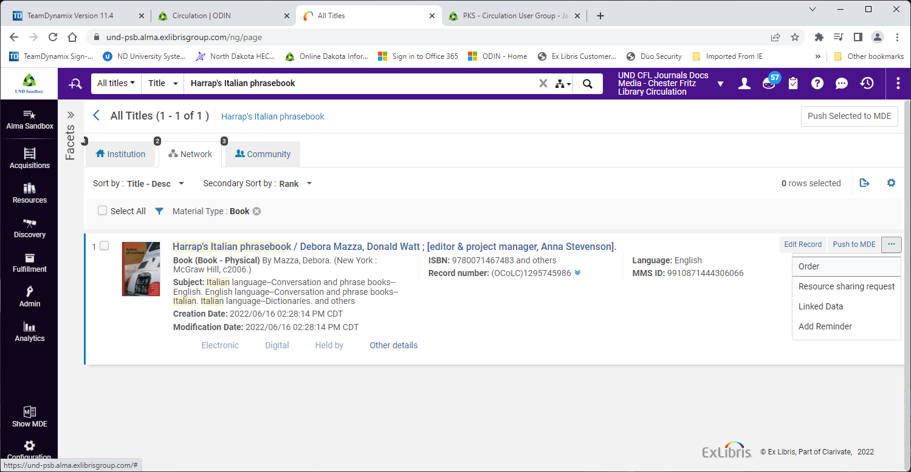

- Select the appropriate PO Line Type
- Select the PO Line Owner
- In this example the Generate barcode using sequence has been activated.
- Leave all other fields and check boxes empty and unchecked
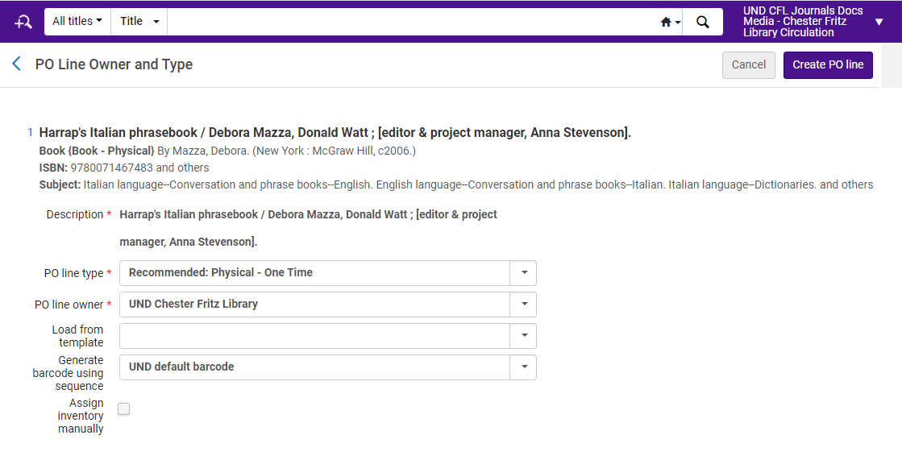

- Click Create PO Line
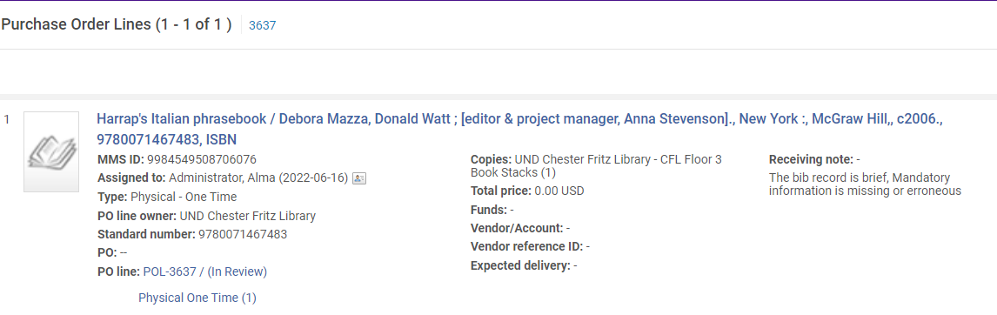

On the PO line details page: Populate all the appropriate fields:
- Library and location – Use default or change to the proper library/location
- Material Supplier – Mandatory
- List Price – Add list price or 0.00 if there in no list price for Gifts
- Quantity for pricing – Default is 1
- Fund – Select the Funds if the Institution uses Full Acquisitions
- Acquisitions method – Select the correct acquisitions method:
  - Purchase at Vendor System
  - Technical
  - Gift
  - Depository
- Material Type – Select the correct material type
- Reporting Codes – Populate the reporting code(s) if they are used at the Institution
- Mandatory or Manual Renewal – Will only display for the PO Line Types for Subscriptions
- Subscription dates

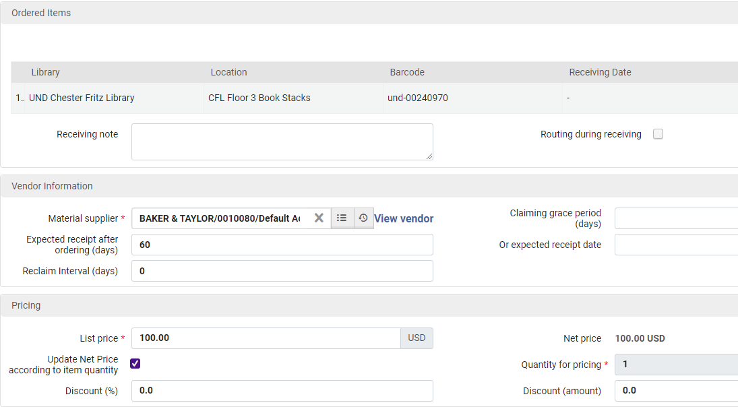
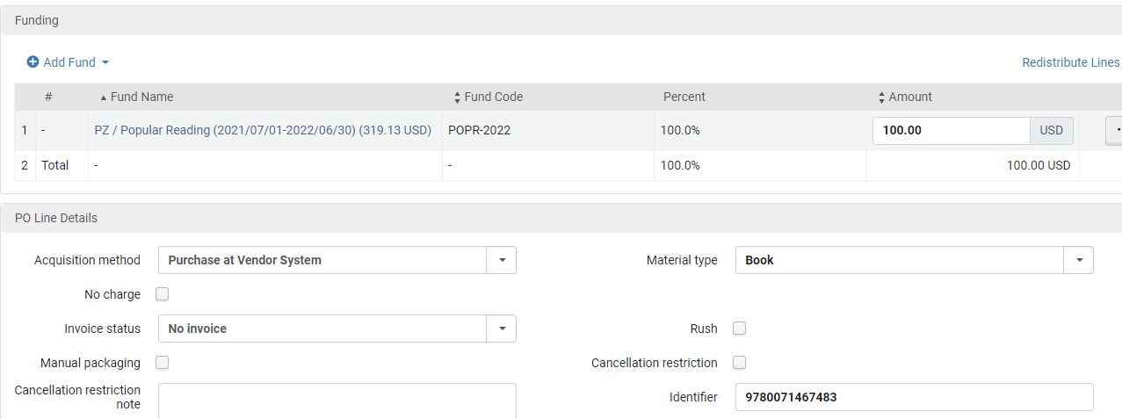

Once you have everything entered as needed Click Save as Template
Enter the Template Name and select if the Template is Public or Private and then click Save
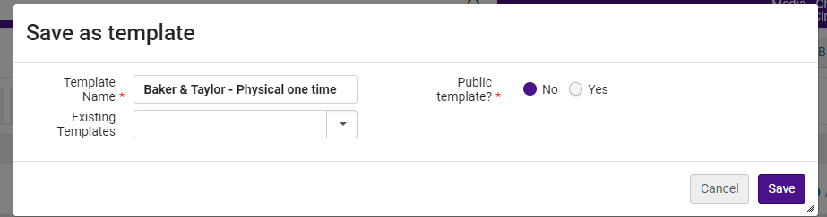
Click on Order Now to complete the order (POL)

