ACAD Discovery/PrimoVE User Group Meeting - 07/15/22 via Teams

Member Updates:
- Bismarck State College – weeded reference section, move Children’s and Oversized collections, busy creating collections and reworking instructional materials, library was “hit by COVID” so staffing affected
- Dickinson State University: Lots of unknowns that are making preparing for the fall interesting. We are still without a VPAA/Provost (really hoping for someone who is supportive of the library and is willing to let us do what we can to make our schedule workable with two people.) Otherwise, Jeanette and I are getting our new laptops ready to circulate in the fall and sending our old laptops off to IT for retirement.
- Mayville State University – hosted discussion on Student Loan Forgiveness, OverDrive consortia meetings – will try to gauge interest and figure out next steps
- Minot State University – no update at this time
- North Dakota State College of Science: Library staff continue to work on deselection project. We will use the new resource recommender “Display Always” option in Primo VE when available in (August). Added NDSCS’s QID (from Wikidata) to NDSCS’s OER and NDSCS Author Collection item records. (Not beneficial to online discovery yet – work in progress.)
- North Dakota State University – no updates at this time
- University of Jamestown – Not too much new, still weeding reference, still waiting on our new campus-wide website
- University of North Dakota – CFL – Working on making catalog mobile-friendly, working with Primo Studio to update color scheme, Browse Author search to display by title is working now, moving and weeding reference materials to complete before classes start
- ODIN:
  - Linda Allbee to become new Director of ODIN when Ellen retires – September 3, 2022
  - ELUNA (Ex Libris Users of North America) 2022 presentations can be found at the Knowledge Center at this address: https://knowledge.exlibrisgroup.com/Cross-Product/Conferences_and_Seminars/ELUNA/027ELUNA_2022
  - Primo NERS (New Enhancements Request System) enhancement voting was due at end of June – Linda distributed the list of successful requests on 7/5/22. Alma and Primo lists can be found: https://www.odin.nodak.edu/academic/ners2022
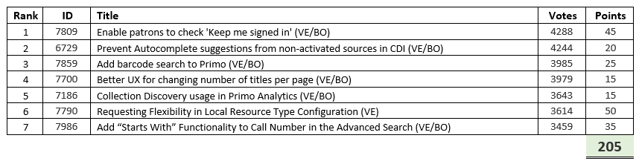
  - The next feature release will be the August release (sandbox 7/24 and production 8/7)
Check out August 2022 Alma Release Sneak Preview on Ex Libris Knowledge Center.
  - More vendors are supporting QuickLinks. Is anyone using them? Link is:
https://knowledge.exlibrisgroup.com/Primo/Content_Corner/Central_Discovery_Index/Rel ease_Notes/001_2022_CDI_Release_Notes
  - Angular 1.8 coming up in November -- make sure you check to make sure it will transition successfully.

Discussion Items
- OER (Open Educational Resource) / Institutional Repository Discussion – UND (Zeineb)
  - https://commons.und.edu/oers/
  - If interested in a shared ECOR group, contact Kelly Kornkven - Mayville
  - NDSU has empty OER collection in their repository - will be willing to host content from anyone in the state. Contact Amy Reese - NDSU https://library.ndsu.edu/ir/handle/10365/31475
  - UND will have open position for OER advertised soon.
  - NDSCS (Trish Dubosky’s) OER Guide
https://researchguides.ndscs.edu/c.php?g=640773&p=4487454
  - UND’s is being used as a preservation tool
  - Other resource links:
    - https://www.oercommons.org
    - https://libretexts.org/

Future Topics:
- ** Student Portal UND implementation / Blackboard NDUS upgrade, library impact or sharing?
- Personalizing results functionality
- PDFs and accessibility issues per vendor
- How to locate resources – when through Primo and when through the databases? Monica DSU

Next Meeting: August 19, 2022, 11 AM

Primo links for all colleges can be found: https://www.odin.nodak.edu/academic

