**May 19, 2022 -- PKS Cataloging Group Meeting Notes**

**Agenda**:

New items:

* What is new in your library? Questions?
  + Cindy, Dickinson Public- they are doing some rearranging of the library
  + Bobby, Grand Forks Public – Lori has fractured her elbow, so she is off right now. They are gearing up for summer reading program, otherwise business as usual.
  + Stacey at the State Library – they have some new staff that have already started, and some others who are starting June 1st.
  + Dustin, West Fargo – have a new director starting on June 13th.
  + Liz, ODIN – contacting libraries that have empty collections and removing them if they are not using them.
* When is it okay to override the bib records that Grand Forks and West Fargo use when their books are in process?

Examples are:

Bib CN 1179250. Note the 035 line. Should that be overridden with the full bib with the OCLC number? Or leave it since they would need to set their OCLC holdings?

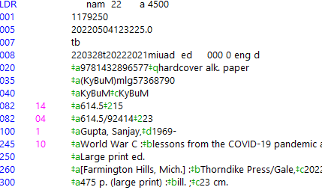

Bib CN 1145257.  This is a short record but has an item attached that says it’s available and circulating. Override it?

Discussion: Bobby explained that she overlays the full record over the short record. She has noticed that others will attach an item to their on-order records even when it is brief. She overlays the full record on it because that was what she was going to do anyway. It doesn’t matter if another library overlays the record first. We all work for each other in a way, by creating fuller records. What Cindy was worried about was that she encountered very few that already had a circulating item on it, so she didn’t know if your OCLC holdings would get set, or if some part of the process would get overlooked. Bobby says she doesn’t mind the records getting overlaid, and Cindy doesn’t mind if Bobby does the same thing. Dustin says overlaying is fine with him as long as items do not get deleted.

* Changing the OCLC numbers of items that were migrated (Bobby’s email from April 4 to PKS-CAT listserv) She is coming across more of these, and she just fixes them. At Grand Forks they put the OCLC number on everything, and when it changes it creates a kink in the chain of what they do. She finds they the record they were merged into were bad records, she pulls in the original record that they had from OCLC which was a good one.

**Next** **Meeting: July 28, 2022**

Scheduled for 4th Thursday alternating months or as needed

Please send any agenda items to [Liz.Mason@ndus.edu](mailto:Liz.Mason@ndus.edu) (or to this list).

Connection information - session will be recorded.

To join click on the following link:

<https://us.bbcollab.com/guest/e1541cbb3ee34da8a29b5fc3d993fa8e>

Session dial-in:

Call in anonymously. Attendees using this PIN appear as anonymous callers in the session.

• Dial-in: 571-392-7650

• PIN: 8825858795