Overview of the Item record in LEAP
In this presentation we will cover all the aspects of the item record, including the settings that control circulation, holds, and blocks. All the settings that appear in the LEAP interface are also available in the client.
The top header part of the item record displays details about the item record- Title, author, barcode, collection, owning and assigned branch, record status and circulation status. This section of the display stays the same when you click on the tabs below to display different areas of the item record below.
By clicking on the “i” you can see the item record id which is a control field, the barcode, and the date the item record was created and modified.
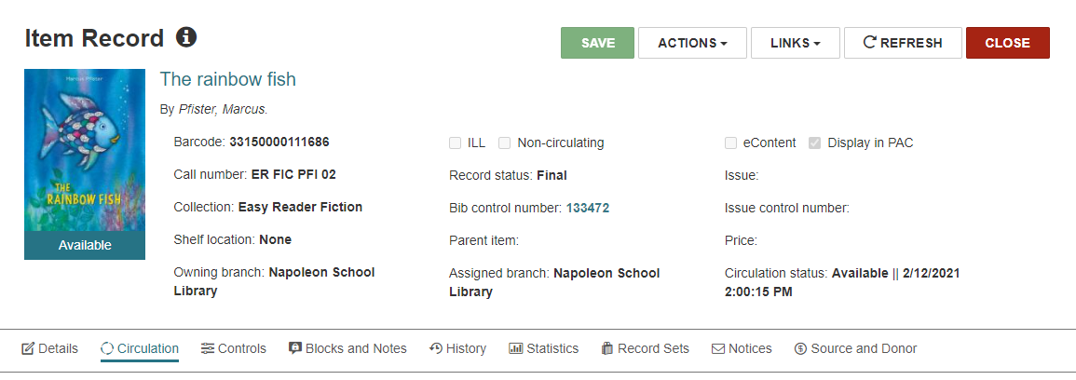
The Actions menu contains the following options:
- Check in
- Place hold
- Copy
- Delete
- Add to a new or existing record set
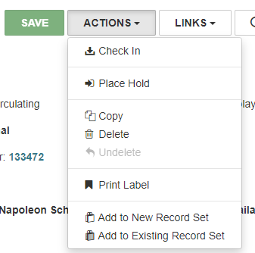
The Links menu provides a link to the holds queue for this item.
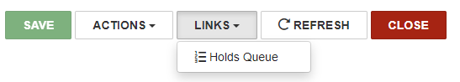
If you used the Find Tool to find this item, there will also be a link to the search results with a “Results” button.
The Details View – If you have permission to modify item records you can change information in the details view that will change the item record’s header information.
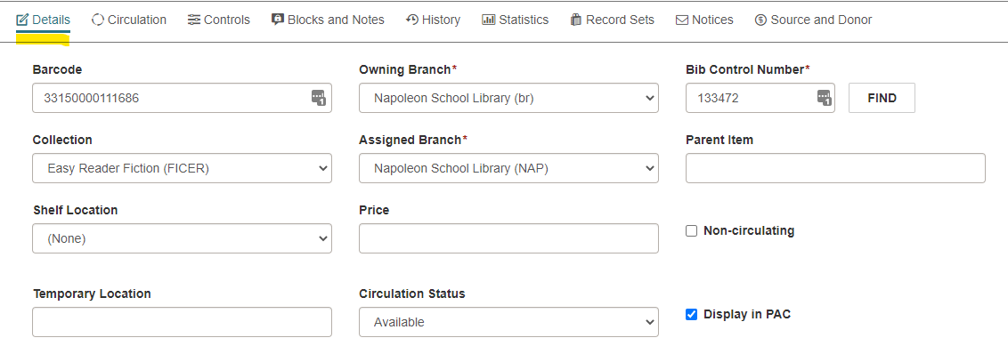
- The owning branch indicates which library owns the item and therefore staff with permission from that owning branch are the only ones who can modify the item.
- Circulation status- The circulation statuses help staff to understand what is happening with the item record- whether it is lost or missing, or in-process.
  - Also, the circulation status will affect whether the item appears in the PAC or not.
  - The circulation status is reflected in a banner on the cover image.
  - Circulation status Lost is slightly different. An item that is overdue a certain number of days has a status changed to Lost and the patron is billed. Staff may also declare an item lost, and that is done from the items attached to a patron record not from the item record.
The Circulation View - here you will find information about the item’s most recent circulation transaction.
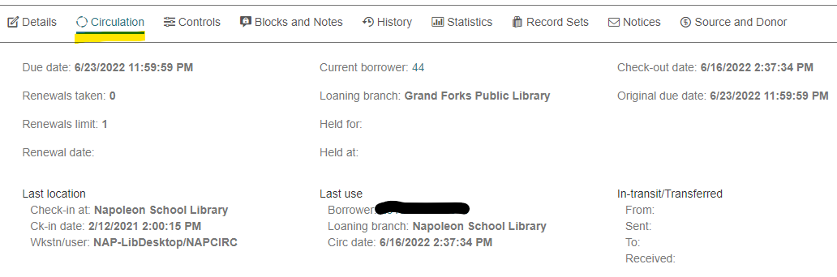
Controls View – many settings for the item appear in the controls view.
- In the top box you will find settings that control circulation- Material type in combination with patron type determine loan limits such as the number of items a patron can have out. Loan period, fine code and renewal limit are self-explanatory. Home branch should be the same as “Owning branch” and we disregard the “Do not float” check box in our consortium.
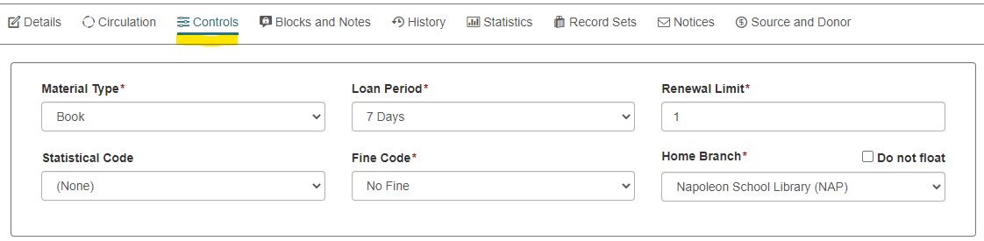
- The middle box down contains the call number information for the item, including volume and copy information.
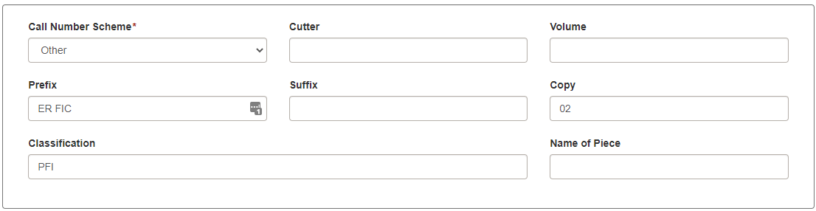
- The last box contains hold information:
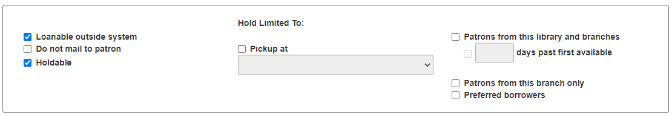
  - Click Loanable outside system if you want to lend this item on interlibrary loan
  - If the check box, Do not mail to patron is checked, the item cannot be mailed to a patron.
  - Select Holdable if you want to allow holds to be placed on the item.
    - Pickup at: limits the item to filling hold requests only by patrons from specified branch. Only one branch can be selected.
    - Patrons from this library and branches- when you select this option, you can also select the number of days past available. This sets the number of days a new item is available only to the assigned library’s patrons. During the specified number of days patrons from all libraries can still find the item and place a hold. After the specified number of days, holds on the new item placed by patrons from other libraries can be filled.
    - Patrons from this branch only – Limit the item to filling hold requests only from patrons registered at the item’s assigned branch.
    - Preferred borrowers – Limit the item to filling hold requests only where the pick-up library is on the preferred lender list of the item’s assigned branch. This option is not used by the ODIN consortium.

Blocks and Notes View – displays blocks and notes associated with the item
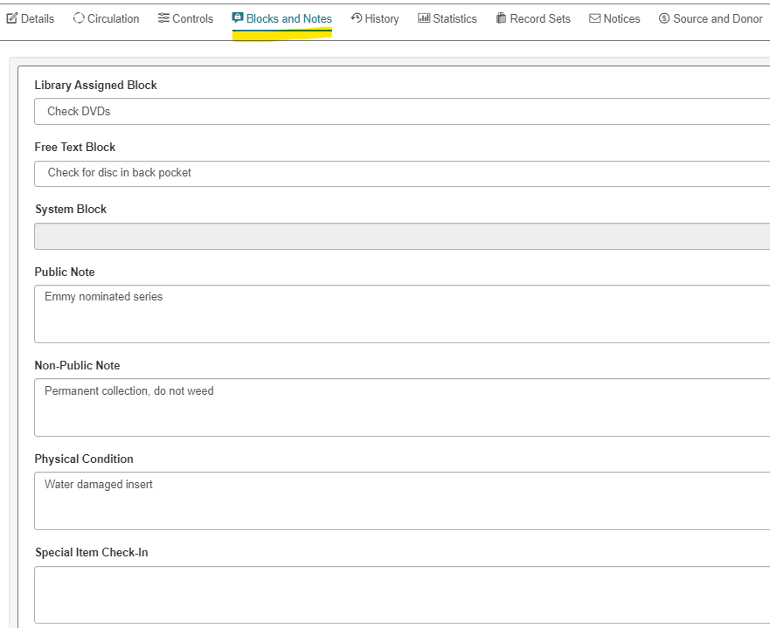
- Library assigned block – these are pre-defined blocks. They appear when the item is checked in. The blocks do not change the circulation status of the item.
- Free Text block – This block is free-text up to 255 characters. It also appears when the item is checked in and does not change the circulation status of the item.
- System Block – system generated blocks are applied and removed automatically by Polaris. Examples are: “Item has missing parts” “Item was created by interlibrary loan” and “Item was created on the fly”
- Public Note – The notes will be displayed in the PAC for this
- Non-public note – The notes are intended for library staff only
- Physical condition Note – The notes describe the physical condition of the item
- Special Item Check-In – When a patron returns an item with a missing part
  - Use the Missing parts tab on the check-in screen, you can do this during check-in or after check-in
  - Click Missing Part, scan in the barcode, add a note “Missing Disc 3” (the option Make item unavailable, just changes the circulation status of the item to unavailable)
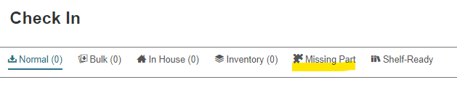
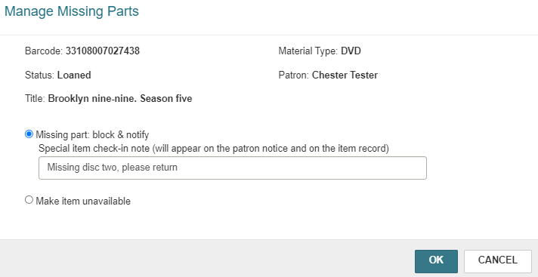
  - If item is never returned, you can bill for the item from the patron record.
  - When the item is returned: Scan the item at check in, a pop up appears letting us know that it has an “Item has missing parts block.”
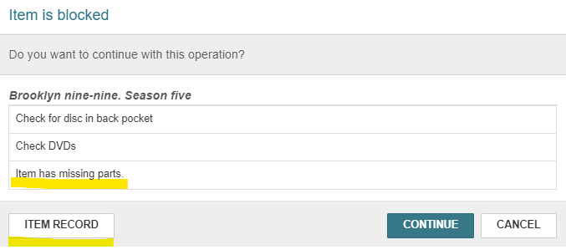
  - Click on the Item Record button, view the blocks and notes tab
  - Delete the Special Item Check-In note and save the item record
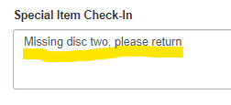
  - Close the item record, and it returns you to the check-in box
  - Click continue. The block and the note are removed from the item record, and the block is removed from the patron record.
History View – displays the item history – circulation status changes and transactions
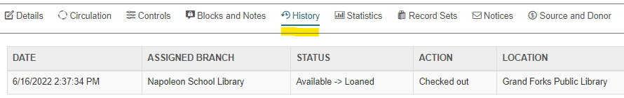
Statistics View – Circulation statistics appear in this view
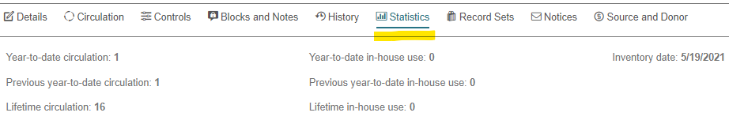
Record Set View – Shows the record sets this item belongs to
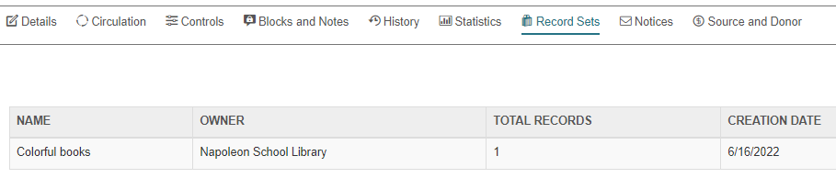
Notices View – shows dates and times notices were issued for the item
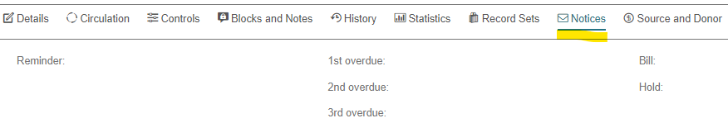
Source and Donor View – shows system supplied information from acquisitions processes in the top box. The bottom box has information for eContent items. The middle box has information about donors.
