Discovery/PAC User Group Meeting Notes – May 11, 2022
Old Business – updates:
- April 13th meeting was cancelled due to weather.
- Is there easier way to help patrons find call numbers in display?
  - Jason investigated issue - the brief results display:
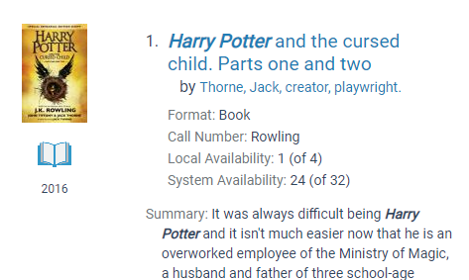
However, display in the full record is not available since bib record information is displayed – not item. Support says call number on brief bib is not correct and should not be used (this is likely more for the ODIN view). Please think about possible label update for “Availability” in the result lists. “Where is it?” and “Full Details”/”More Details” and “Place hold” are options other libraries use. ** If you wish to change the wording, please submit a ticket. It is customizable by library.
- Investigate Subject heading list length and fields displayed for FULL Display
** If you have ideas on what you would like to see, please bring to June meeting or submit via email to Lynn or the listserv.

Roundtable Open Forum - Summer plans/programs, patron outreach:
- Dickinson Area Public – preparing for Summer Reading Program – kickoff on May 28th, rearranging Juvenile Fiction area, still part time staff shortages
Topics for discussion:
- Polaris 7.1 installed on PROD – 4/12/22 morning – any problems or comments?
- IUG Virtual Conference – who attended? any take-aways?
- ODIN Workday – session recordings have been posted on the ODIN website
- Quick demo of ODIN Polaris PAC Search Explorer Tool (still in development) – link found in https://www.odin.nodak.edu/training/systems-and-reporting/polaris-pac-search-explorer-tool
Questions/Comments/Feedback
- Next Meeting – WFP – how is Novelist display fields working for your library?
- What are you doing for migration from Overdrive app to Libby App? Wishlist?

Next meeting June 8th – Second Wednesday of each month

