Creating Templates in the Metadata Editor

You will need one of the following roles to work with templates:
- Cataloger
- Cataloger extended
- Catalog manager
- Catalog administrator
To view available templates, click on the Templates tab and select either the MARC21 Bib tab or Holdings tab (depending on the type of template you want).
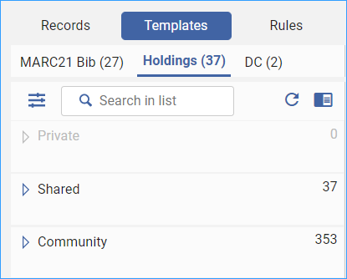
To make a copy of a community template, make sure your record placement options are set to save templates locally. Menu: New > Placement Options.
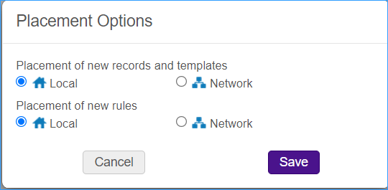
Use the search box to help you find the type of template you need.
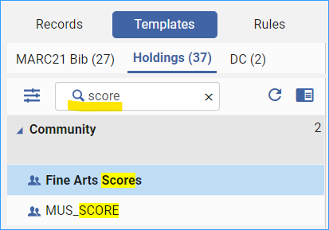
Then, right-click and select “Duplicate.”
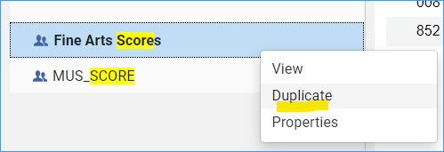
Give the template a name and a description so you know what it is for. You can save it to a private folder, so only you can use it, or you can save it to the shared folder so everyone in your institution can use it. (This can be changed later if you change your mind.)
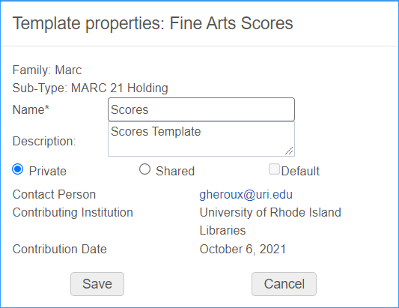
Now you can edit the template. Find the template in either the private or shared folder and click on it to open it in the metadata editor.
Edit the template so it looks the way you want it to and save it.
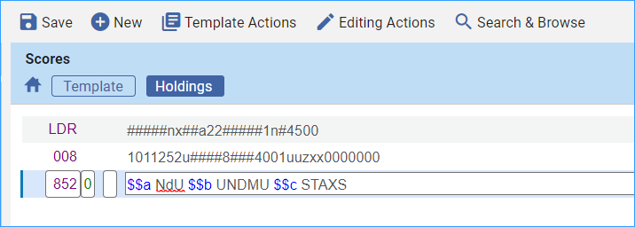
You can now use the “Expand from Template” (Ctrl-E) option from the Editing Actions menu to enhance a bibliographic or holdings record with the template.
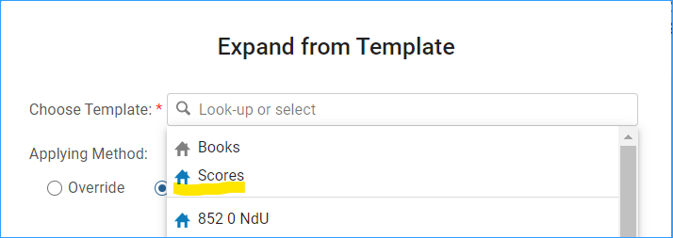
Now you will want to add it to your +Add Inventory menu.
From the New menu, select “Templates display configuration.”
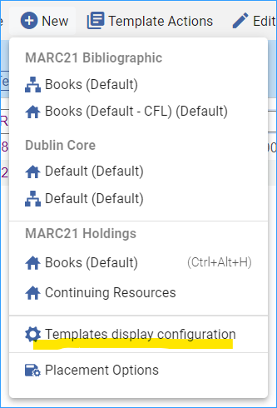
A bunch of templates appear, and on the right side, there is a toggle to Display in Menu.
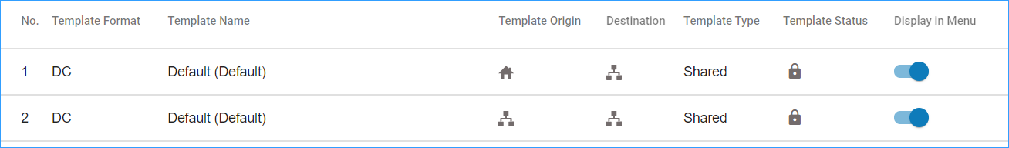
From this screen you can remove templates you do not use and add the ones that you do use. When you are done, click the save button on the upper right.
Now when you click on +Add Inventory you will see your new template:
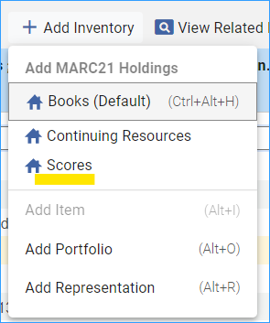
*Note: Others in the institution will not see this menu option until they go through the Templates Display Configuration and add the template to their menu. The template must be saved in the “Shared folder” for others to use it.

