Polaris notices focus on Overdue letter setup

You can send up to three overdue notices, scheduling the interval between them.
Each overdue interval is measured from the date and time the item status changed to overdue, not from the date and the previous notice was set.

If an item has qualified for overdue notice processing, but is returned before the notice is sent, the item is removed from notice processing.

Overdue notices can be delivered through the mail as print notices, by e-mail, by phone or as text message to mobile phones.

When overdue notices are generated, the date is recorded in the appropriate item records, the notices are posted in the transaction file, the patron notification history is updated, and the notice queue is cleared.

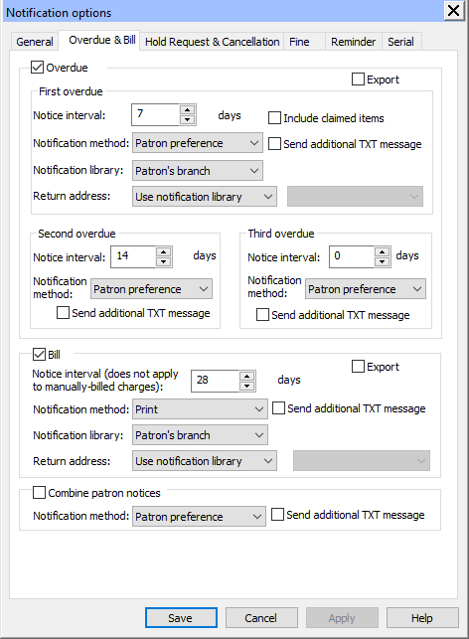

Here is information on what each setting means and how it works.

Notice interval - Type or select the number of days (999 maximum) after an item is declared overdue that the item is added to the queue for the first overdue notice.
Include claimed items - Select (check) to include claimed items in overdue notice processing. If they Include claimed items and Combined patron notices options are selected, the Missing Parts notice is included in the combined notice.
Send additional TXT message - Select (check) to send a text message notice to patrons’ mobile phones in addition to the notification method you selected. A patron will receive the additional text message only if the Additional TXT messaging option is checked in the patron record. If you selected Patron Preference in the Notification Method box, patrons who have text messaging set as their preferred notification method in the patron record will receive text message notices only.
Notification method - Select a delivery method. You can deliver overdue notices by any of the methods you selected on the General tab. Patron Preference means that the method is taken from the patron record. If you select another method, your selection overrides the method specified in the patron record.
Notification library - Select the library that should generate the overdue notice. For information on how this selection determines which patrons and items are identified for overdue notice processing.
Return address - Select Use notification library to use the address specified in the organization record for the notification library. Select Use optional address to use an address other than the notification library’s. If you select this option, select the organization whose address should appear on the notice.

Reminders:

You can send e-mail reminders notices to any qualifying patron with a valid e-mail address, regardless of patron’s preferred notification method, and optionally send an additional text message.

If a patron’s record does not contain an e-mail address but does contain a phone number and carrier for text messaging, reminder notices will be sent via text message.

The following e-mail reminders notices are available:
- Almost overdue notice/Auto-renew - A notice is sent a specified number of days before a patron’s item becomes overdue. If automatic renewals are enabled, and the patron has items out that were renewed, the notice also includes these items. The notice also lists other items that the patron currently has checked out. Polaris supplies the item title, call number, volume, due date, format, check-out branch, and number of renewals left for each item. When an Almost Overdue reminder notice is sent regarding an item, the date is recorded in the item record. The default setting in the Notification options parameter is to exclude integrated eContent titles in reminder notices, but your library can change this default setting.
- Patron record expiration notice - A notice is sent a specified number of days before a patron’s registration expires. The notice alerts the patron to contact the library. Polaris supplies the patron’s home address, telephone number, and email address for verification.
- Inactive patron notice - A notice is sent to a patron whose account has had no activity for a specified number of days. The notice advises the patron to visit the library or call to update the patron’s registration. Polaris supplies the patron’s home address, telephone number, and email address for verification.
- Missing part notice - A notice is sent to a patron if an item was checked in using the Special Item Check-in function, and the Missing part: block & notify option was selected.

Reminder notices are sent only once. The notice processing program runs daily so that reminder notices are not re-sent to the same patrons.

Missing part mailers can be delivered through the mail as print notices, text, or phone.

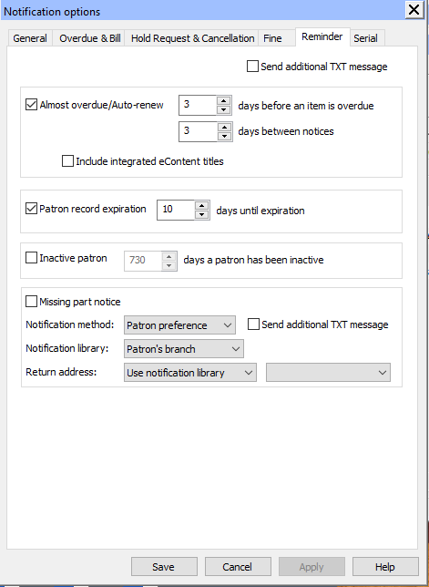

Ex. Almost overdue/Auto renew reminder shows in the patron’s notices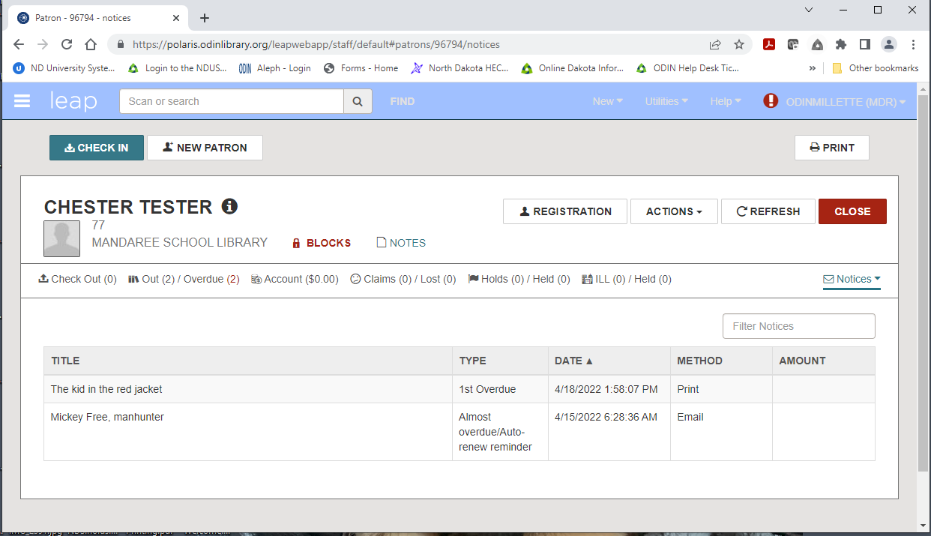

Generating Notices
- A scheduled SQL job, Notices Processing, runs each day at 6:00 a.m.
- Depending on the libraries chosen deliver options, the following happens at 6:00 a.m.
- Email messages are posted to the SMTP server and begin to be delivered.
- TXT messages are also posted to the SMTP server and set beginning at 6:00 a.m.
- Phone calls are sent to the Telephony server and the calls begin per the server settings.
- Print notices are posted to the queue and must be generated in Reports and Notices.
- Notices resulting in print must be manually generated.
- In Reports and Notices, go to the Notices folder.
- Each type of paper notice that the library uses will have to be generated.
- This may include:
  - Overdues
  - Bills
  - Combined
  - Hold Pick-Up
  - Second Pick Up
  - Cancelled Requests
  - Fines
  - Claims (Missing part mailer)
- Whether or not the library prints the notices and mails them out, the notices must be generated and posted.

Print notices
Run the following print notice jobs:
Overdue notices
Billing notices
Hold notices

For this demonstration, I will run the Overdue notice job to give you overview.
To generate overdue notices, select one of the jobs that start with “Overdues”
You will get a long list of options for each type of notices
Billing, Overdues or Patron Billing

We are going to choose the Overdues, and it is recommended to select
Overdues Z Fold Mailer or in the case for a Billing you would choose the
Billing Z Fold Mailer.

A dialogue box will open
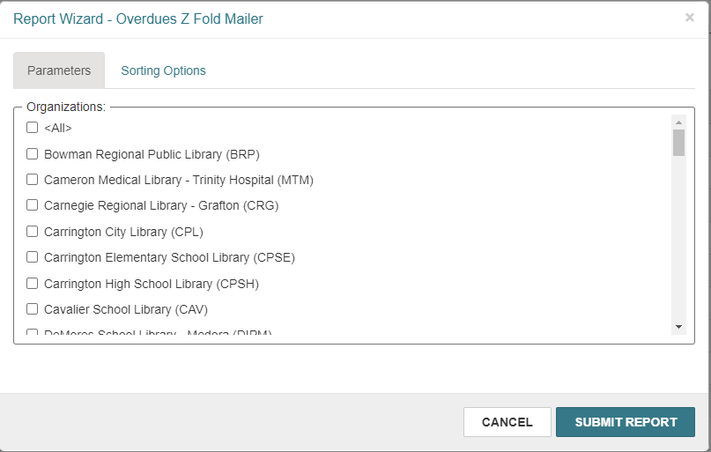
Select your branch from the list of options.
Please take your time here and make sure you are selection the correct branch!
Click Submit Report.

NOTE: it is also an option to select the Sorting Options tab to select parameters by which to sort. Check the parameters and click the arrow to move them the right-hand Selected box. Then check the parameter by which you wish to sort before clicking Submit Report. It is not necessary to complete this step-in order to generate notices.
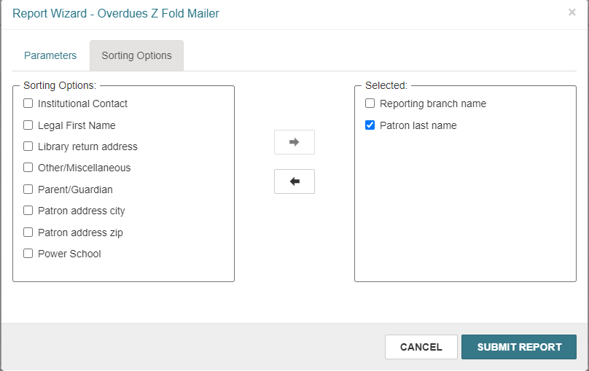

The job will begin generating overdue notices. This will include first, second, and third overdue notices. Once you click on “Submit Report” A preview of the notice(s) will open. This example shows that the book was overdue on 4/15 and I printed the notice the following Monday. The first overdue interval is set to 1 day after the due date.
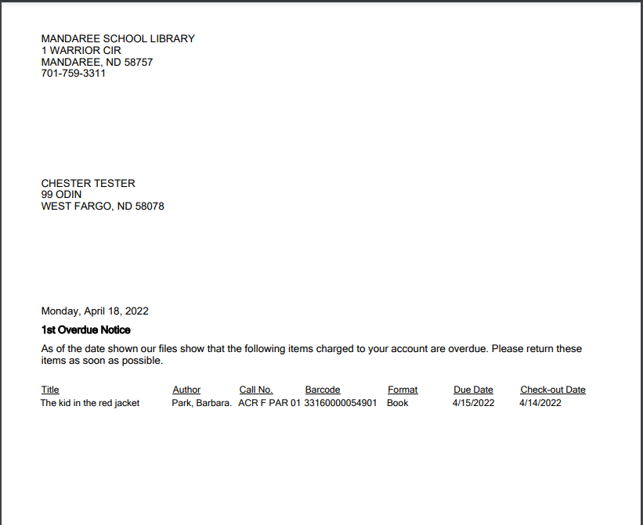

This example was to show you that on Sunday, April 24 I ran the overdue notices and I did receive a new overdue for Chester.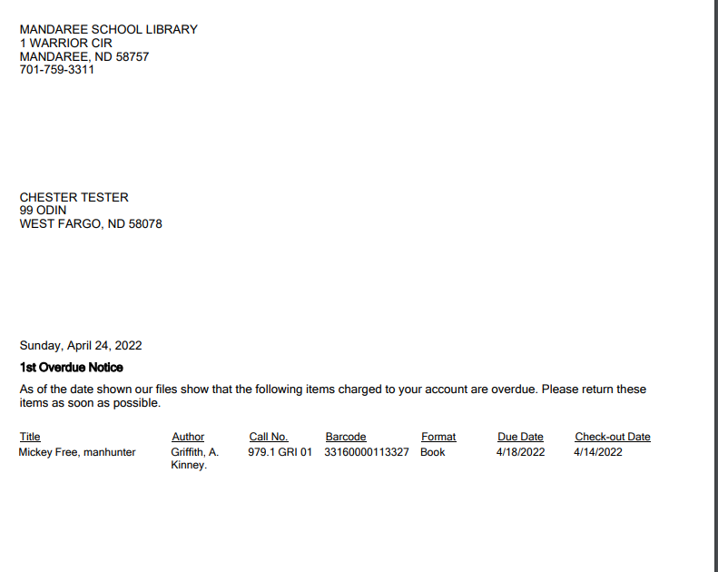

This example shows that since the first overdue was posted and the book was still overdue it was now ready for a 2nd Overdue notice. 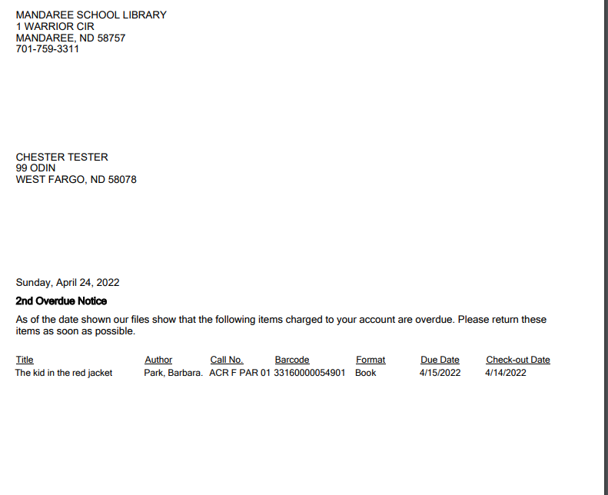

Scroll through the PDF to review the notices. If the notices are formatted correctly print the notices or download them to your computer. Once the notices are printed or downloaded, click “Yes” in Leap to post the notices to the database.
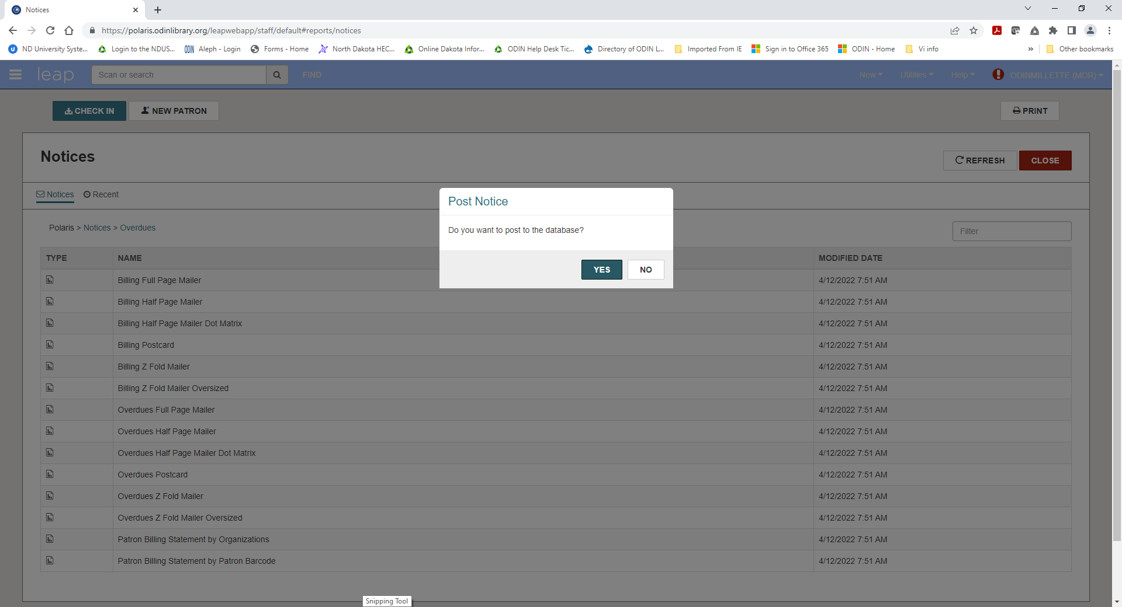
When you click “Yes” the notices are posted to the database and your branch’s notice queue for that type of notice is cleared out. Even if you will not be mailing the notices, you must select “Yes” to post them to the database.
If the notices do not look as expected – for example you selected the wrong format or the wrong library branch, click NO. This option allows you to start over.
Since the notice(s) look as we expected, I will click YES and print these notices and post to the database.
Accessing recent print notices jobs
Leap retains a copy of the most recently run file for each notice job.
This files that have been generated will be available for 24 hours OR until the notice job is re-run, whichever comes first.
To view a file, navigate to the “Recent tab” and you will be able to click on this entry or others if available and preview the notices to print or download to your computer.
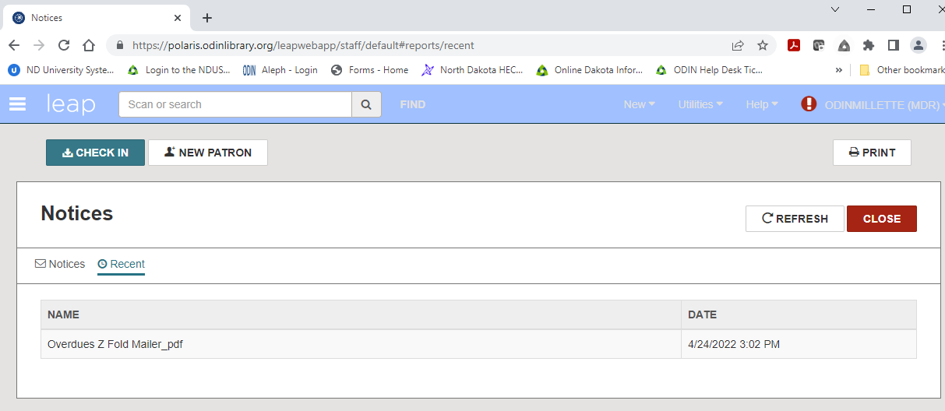
Please keep these tips at mind when running your notices in LEAP.
Here are some tips about the “Recent” tab
Both notice files that have been posted AND notice files that have not been posted will populate the “Recent” tab.
Staff are not able to post a notice file to the database from the “Recent” tab
Posting a notice file to the database can only be done when generating a new file from the “Notice” tab.
The “Recent” tab is tied to the Polaris Username
You will be able to view recent files on notices jobs you ran but will be unable to view recent files of notice jobs your coworkers ran.
Finally, the “Recent” tab does not include notice files that were generated from the staff client.
It only displays notice files that were generated from Leap.

