Alma Fulfillment User Group Meeting Agenda
Thursday, March 31st, 2022
Chair: Karlene Clark

- Updates
  - Rescheduled from Wed. March 30th
  - March/April Release Notes
    - May Release = Last full monthly release (features & fixes)
    - June & July Releases = Resolved issues only
    - August Release = First quarterly full release
    - March Release (Prod. release March 6th)
      - Require Explicit Confirmation of Fulfillment Messages
        - Prevents unintended confirmation of pop-up Fulfillment messages by hitting Enter or scanning the next item
        - Fulfillment Other Settings disable_enter_closing_fulfillment_popups parameter

      - Allow due date after patron account expiry date
        - Can enable staff to extend a loan due date at check-out beyond the expiry date of a patron
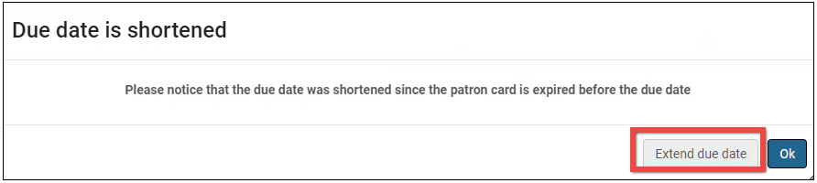

        - Fulfillment Other Settings extend_due_date_beyond_user_expiry parameter
    - April Release (Prod. release April 3rd)
      - Support for ‘Reply to’ Address in Letters
        - Check ‘Circulation Communication’ in Library Details Contact Info
- ODIN Workday Topic Options
  - Overdue & Lost Loan Profiles + Corresponding Letters/Notices
  - Configuration of Fulfillment Letters/Notices
  - Terms of Use/Fulfillment Units
  - Other ideas?
- Alma NERS Enhancement Voting (Fulfillment or Resource Sharing)
  - Feedback deadline is April 7th
  - Can be submitted via ODIN Help Ticket or emailing Linda (linda.allbee@ndus.edu)
  - Fulfillment & RS enhancements

- Anything else you would like to discuss or address?
  - Create a Fulfillment Teams channel for meeting agendas, recordings, etc.

- Next meeting is scheduled for Wednesday, May 25th at 9am

