Discovery/PAC User Group Meeting Notes – March 9, 2022
Old Business – updates:
- Is there easier way to help patrons find call numbers in display?
  - Jason investigated issue - the brief results display:
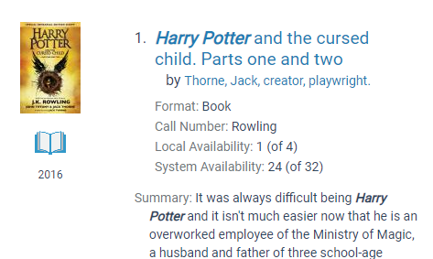
However, display in the full record is not available since bib record information is displayed – not item. Support says call number on brief bib is not correct and should not be used (this is likely more for the ODIN view). Please think about possible label update for “Availability” in the result lists. “Where is it?” and “Full Details”/”More Details” and “Place hold” are options other libraries use.
- Investigate Subject heading list length and fields displayed for FULL Display

Roundtable Open Forum:
- Grand Forks Public – call number display – already discussed
- Dickinson Area Public – no updates – client routing slips going to LEAP?
Print route slip: If the option is available, the Print Route Slip dialog appears. Select Yes to see the Print dialog. Select Cancel to continue the check-in without printing the route slip.
- West Fargo Public – working on automating acquisitions, on order records will be appearing in PAC, still searching for director and other positions.

Topics for discussion:
- LEAP update – patch applied 2/6/22 – no further reported issues
- Polaris 7.1 install scheduled on TRN for next week – 3/16/22 morning
https://documentation.iii.com/product-documentation/polaris.php
- IUG Virtual Conference – Register before 3/18/22. Information and registration link can be found: https://www.odin.nodak.edu/events/announcement/iug-2022-virtual-conference

Questions/Comments/Feedback

Next meeting April 13th – Second Wednesday of each month

