Three Methods to Add Portfolios to a Local Electronic Collection

Create a Local Electronic Collection
  - Create a local electronic collection. Resources > Add Local Electronic Collection.
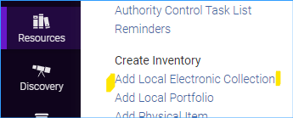
  - Give the local electronic collection a name and set the collection type and service type. Click Save and continue.
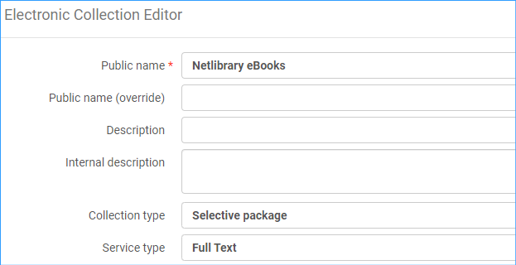
  - Change service activation to Available.
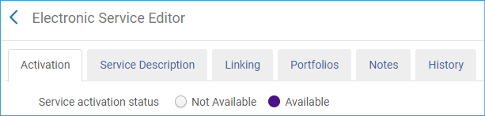
  - Click the next tab Service Description. It should say Full Text.
  - Click the Linking tab. Fill this tab in according to your collection. If the links must be proxied as for Netlibrary you would put that information here: Proxy enabled: Yes, and Select your proxy from the drop-down box.
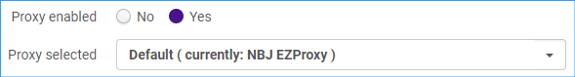
  - Click Save and Save again.
  - Note: if you missed setting up the service when you created a local electronic collection, you can get to it easily by searching for the collection and using the row action menu:
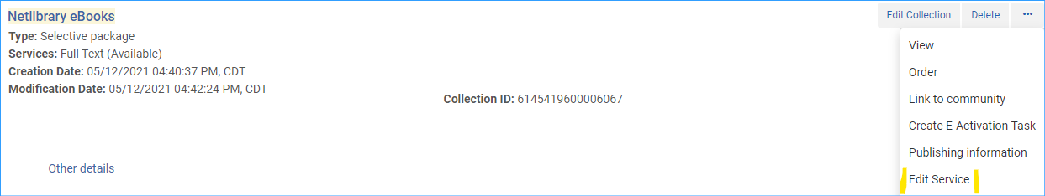
As above, the proxy information is under the linking tab. Proxy information should be stored in the service, not at the portfolio level.
Method 1. Add the portfolio to the electronic collection while creating it in the Metadata Editor
Method 2. Adding a local portfolio by creating a new title
- Locate the electronic collection and click on the row action menu and select “Edit Service.”
- Click on the Portfolio tab.
- Click on +Add and select “Add Local Portfolio.” The following work form appears.
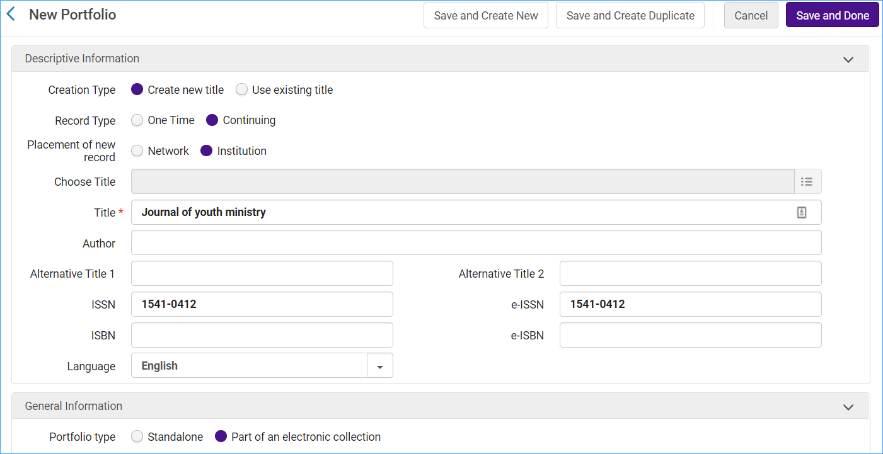
- Click “Create new title.”
- Record type “Continuing” for serials and “One Time” for monographs.
- Placement of new record “Institution.”
- Fill in the title and ISSN or ISBN.
- In the General Information section, the electronic collection and service should already be filled in.
- The next section is Coverage information. Fill in the journal coverage information:
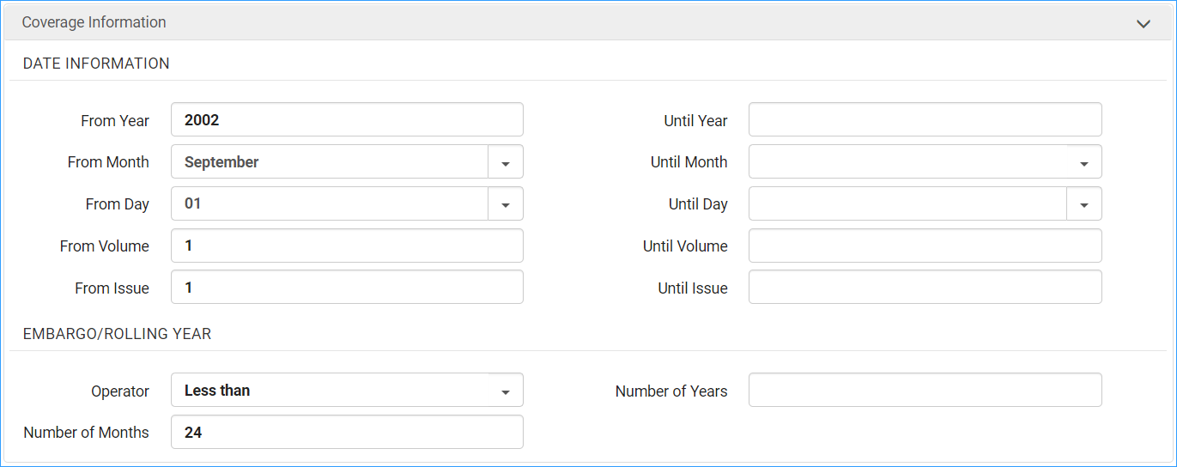
Note: Operator Less than will display as Most recent 24 month(s) available.
Operator Greater than will display as Most recent 24 month(s) not available.

- Next is inventory and linking information. Fill in the url and electronic material type. No need to add proxy here as we already set it up in the electronic collection.
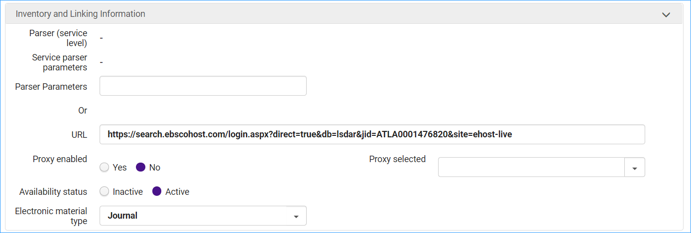
- The next section is notes. You can fill those in if necessary.
- Click Save and Done.
Method 3. Add portfolios to a collection as a set.

